Alphabet Outdoor Exploration

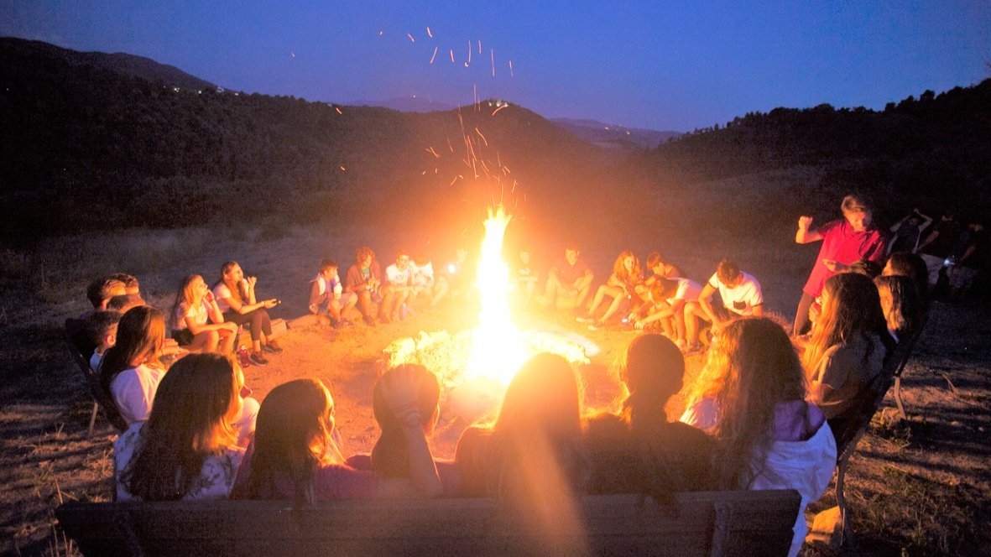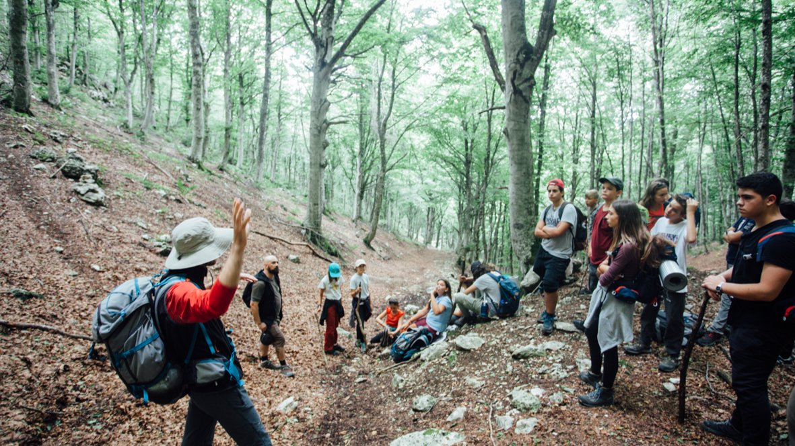

Umbria, Italia, from 12 to 17 age

Course intensity | 12
Accommodation | Residencia
Room type | Doble
Bathroom facilities | En-suite
Meals | Desayuno, comida y cena
Excursions per week | 2
Weekday excursions
Full day excursions

Description

Why choose this program

Infrastructure

Sport infrastructure

Hobbies and clubs

What else included in the program price

Recommended arrival city

Рим

Sample timetable
 | Morning | Afternoon | Evening
Day 1 |  | Campers arrive | Orientation
Day 2 | English Lesson and Outdoor Education | Team sports/Climbing | Reading the stars
Day 3 | English Lesson and Outdoor Education | Team sports/Rafting or Canyoning
Day 4 | English Lesson and Outdoor Education | Team sports/Mountain biking
Day 5 | English Lesson and Outdoor Education | Team sports/Trekking | Overnight camping excursion
Day 6 | Trekking back to camp | Team sports/orienteering | Disco night
Day 7 | Final language assessment | One week campers leave | Evening entertainment

For booking please go to www.travelclass.org

