friLingue Leysin School — language school in Switzerland

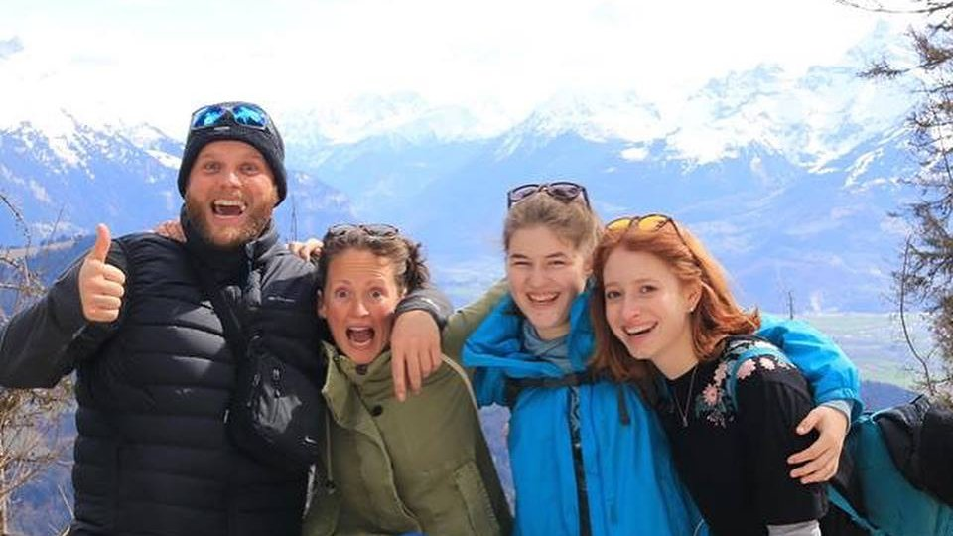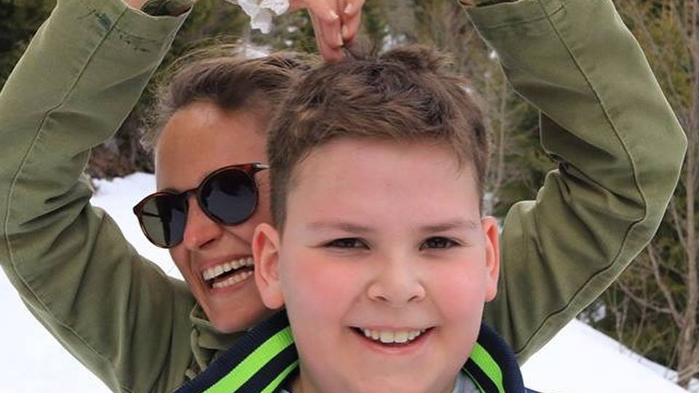

Leysin, Switzerland, from 8 to 17 age

Course intensity | 15
Accommodation | Hotel
Room type | Quadraple
Bathroom facilities | En-suite
Meals | Desayuno, comida y cena
Excursions per week | 3
Weekday excursions | 2
Full day excursions | 1

Description

Why choose this program

Infrastructure

Sport infrastructure

Hobbies and clubs

What else included in the program price

Recommended arrival city

Женева

Sample timetable
 | Morning | Afternoon | Evening
Day 1 | Free | Arrivals | Welcome meeting and oral test
Day 2 | Classes | Workshops | Swimming pool
Day 3 | Classes | Hiking ( excursion ) | Casino Night
Day 4 | Classes | Workshops | Sports Tournament
Day 5 | Classes | Adventure Park/ Laser Tag | Free
Day 6 | Classes | Free | Disco
Day 7 | Excursion to Sion | Excursion to Sion | Free time
Day 8 | Free Day
Day 9 | Classes | Workshops | Aigle Castle
Day 10 | Classes | Aigle Castle | Casino Night
Day 11 | Classes | Workshops | Camp fire
Day 12 | Classes | Col des Mosses | Karaoke
Day 13 | Classes | Free | Hotel Cinema
Day 14 | Excursion to Chaplin's World in Vevey | Excursion to Chaplin's World in Vevey | Excursion to Chaplin's World in Vevey

For booking please go to www.travelclass.org

