Enforex Alicante School — language school in Spain

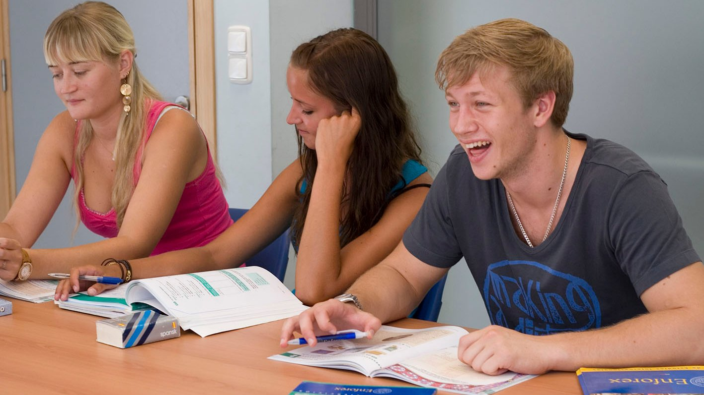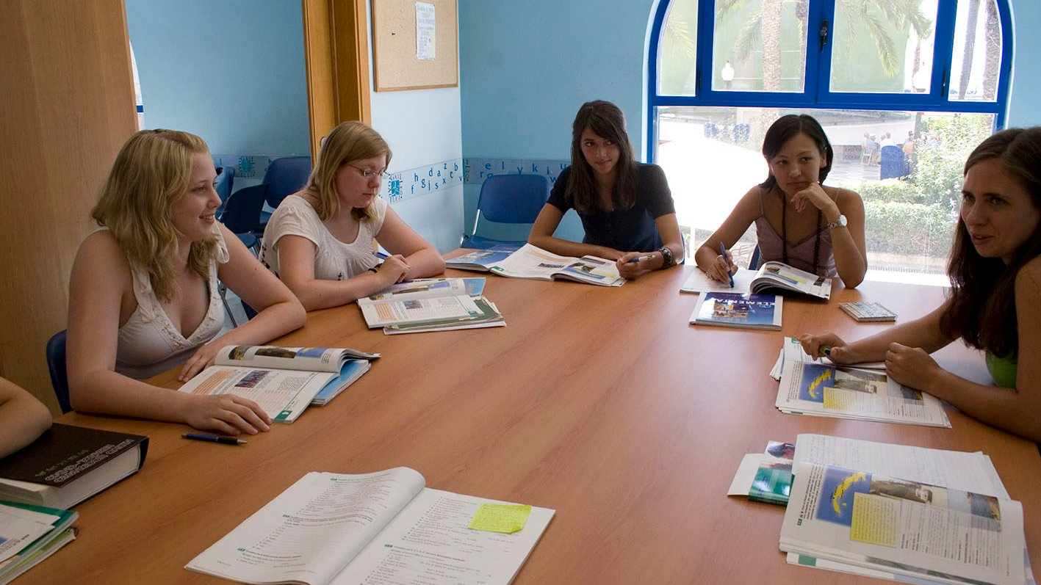

Explanada de España, 15, 03001 Alicante, Spain, from to age

Course intensity | 20
Accommodation | Casa de familia
Room type | Doble
Bathroom facilities | Compartido
Meals
Excursions per week | 5
Weekday excursions | 4
Full day excursions | 1

Description

Why choose this program

Infrastructure

Sport infrastructure

Hobbies and clubs

What else included in the program price

Recommended arrival city

Аликанте

Sample timetable
 | Morning | Afternoon | Evening
Day 1 | Arrival
Day 2 | Level test & orientation | Discovering Barrio de Santa Cruz | Free Time
Day 3 | Spanish lessons | Movie | Free time
Day 4 | Spanish lessons | the Gravina Museum of Art (extra paid) | Free Time
Day 5 | Spanish lessons | Shopping at the Central Market | Free evening
Day 6 | Spanish lessons & Course Certificates | Spanish cultural workshop | Dinner with the group
Day 7 | Trip to Valencia (extra paid) | Trip to Valencia (extra paid) | Dinner

For booking please go to www.travelclass.org

