Target University of Bath — summer school in the UK

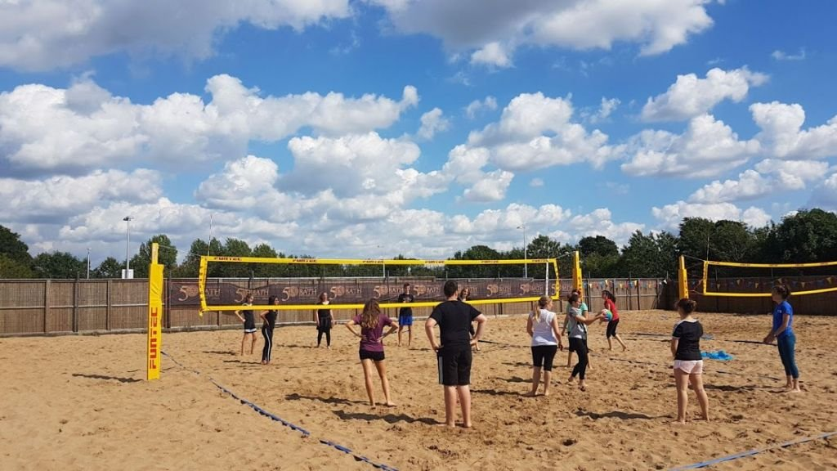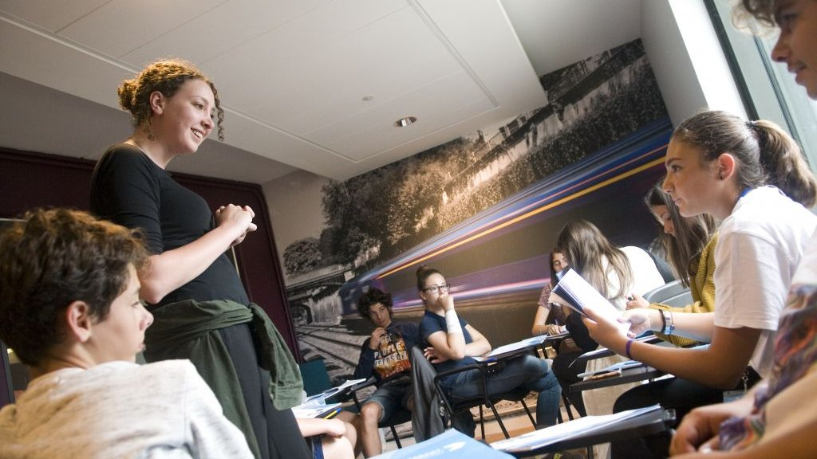

Claverton Down Road, Claverton Down, Bath BA2 7AY, UK, from 10 to 19 age

Course intensity | 15
Accommodation | Campus
Room type | Single
Bathroom facilities | Shared
Meals | Breakfast, Lunch and Dinner
Excursions per week | 5
Weekday excursions | 3
Full day excursions | 2

Description

Why choose this program

Infrastructure

Sport infrastructure

Hobbies and clubs

What else included in the program price

Recommended arrival city

Лондон

Sample timetable
 | Morning | Afternoon | Evening
Day 1 | Test & Induction Lesson | Bath Walking Tour and Orientation | Evening activity
Day 2 | Lesson | Sports, activities and workshops | Evening activity
Day 3 | Lesson | Half day excursion to Stonehenge | Evening activity
Day 4 | Lesson | Sports, activities and workshops | Evening activity
Day 5 | Lesson | Local visit to Bath and entrance to Roman Baths | Evening activity
Day 6 | Full day excursion to Cardiff with Cardiff Castle entrance | Full day excursion to Cardiff with Cardiff Castle entrance | Evening activity
Day 7 | Full day excursion to London and walking tour with late return | Full day excursion to London and walking tour with late return | Evening activity

For booking please go to www.travelclass.org

