Alpha School of English — language school in Malta

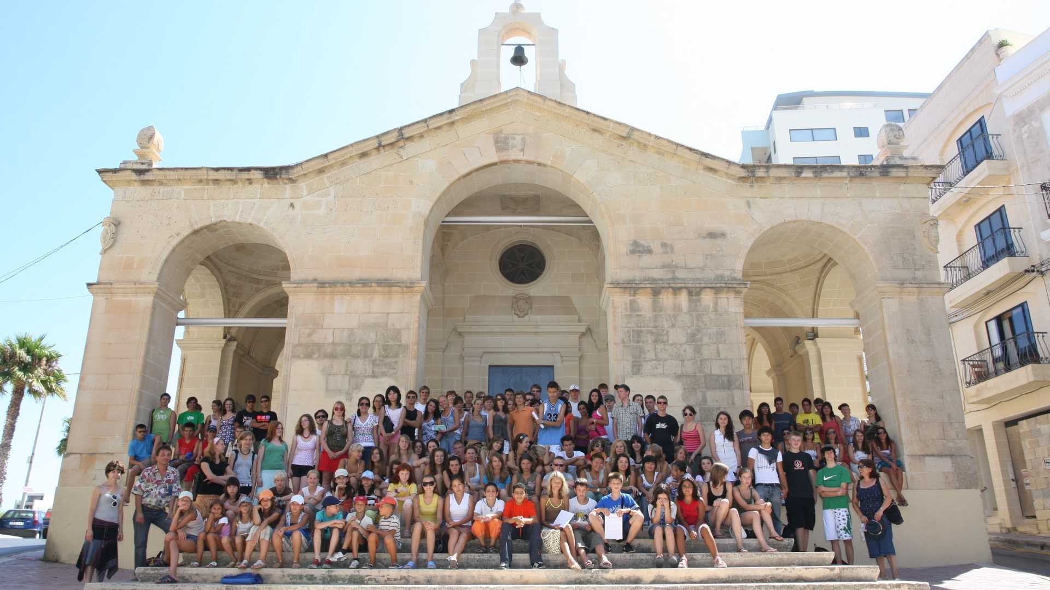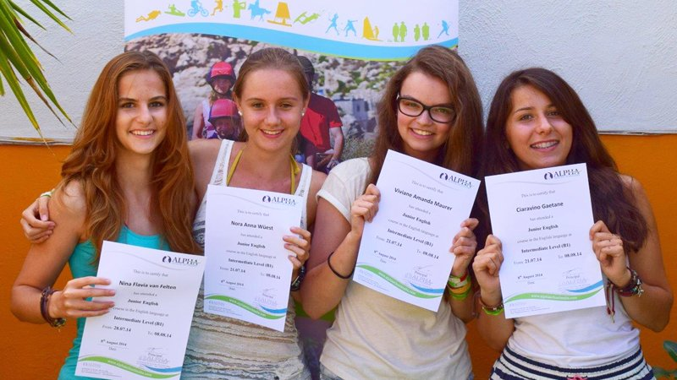

St Paul's Bay, Malta, from 13 to 18 age

Course intensity | 15
Accommodation
Room type | Doble
Bathroom facilities | Compartido
Meals | Desayuno, comida y cena
Excursions per week | 2
Weekday excursions | 1
Full day excursions | 1

Description

Why choose this program

Infrastructure

Sport infrastructure

Hobbies and clubs

What else included in the program price

Recommended arrival city

Сан-Пауль-иль-Бахар

Sample timetable
 | Morning | Afternoon | Evening
Day 1 | Arrival
Day 2 | Lessons | Free time | Free time
Day 3 | Lessons | Excursion to Valletta/Mdina | Free time
Day 4 | Lessons | Free time | Free time
Day 5 | Lessons | Free time | Cultural entertainment
Day 6 | Lessons | Free time | Free time
Day 7 | Full day excursion to the Blue Lagoon in Comino/Waterpark

For booking please go to www.travelclass.org

