NSTS Malta English Language Institute — language school in Malta

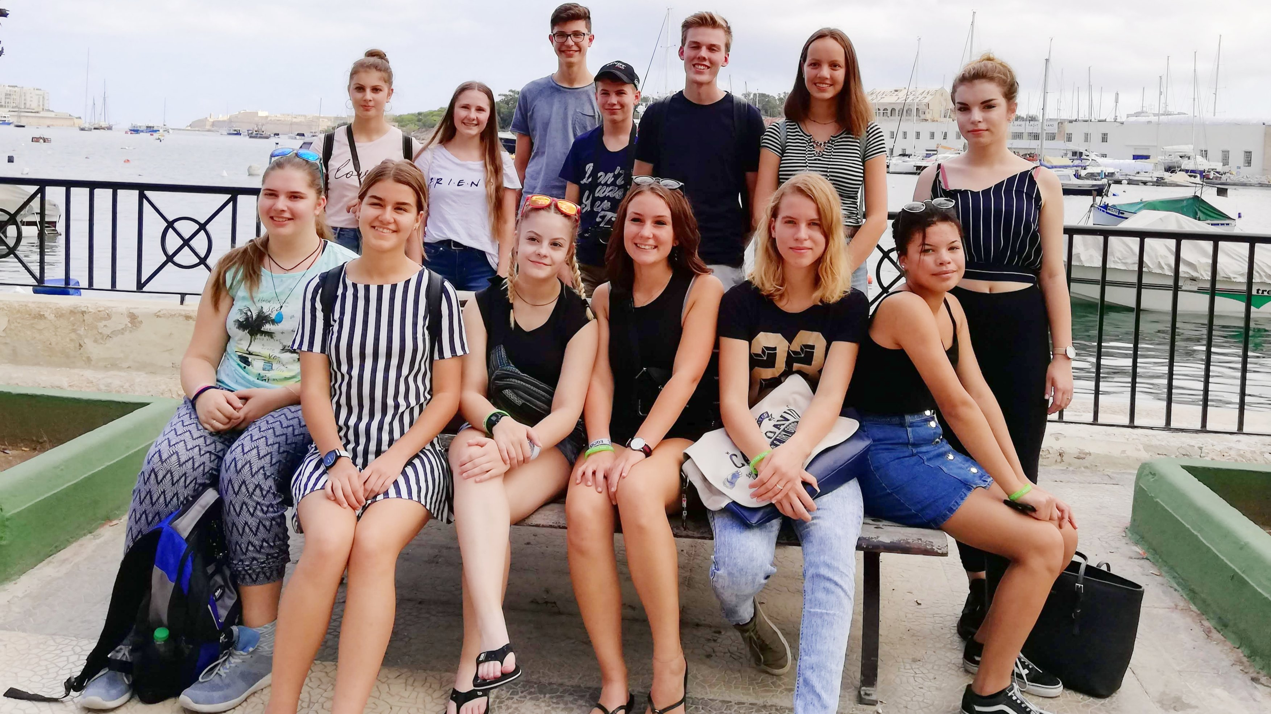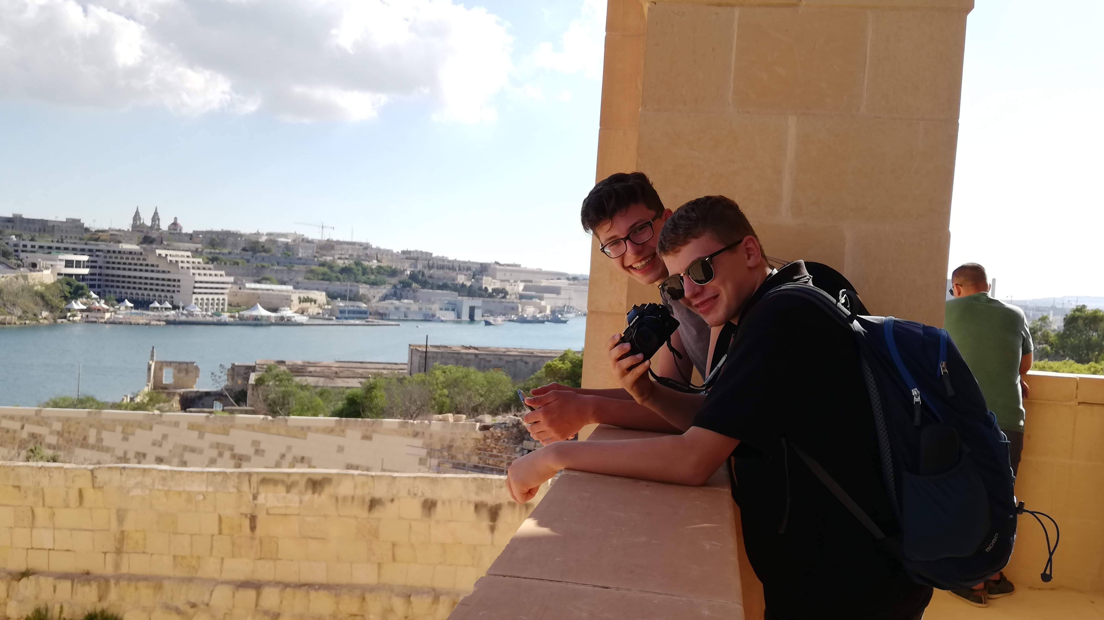

Gzira, Malta, 12 Taliana Lane, from 13 to 90 age

Course intensity | 9
Accommodation | Universidad
Room type | Quadraple
Bathroom facilities | En-suite
Meals | Desayuno, comida y cena
Excursions per week | 5
Weekday excursions | 0
Full day excursions | 1

Description

Why choose this program

Infrastructure

Sport infrastructure

Hobbies and clubs

What else included in the program price

Recommended arrival city

Гзира

Sample timetable
 | Morning | Afternoon | Evening
Day 1 | Arrival Greetings/ Transfer/ Check-in | Welcome Ice Breakers | Town Orientation walk
Day 2 | English lessons | Sandy Beach Swimming | Pool Animation Party
Day 3 | English lessons | Discover Valletta + Malta Experience | LOL Try not to Laugh Challenge
Day 4 | English lessons | Sandy Beach Swimming, games | Night Swim and Beach Party
Day 5 | English lessons | Sliema Centre Walk | Exploring the Three Cities
Day 6 | English lessons | Manoel Island Rocky Beach | Sports Festival
Day 7 | Best of Malta North | Best of Malta North (Leisure, Beach) | Maltese Festa
Day 8 | Lazy Relaxing Pool Swim | Surfside Sliema Rocky Beach | Horror Movie Night and English Debate
Day 9

Day 10

Day 11

Day 12

Day 13

Day 14

For booking please go to www.travelclass.org

