MLA Lazio — language school in Italy

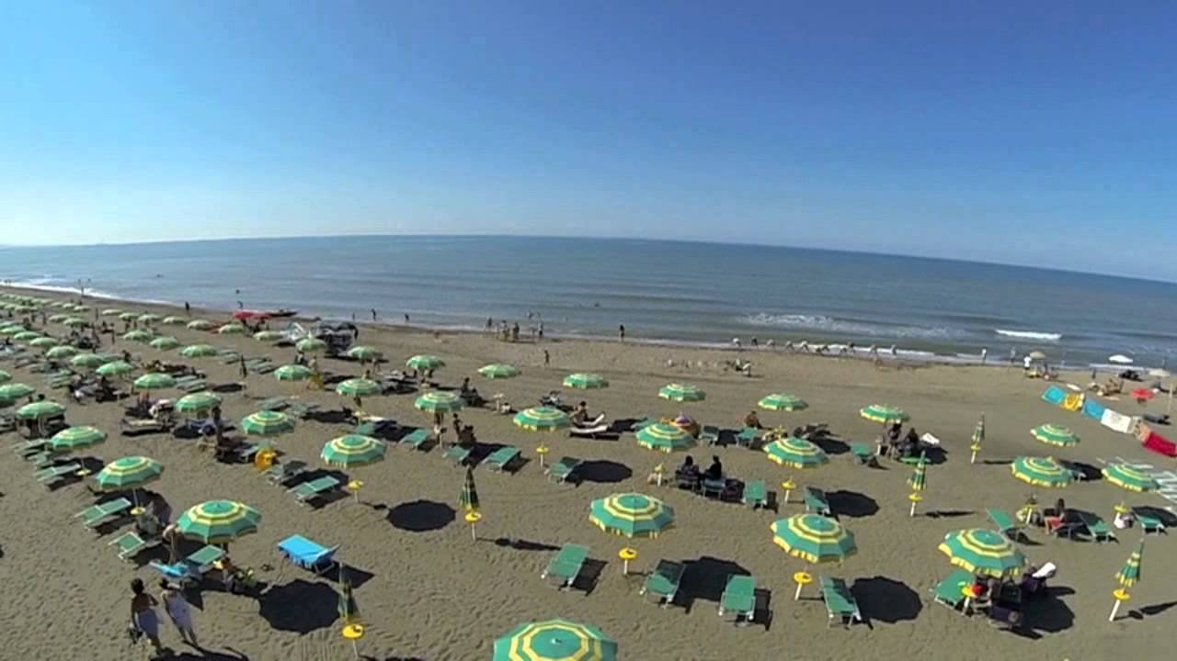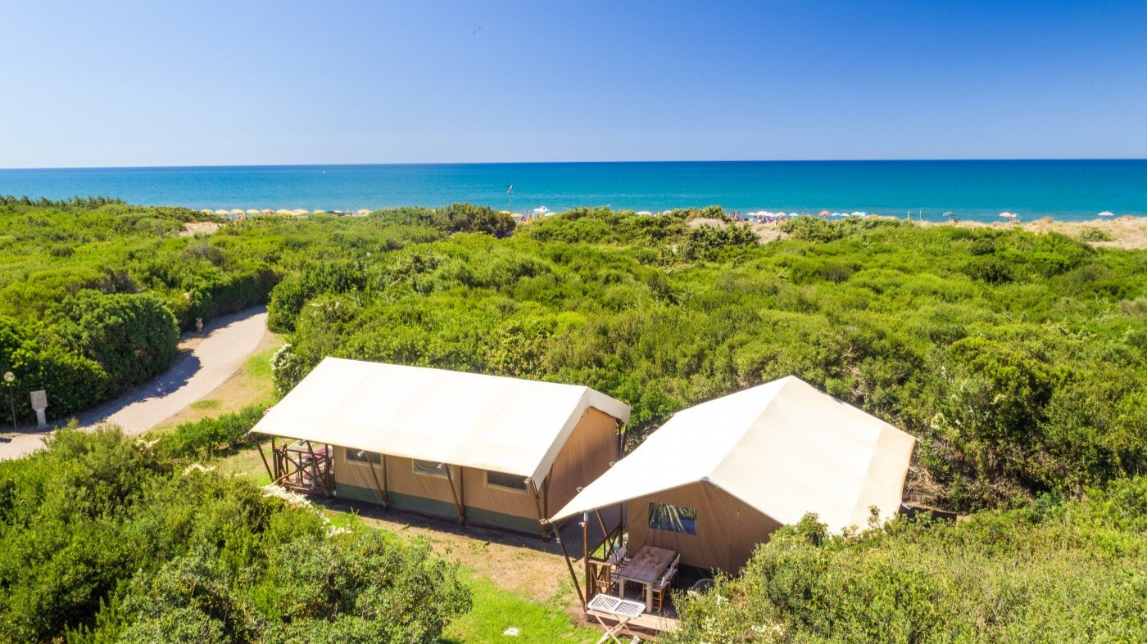

Località Le Casalette, 01014 Montalto Marina VT, Italy, from 8 to 14 age

Course intensity | 15
Accommodation | Hotel
Room type | Doble
Bathroom facilities | En-suite
Meals | Desayuno, comida y cena
Excursions per week | 2
Weekday excursions | 1
Full day excursions | 1

Description

Why choose this program

Infrastructure

Sport infrastructure

Hobbies and clubs

What else included in the program price

Recommended arrival city

Рим

Sample timetable
 | Morning | Afternoon | Evening
Day 1 | Arrival | Orientation Learning MLA Summer Song | Welcome Disco Party
Day 2 | Lessons | Sun & Sea Sport On the beach | Karaoke Chit Chat Club
Day 3 | Lessons | Tea Party Experience The story of the Tea | Fashion Night
Day 4 | Lessons | Half Day The Tarot Garden* | Pool Party
Day 5 | Lessons | Lessons | Hawaiian Disco Party
Day 6 | Full Day Orvieto Walking Tour of the city & shopping | Full Day Orvieto Walking Tour of the city & shopping | Graduation Ceremony & Student Portfolio
Day 7 | Packing and Goodbyes | departure | departure

For booking please go to www.travelclass.org

