Cavendish School of English Malta — language school in Malta

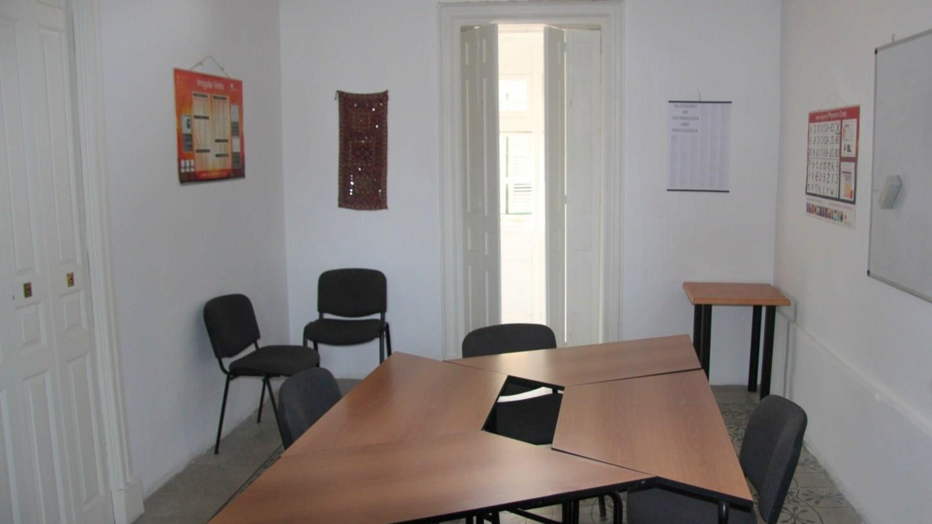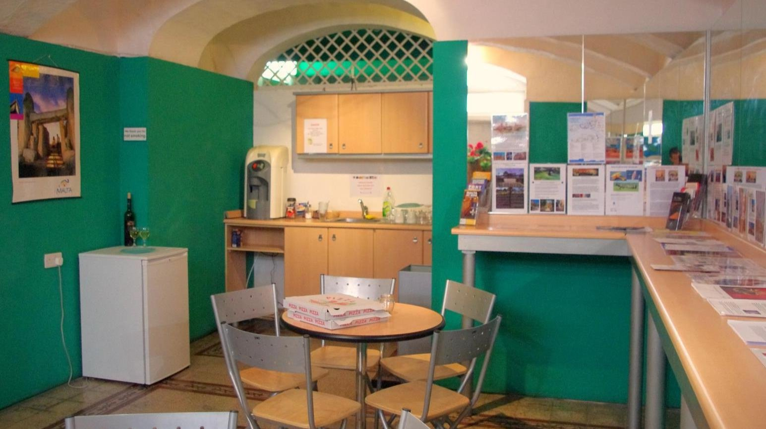

124 Melita Street, Valletta, Malta, from 10 to 99 age

Course intensity | 18
Accommodation | Casa de familia
Room type | Doble
Bathroom facilities | Compartido
Meals | Desayuno, comida y cena
Excursions per week | 5
Weekday excursions | 4
Full day excursions | 1

Description

Why choose this program

Infrastructure

Sport infrastructure

Hobbies and clubs

What else included in the program price

Recommended arrival city

Валлетта

Sample timetable
 | Morning | Afternoon | Evening
Day 1 | Arrival day
Day 2 | Lessons | Guided tour of Valetta | Welcome boat party
Day 3 | Valletta Treasure Hunt | Lessons | Karaoke
Day 4 | Full day to Comino | Full day to Comino | Full day to Comino
Day 5 | Optional excursion/free time | Optional excursion/free time | Optional excursion/free time
Day 6 | Visit to Sliema | Lessons | DVD Night
Day 7 | Visit to Golden Bay Beach | Lessons | International Student party

For booking please go to www.travelclass.org

