PLUS Malta — summer school in Malta

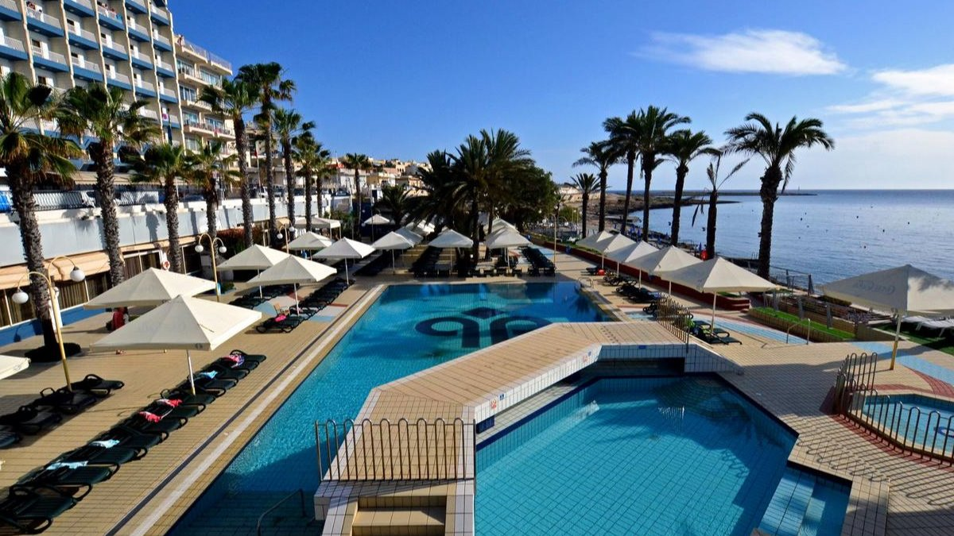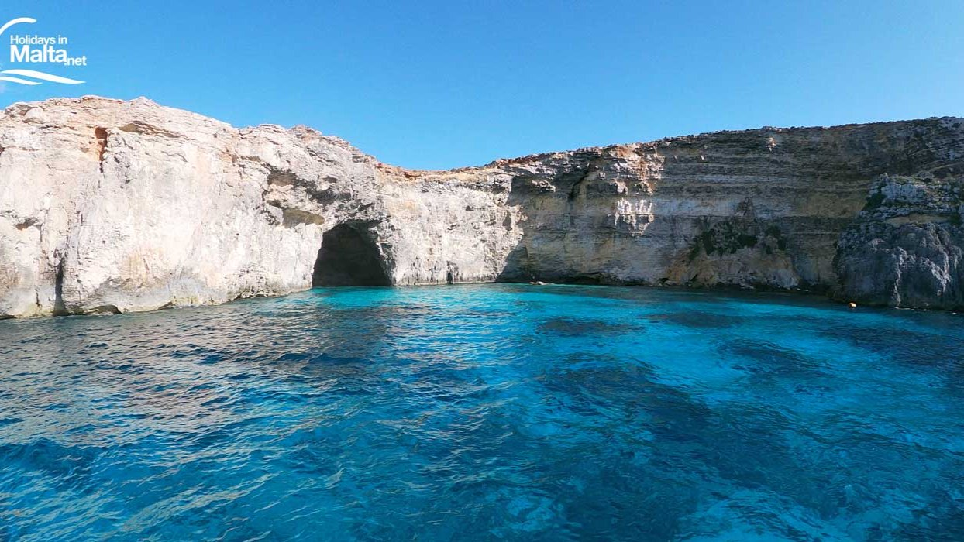

Malta International Airport (MLA), Luqa, Malta, from 9 to 17 age

Course intensity | 15
Accommodation | Hotel
Room type | Quadraple
Bathroom facilities | En-suite
Meals | Desayuno + Cena
Excursions per week | 4
Weekday excursions | 7
Full day excursions | 2

Description

Why choose this program

Infrastructure

Sport infrastructure

Hobbies and clubs

What else included in the program price

Recommended arrival city

Валлетта

Sample timetable
 | Morning | Afternoon | Evening
Day 1 | Arrivals | Check in | Free evening
Day 2 | Lesson | Half Day Excursion to Ghajn Tuffieha Beach | BBQ Beach Party
Day 3 | Lesson | Half Day Excursion to Ghadira Beach | Excursion to Mdina by night
Day 4 | Full day excursion (09:00-17:30) | La Valletta & Golden Bay | Free Evening
Day 5 | Full day at the beach (09:00 - 16:00) | Full day at the beach (09:00 - 16:00) | Free Evening
Day 6 | Lesson | Free afternoon | Disco
Day 7 | Lesson | Half Day Excursion to Comino Island | Free Evening
Day 8 | Lesson | Free afternoon | Beach games
Day 9 | Lesson | Half Day Excursion to Sliema | Evening in the city centre
Day 10 | Lesson | Half Day Excursion to Armier Beach | Evening in the city centre (eg La Valletta)
Day 11 | Full day at the beach | Full day at the beach | Full day at the beach
Day 12 | Full day at the beach | Full day at the beach | Full day at the beach
Day 13 | Lessons | Half Day Excursion Harbour Cruise | Disco
Day 14 | Departure

For booking please go to www.travelclass.org

