PLUS Iona College — summer school in the USA

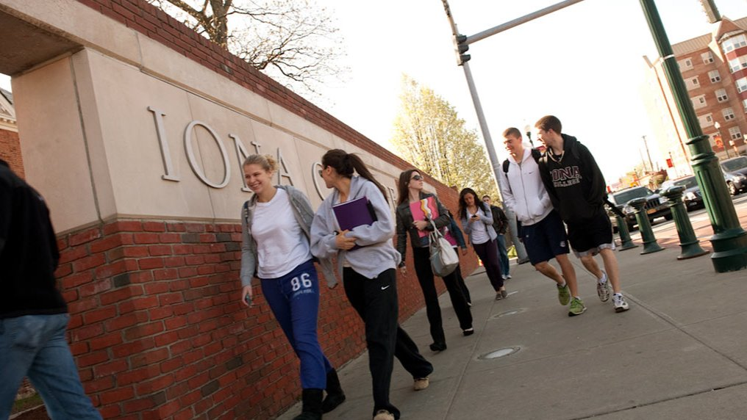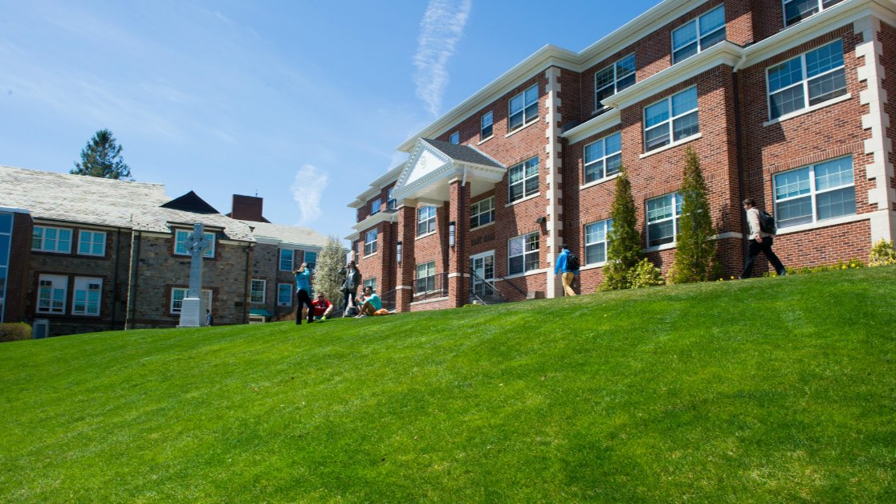

Iona College, North Avenue, New Rochelle, NY, USA, from 10 to 20 age

Course intensity | 15
Accommodation | Universidad
Room type | Individualmente
Bathroom facilities | En-suite
Meals | Desayuno, comida y cena
Excursions per week | 3
Weekday excursions | 1
Full day excursions | 2

Description

Why choose this program

Infrastructure

Sport infrastructure

Hobbies and clubs

What else included in the program price

Recommended arrival city

Нью-Йорк

Sample timetable
 | Morning | Afternoon | Evening
Day 1 | Arrivals - Check in | Orientation Tour | Welcome Night
Day 2 | Full Day Excursion to Manhattan | Brooklyn Bridge, Chinatown, Little Italy, SoHo | Karaoke Night
Day 3 | Lesson | Organized Recreation Games and/or Sports | Red, White, & Blue Disco
Day 4 | Full Day Excursion to Manhattan | Central Park, Metropolitan Museum of Art (entrance included) | Trivia Night
Day 5 | Lesson | Full Day Excursion to Manhattan visiting: | Greenwich Village, The High Line, Chelsea Market, Hudson Yards, Herald Square (Macy's)Bryant Park, Netflix Film Festival (entrance)
Day 6 | Lesson | Lesson | Ice Cream Social
Day 7 | Organized Recreation Games and/or Sportsand/or Opportunity for extra excursion | Organized Recreation Games and/or Sportsand/or Opportunity for extra excursion | Movie Night

For booking please go to www.travelclass.org

