Trinity UK Sestriere — summer school in Italy

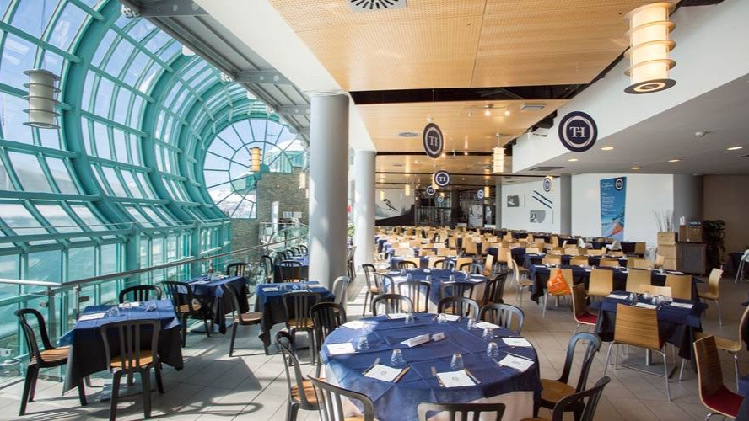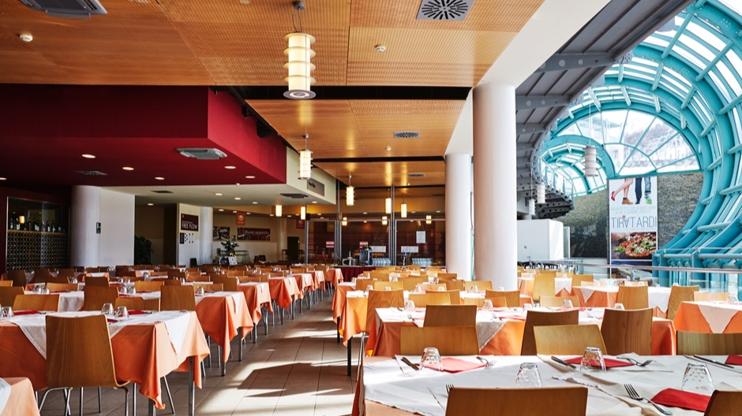

Sestriere, TO, Italia, from 13 to 18 age

Course intensity | 15
Accommodation | Universidad
Room type | Triple
Bathroom facilities | En-suite
Meals | Desayuno, comida y cena
Excursions per week | 1
Weekday excursions
Full day excursions

Description

Why choose this program

Infrastructure

Sport infrastructure

Hobbies and clubs

What else included in the program price

Recommended arrival city

Турин

Sample timetable
 | Morning | Afternoon | Evening
Day 1 | Arrival day
Day 2 | Full Day Excursion or full day activity
Day 3 | Lessons | Labs + activities | Fashion Show
Day 4 | Lessons | Labs + activities | Disco
Day 5 | Lessons | Labs + activities | Quiz night
Day 6 | Lessons | Labs + activities | Talent show
Day 7 | Lessons | Labs + activities | Karaoke night

For booking please go to www.travelclass.org

