ILSC Vancouver — summer school in Canada

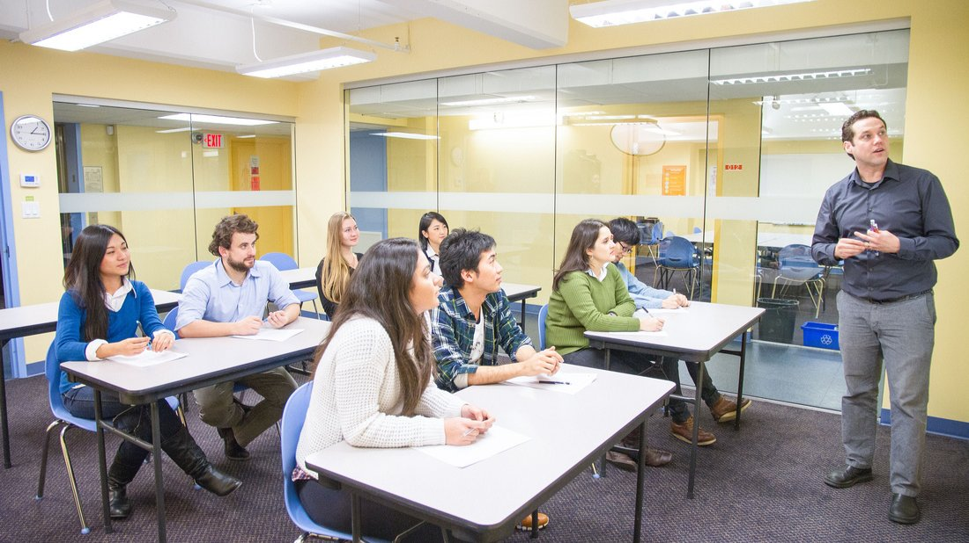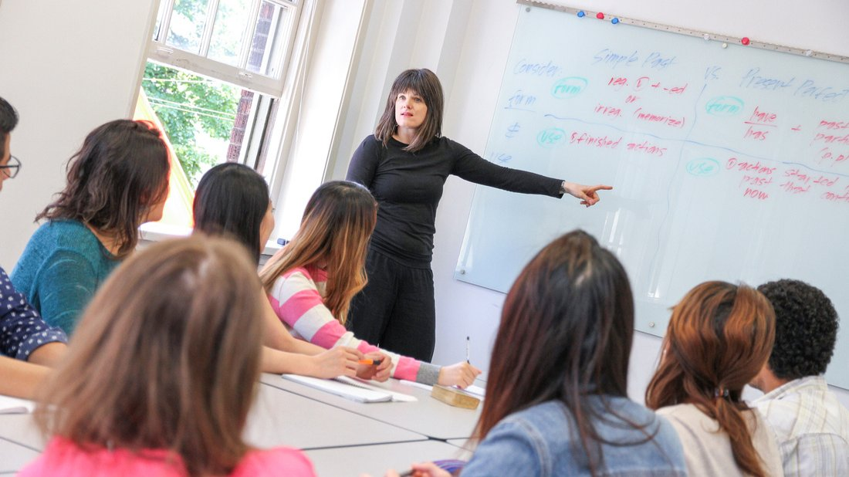

555 Richards Street, Vancouver, BC, Canada, from 10 to 17 age

Course intensity | 17
Accommodation | Campus
Room type | Single
Bathroom facilities | Shared
Meals | Breakfast, Lunch and Dinner
Excursions per week | 5
Weekday excursions | 4
Full day excursions | 1

Description

Why choose this program

Infrastructure

Sport infrastructure

Hobbies and clubs

What else included in the program price

Recommended arrival city

Ванкувер

Sample timetable
 | Morning | Afternoon | Evening
Day 1 | English classes till 12:00 | Athletics or arts | Scavenger hunt
Day 2 | English classes till 12:00 | Capilano Suspension Bridge | Capilano Suspension Bridge
Day 3 | English classes till 12:00 | Athletics or arts | Photo contest
Day 4 | English classes till 12:00 | Vancouver Aquarium | Sports Night
Day 5 | English classes till 12:00 | Athletics or arts | Karaoke night
Day 6 | Group activities | UBC Botanical Garden and Canopy Walkway | UBC Botanical Garden and Canopy Walkway
Day 7 | Group activities | Gastown walking tour | Gastown walking tour
Day 8 | English classes | Athletics or arts | Games night
Day 9 | English classes | Capilano Suspension Bridge | Capilano Suspension Bridge
Day 10 | English classes | Athletics or arts | Prize Bingo
Day 11 | English classes | Canada Place | Sports Night
Day 12 | English classes | Athletics or arts | Dance party
Day 13 | English classes | UBC Botanical Garden and Canopy Walkway | UBC Botanical Garden and Canopy Walkway
Day 14 | Departure

For booking please go to www.travelclass.org

