TLA - The Language Academy

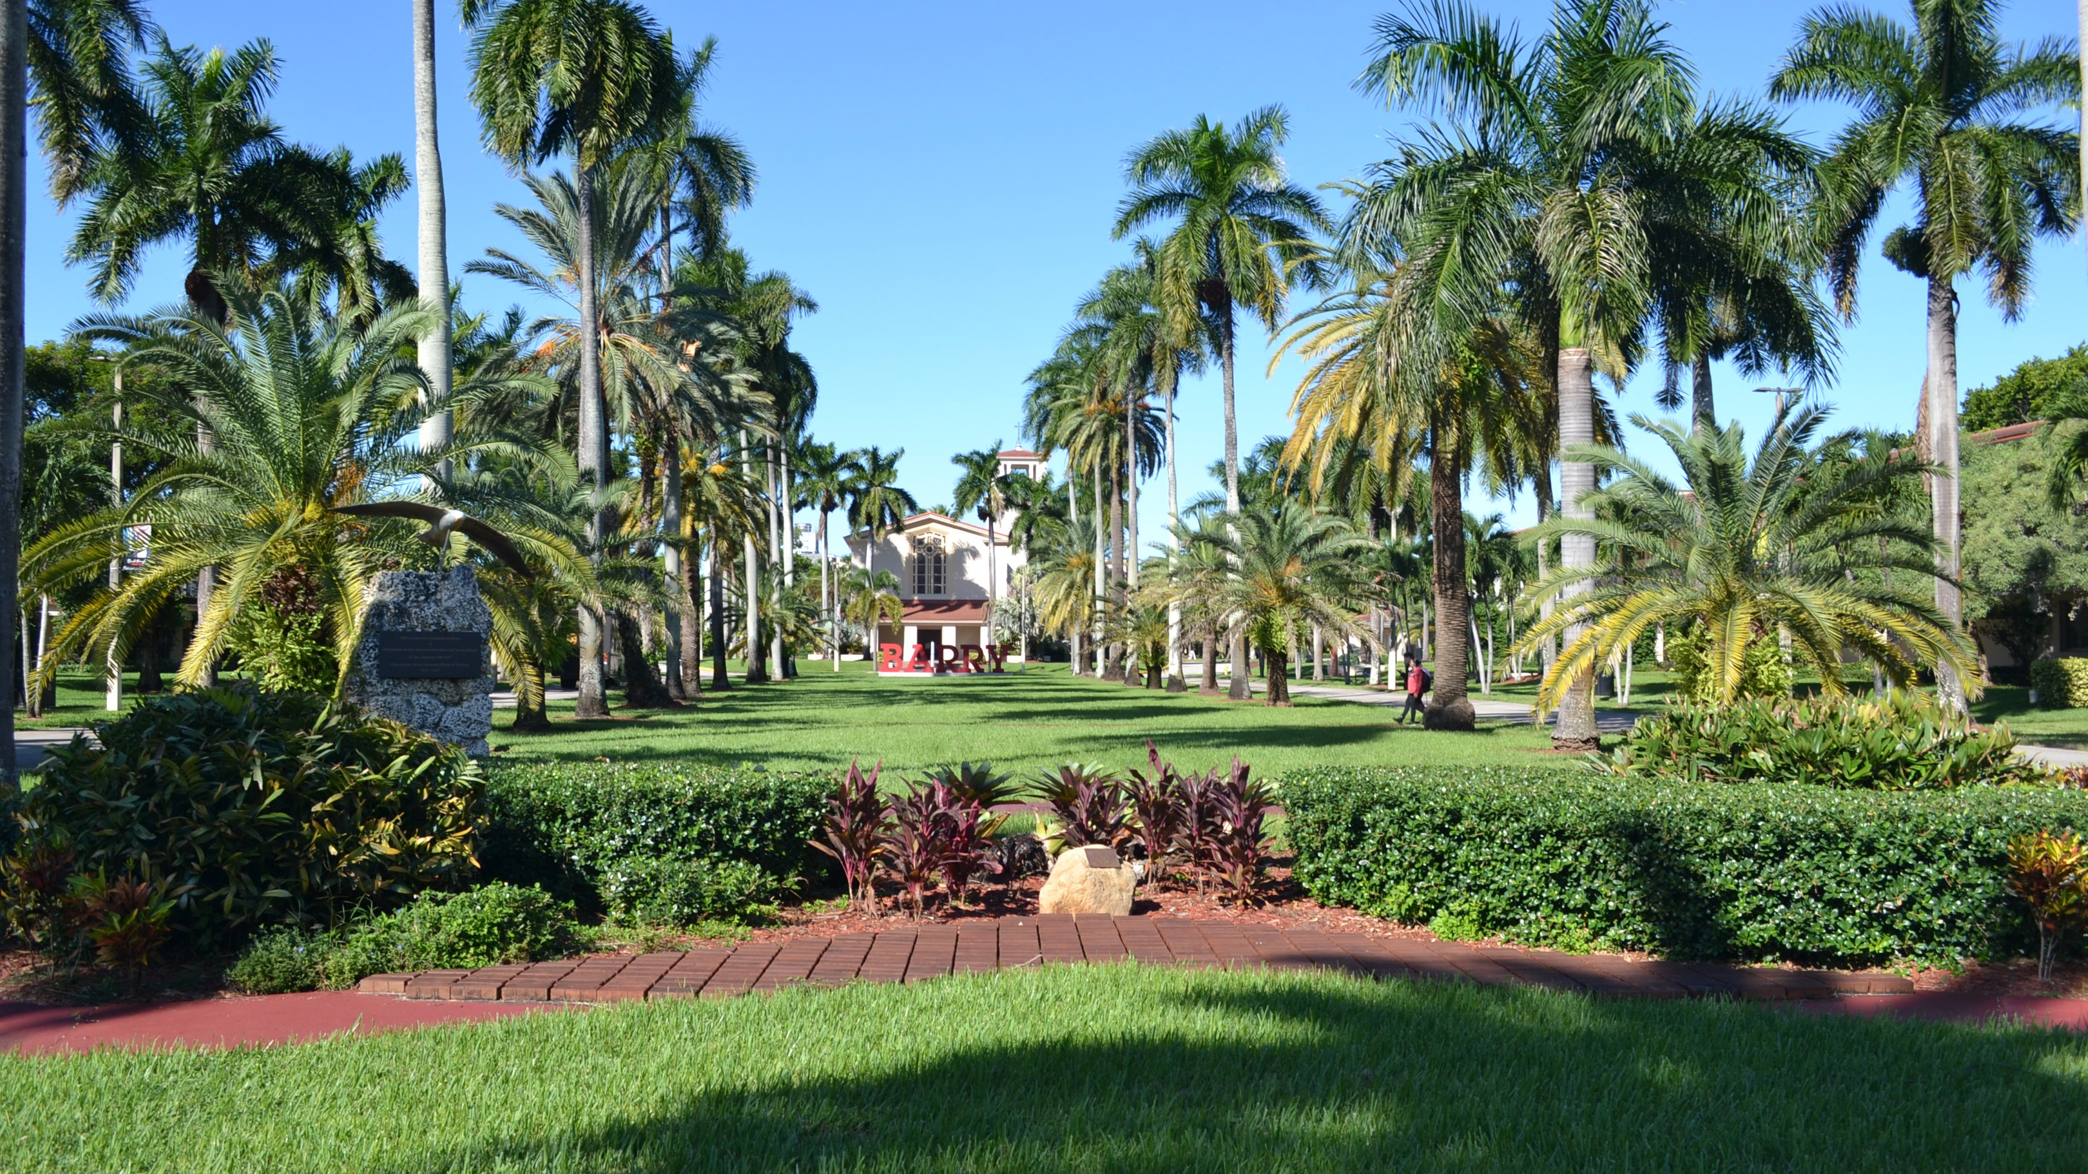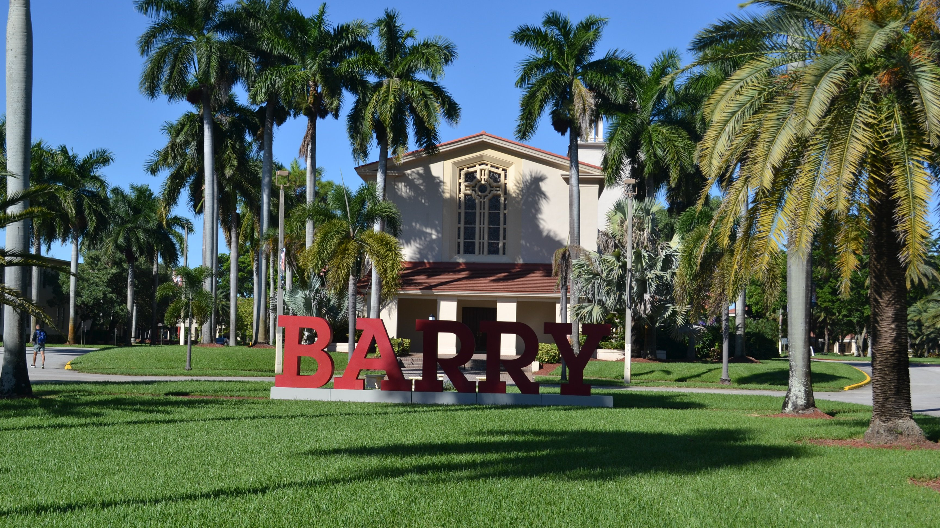

15980 NW 2nd Ave, Miami, FL 33169, USA, from 13 to 18 age

Course intensity | 15
Accommodation | Campus
Room type | Twin
Bathroom facilities | En-suite
Meals | Breakfast, Lunch and Dinner
Excursions per week | 6
Weekday excursions | 5
Full day excursions | 1

Description

Why choose this program

Infrastructure

Sport infrastructure

Hobbies and clubs

What else included in the program price

Recommended arrival city

Майами

Sample timetable
 | Morning | Afternoon | Evening
Day 1 | Arrival day
Day 2 | Orientation, Testing & Downtown Walking Tour | Miami, South Beach | Miami, South Beach
Day 3 | Lesson | Miami Wynwood Design District | Evening Activity on campus
Day 4 | Lesson | Fort Lauderdale Canals Cruise | Evening Activity on campus
Day 5 | Lessons | Sports Afternoon | Miami Marlins Baseball game
Day 6 | Lessons | Miami Tour Bayside | Dinner at Hard Rock Cafe
Day 7 | Full day excursion Kennedy Space Center NASA- Cape Canaveral | Full day excursion Kennedy Space Center NASA- Cape Canaveral | Evening Activity on campus
Day 8 | Free time | Sawgrass Mills | Free time
Day 9 | Lessons | Red Reef Park - Boca Raton | Evening Activity on campus
Day 10 | Lessons | Key Biscayne | Evening Activity on campus
Day 11 | Lessons | Everglades Gator Park | Evening Activity on campus
Day 12 | Lessons | Fort Lauderdale Beach | Dinner at Bubba Gump
Day 13 | Lessons | Pool & Sports Afternoon | Brickell City Center
Day 14 | Departure

For booking please go to www.travelclass.org

