Melton College York — language school in the UK

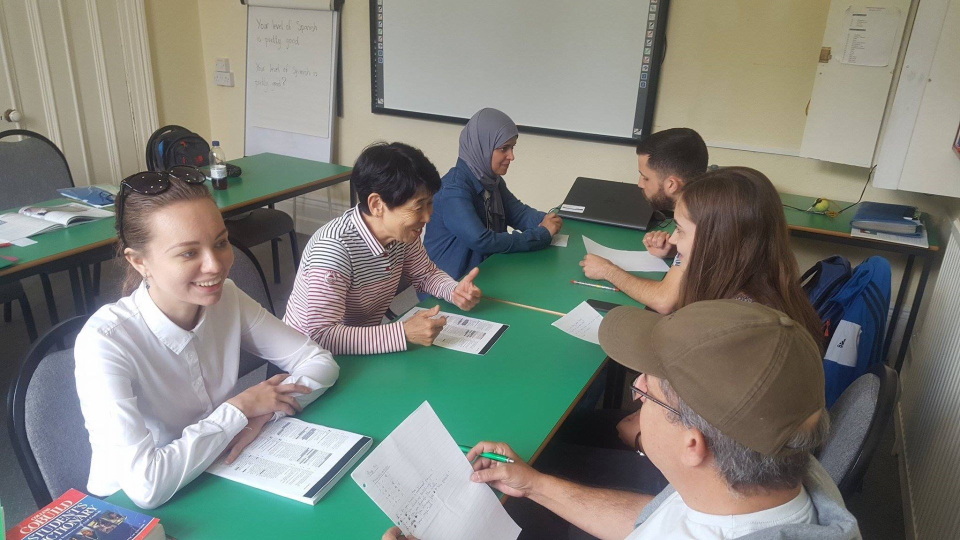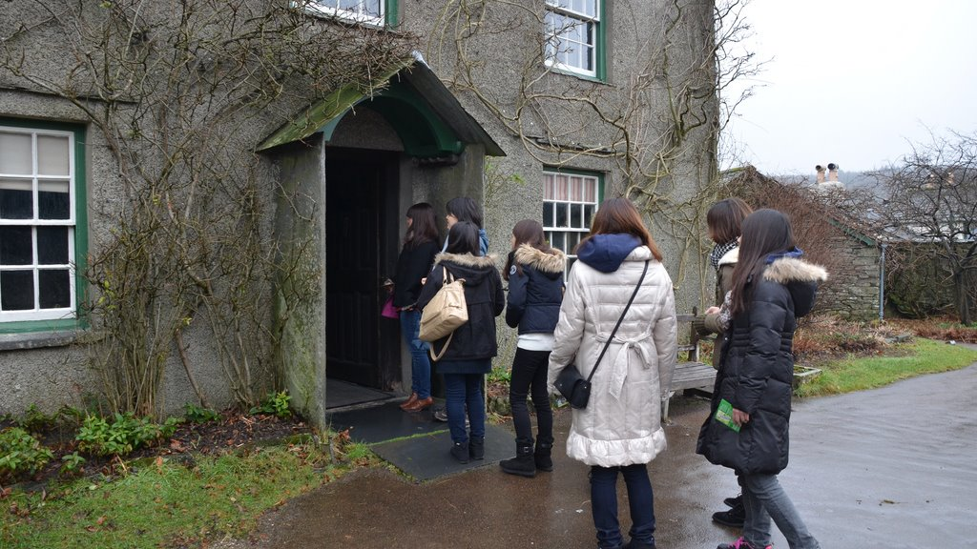

137 Holgate Rd, York YO24 4DH, United Kingdom, from 10 to 100 age

Course intensity | 22
Accommodation | Host family
Room type | Single
Bathroom facilities | Shared
Meals | Breakfast, Lunch and Dinner
Excursions per week
Weekday excursions
Full day excursions

Description

Why choose this program

Infrastructure

Sport infrastructure

Hobbies and clubs

What else included in the program price

Recommended arrival city

Лидс

Sample timetable
 | Morning | Afternoon | Evening
Day 1 | Lessons | Lessons | Evening Activity e.g Quiz
Day 2 | Lessons | 'Lesson Out' in York | Evening with host family
Day 3 | Lessons | Lessons | Evening Activity e.g Cinema
Day 4 | Lessons | 'Lesson Out' in York | Evening with host family
Day 5 | Lessons | Lessons | Evening Activity e.g Farewell Party
Day 6 | Full-day excursion | Full-day excursion | Evening with host family
Day 7 | Morning with host family | Departure

For booking please go to www.travelclass.org

