France Langue Biarritz — summer school in France

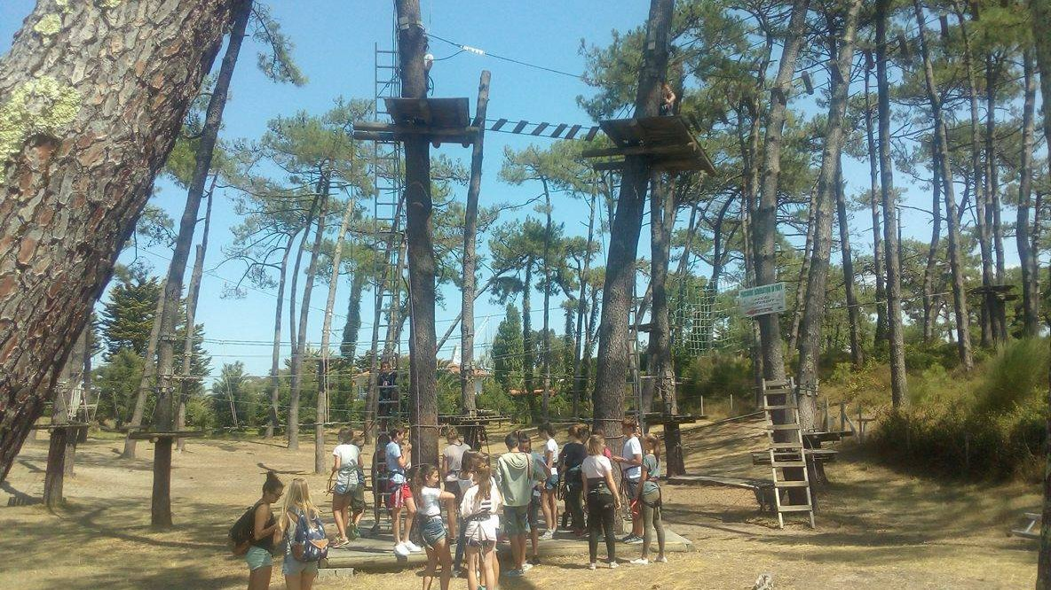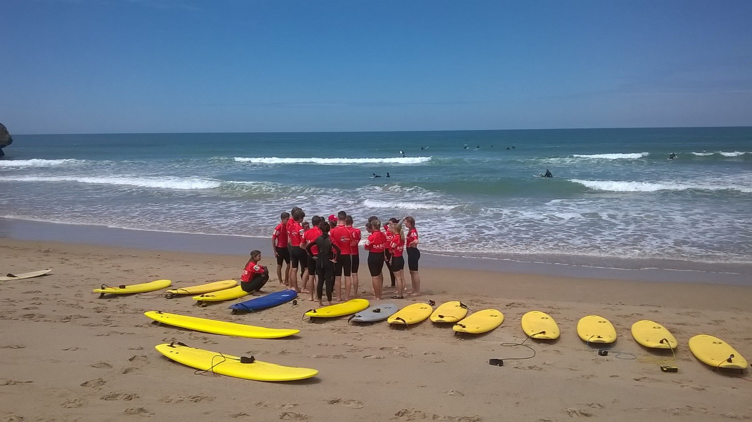

21 Avenue de la République, 64200 Biarritz, Франция, from 10 to 14 age

Course intensity | 15
Accommodation | Host family
Room type | Twin
Bathroom facilities | Shared
Meals | Breakfast, Lunch and Dinner
Excursions per week | 1
Weekday excursions | 1
Full day excursions

Description

Why choose this program

Infrastructure

Sport infrastructure

Hobbies and clubs

What else included in the program price

Recommended arrival city

Биарриц

Sample timetable
 | Morning | Afternoon | Evening
Day 1 | Arrival | Orientation | Picnic
Day 2 | Rock climbing / pool | French lessons | Beach
Day 3 | Surfing / sea museum | French lessons | Bowling
Day 4 | Surfing / free time | French lessons | Quest
Day 5 | Oceanarium | French lessons | Music festival
Day 6 | Mini golf / surfing | French lessons | Evening on the beach / walk in the evening Biarritz
Day 7 | Aquapark | Aquapark | Aquapark

For booking please go to www.travelclass.org

