Anglophiles Funcoast World — summer school in the UK

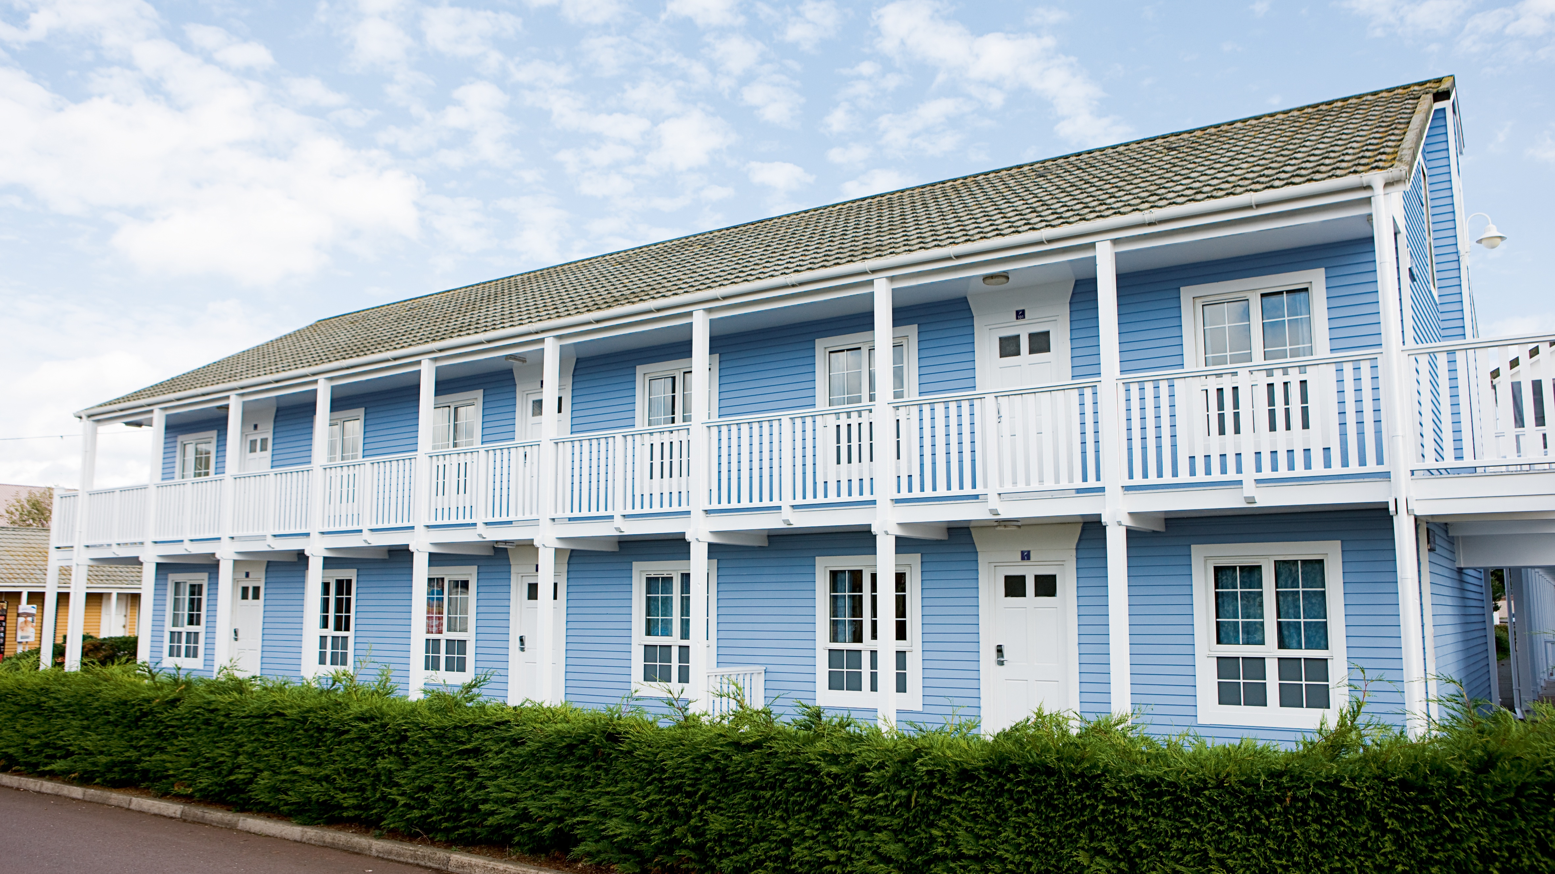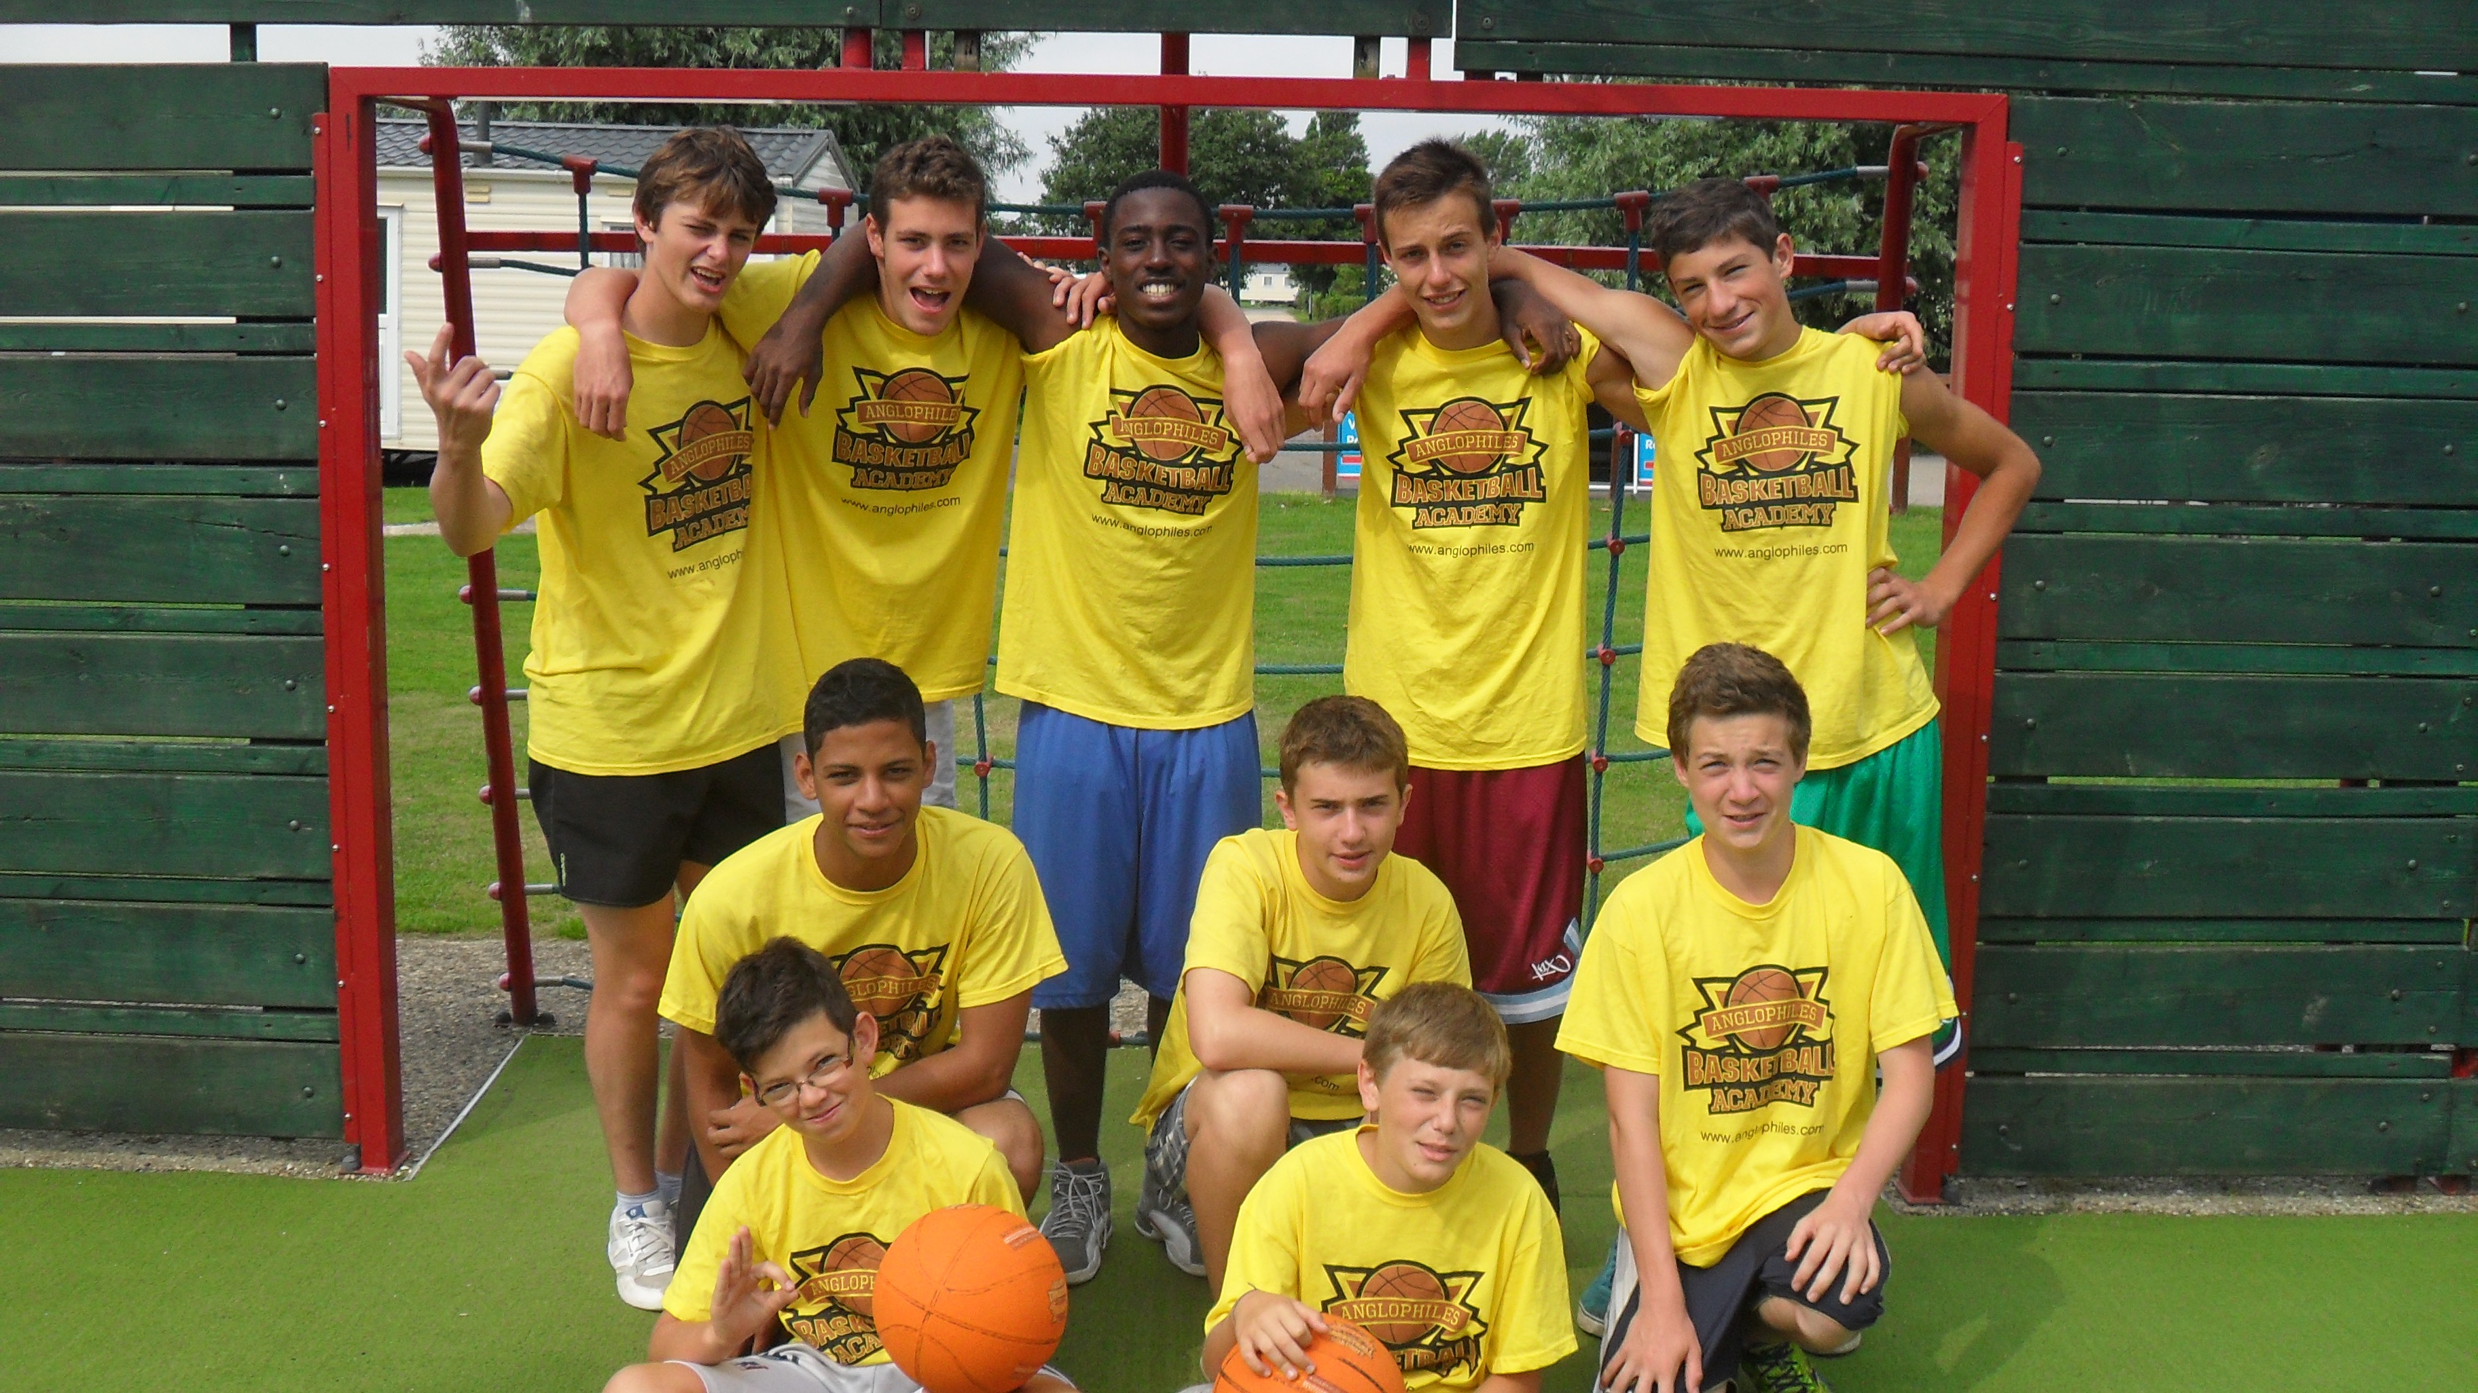

Ingoldmells, Skegness PE25 1NJ, UK, from 7 to 15 age

Course intensity | 180
Accommodation | Residence
Room type | Triple
Bathroom facilities | Shared
Meals | Breakfast, Lunch and Dinner
Excursions per week | 1
Weekday excursions
Full day excursions

Description

Why choose this program

Infrastructure

Sport infrastructure

Hobbies and clubs

What else included in the program price

Recommended arrival city

Лондон

Sample timetable
 | Morning | Afternoon | Evening
Day 1 |  | Arrival at Funcoast world. Discover the campus and settle into accommodation.
Day 2 | English Test + Tuition | Orientation of the campus and team games | Ice breaker games
Day 3 | 3 hours English Tuition + 30 min break | Sports Competition | Team games
Day 4 | 3 hours English Tuition + 30 min break | Treasure Hunt and Grid Game | A choice of sports
Day 5 | 3 hours English Tuition + 30 min break | Sports: Climbing and beach games | Movie
Day 6 | 3 Hours English Tuition + 30 min break | Swimming | Board Games Tournament
Day 7 |  | Full Day Excursion | evening activities

For booking please go to www.travelclass.org

