Международный Союз Молодежи — языковая школа в Чехии

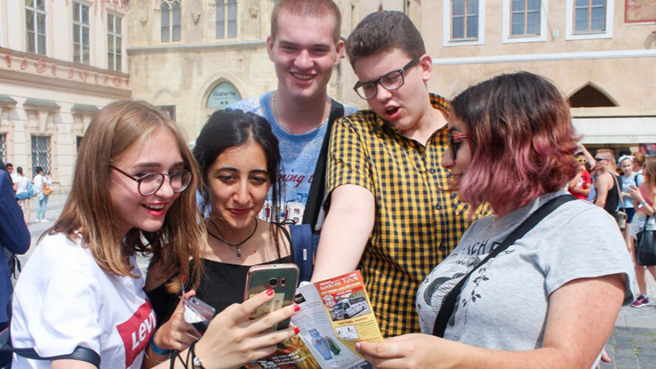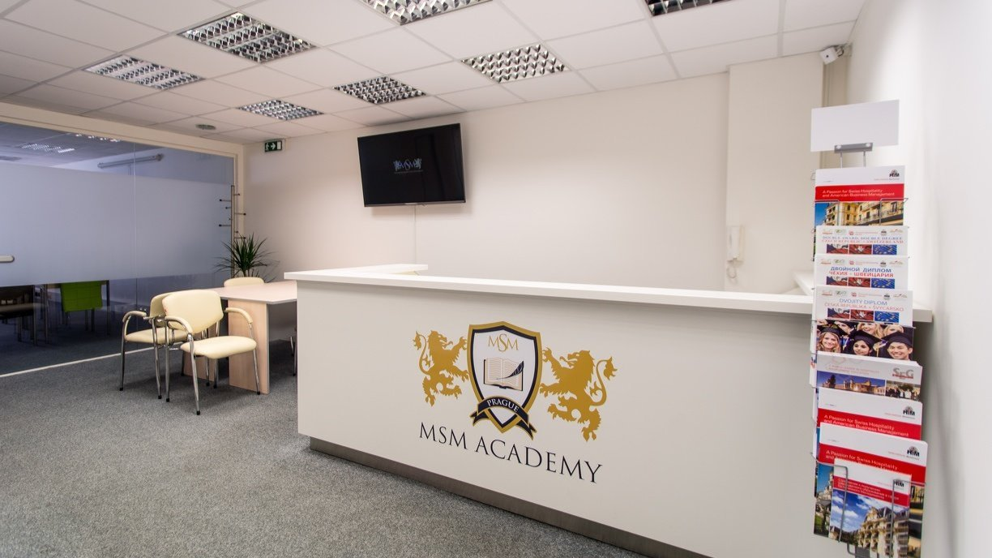

Prague, Czech Republic, from 13 to 35 age

Course intensity | 15
Accommodation | Residence
Room type | Twin
Bathroom facilities | Shared
Meals | Breakfast + Dinner
Excursions per week | 4
Weekday excursions | 3
Full day excursions | 1

Description

Why choose this program

Infrastructure

Sport infrastructure

Hobbies and clubs

What else included in the program price

Recommended arrival city

Прага

Sample timetable
 | Morning | Afternoon | Evening
Day 1 | Arrival
Day 2 | Lessons | Sports events | Orientation around Prague
Day 3 | Lessons | Walk along Prague | Activity
Day 4 | Lessons | Prague castle | Free time
Day 5 | Lessons | Sports events | Activity
Day 6 | Lessons | Vltava cruise | Free time
Day 7 | Trip to Karlovy Vary | Trip to Karlovy Vary | Trip to Karlovy Vary
Day 8 | Free Day
Day 9 | Lessons | Sports events | Activity
Day 10 | Lessons | Zoo | Activity
Day 11 | Lessons | Charles Bridge | Free time
Day 12 | Lessons | Sports events | Night walk in Prague
Day 13 | Lessons | Waterpark | Free time
Day 14 | Excursion to a castle | Excursion to a castle | Excursion to a castle

For booking please go to www.travelclass.org

