UKLC Bristol Badminton School — language school in the UK

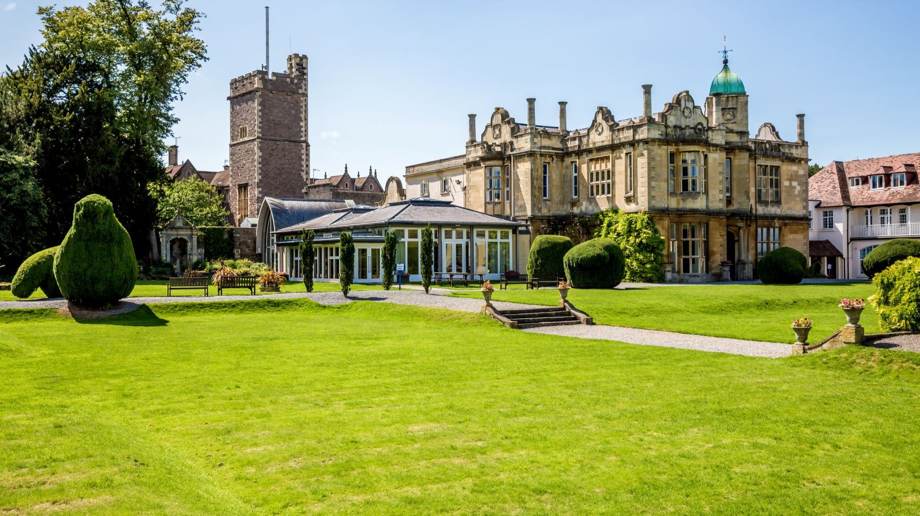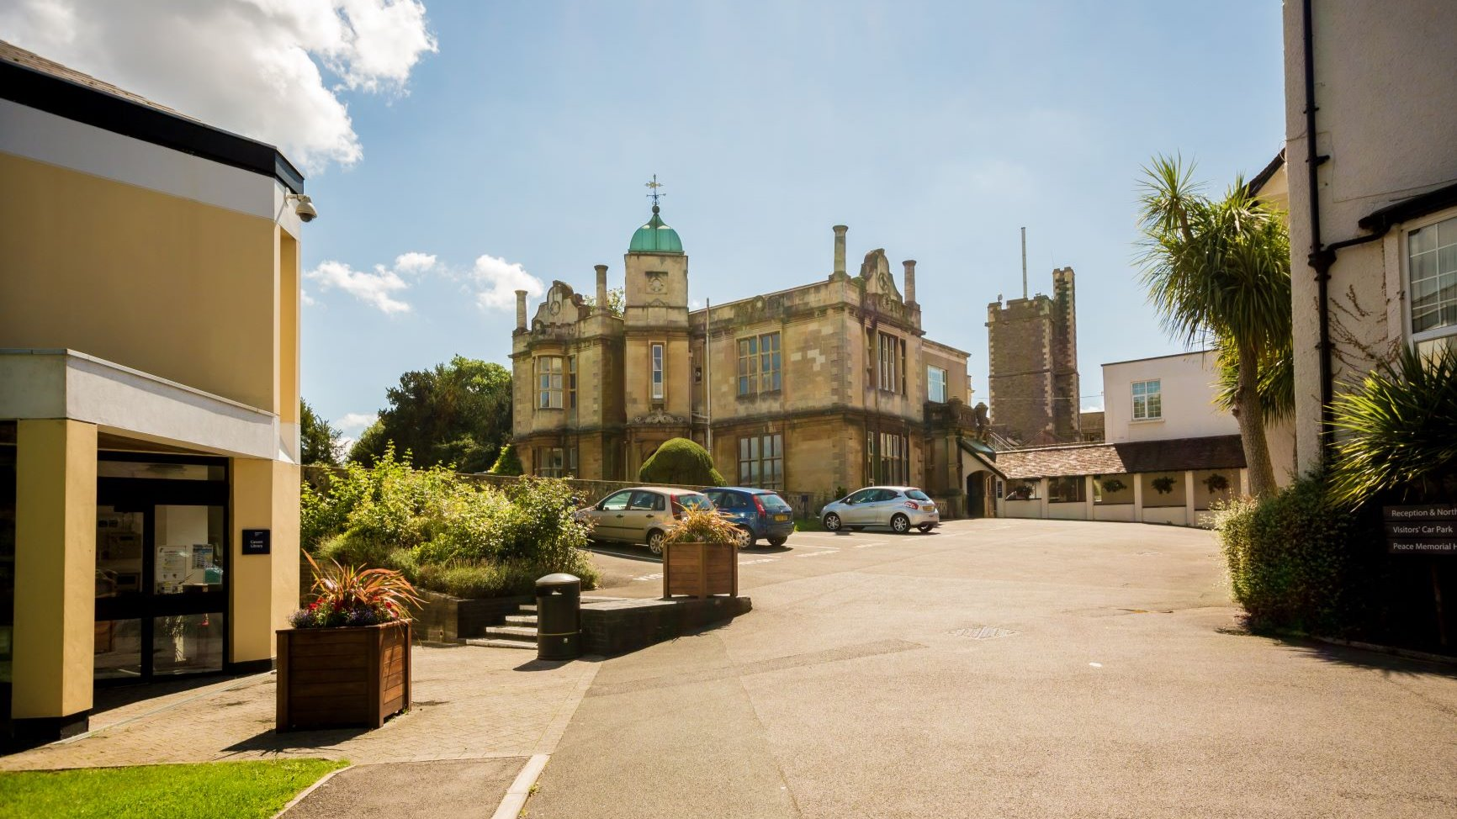

Badminton School, Bristol, UK, from 11 to 15 age

Course intensity | 15
Accommodation | Campus
Room type | Multi-bedded
Bathroom facilities | Shared
Meals | Breakfast, Lunch and Dinner
Excursions per week | 3
Weekday excursions | 2
Full day excursions | 1

Description

Why choose this program

Infrastructure

Sport infrastructure

Hobbies and clubs

What else included in the program price

Recommended arrival city

Лондон

Sample timetable
 | Morning | Afternoon | Evening
Day 1 | English Lessons | Multi Activity or Chosen Programme | Murder Mystery
Day 2 | English Lessons | Bristol Orientation | Casino Night or Conversation Club
Day 3 | English Lessons | Multi Activity or Chosen Programme | Trashion Show
Day 4 | English Lessons | Wales with Chepstow Castle | Disco
Day 5 | English Lessons | Multi Activity or Chosen Programme | Red vs Blue
Day 6 | Cardiff with Boat Trip | Cardiff with Boat Trip | Attractions
Day 7 | Optional Excursion to London with Walking Tour, British Museum & London Eye | Optional Excursion to London with Walking Tour, British Museum & London Eye | Film Night
Day 8 | Multi Activity or Chosen Programme | English lessons | Speed Dating
Day 9 | Bristol with SS Great Britain | English lessons | Paparazzi
Day 10 | Multi Activity or Chosen Programme | English lessons | Trashion show
Day 11 | Cheddar with Cheddar Gorge | English lessons | Quiz night
Day 12 | Multi Activity or Chosen Programme | English lessons | Disco
Day 13 | Bath World Heritage Site with Roman Baths | Bath World Heritage Site with Roman Baths | Bath World Heritage Site with Roman Baths
Day 14 | Depart

For booking please go to www.travelclass.org

