Vysokovskiy bor — summer camp in Russia

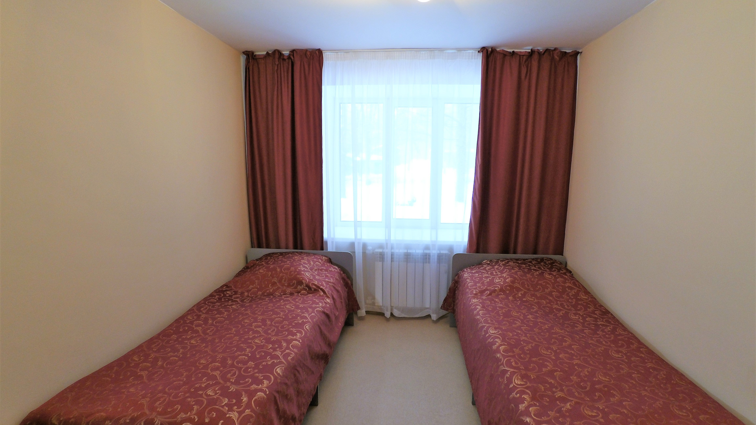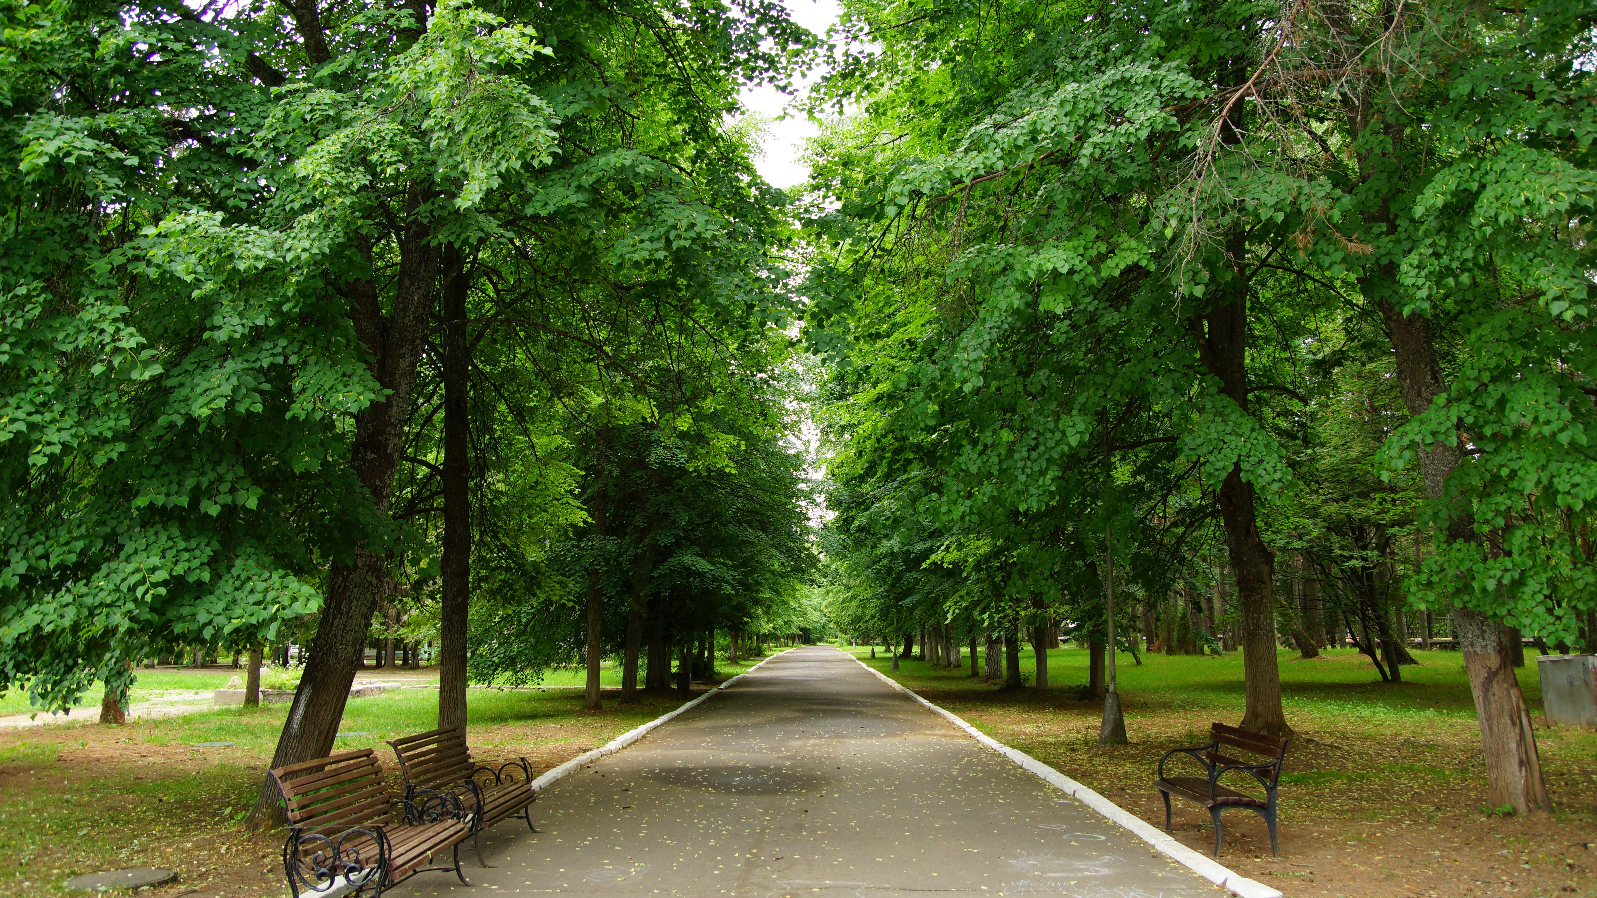

Высоковский Бор, Yaroslavl Oblast, Russia, from 9 to 17 age

Course intensity | 15
Accommodation | Campus
Room type | Quadraple
Bathroom facilities | Shared
Meals | Breakfast, Lunch and Dinner
Excursions per week | 1
Weekday excursions | 1
Full day excursions | 1

Description

Why choose this program

Infrastructure

Sport infrastructure

Hobbies and clubs

What else included in the program price

Recommended arrival city

Ярославль

Sample timetable
 | Morning | Afternoon | Evening
Day 1 | Lessons | Creative workshops | Disco “Superstars”
Day 2 | Lessons | Intellectual game | Counselors concert
Day 3 | Lessons | Marathon ideas | Disco
Day 4 | Lessons | Sports games | Games
Day 5 | Lessons | The quest on-site | Intellectual game
Day 6 | Sport contest | “Dancing without rules” | Disco in green
Day 7 | Issue | Quilt - information booth from each studio, from individual interesting flaps with different topics
Day 8 | Lessons | Entertainment program “Stand up” | Competition Videos
Day 9 | Lessons | Entertainment program | Disco
Day 10 | Lessons | Playing on-site | Entertainment program “League of good jokes”
Day 11 | Lessons | Entertainment program Dream team | Disco
Day 12 | Lessons | Mischievous sport | Film Director's evening
Day 13 | Sports game | Photo cross | Movie
Day 14 | Sport contest | Friendship Day | Drama workshop

For booking please go to www.travelclass.org

