UKLC University of Chester Parkgate Campus — language school in the UK

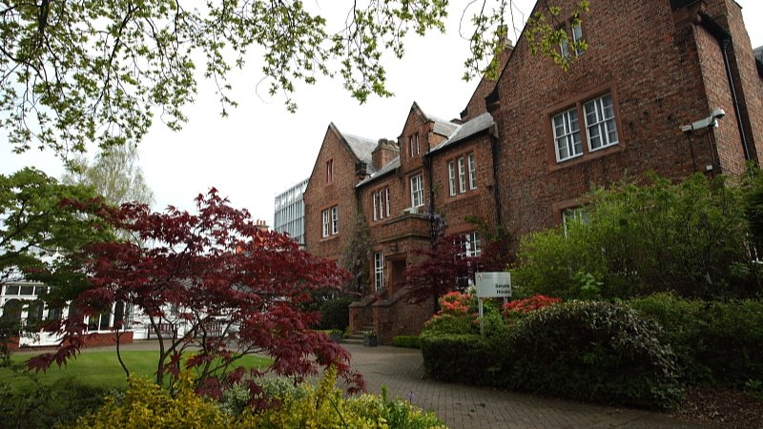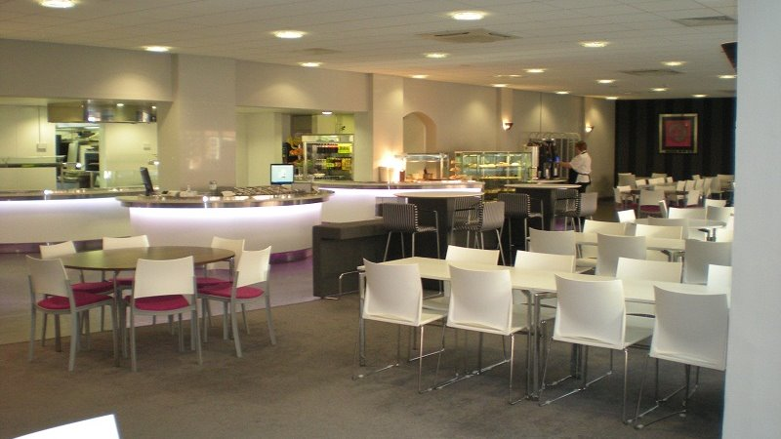

University of Chester, Parkgate Road Campus, Parkgate Road, Chester, UK, from 11 to 17 age

Course intensity | 15
Accommodation | Host family
Room type | Twin
Bathroom facilities | Shared
Meals | Breakfast, Lunch and Dinner
Excursions per week | 3
Weekday excursions | 3
Full day excursions | 0

Description

Why choose this program

Infrastructure

Sport infrastructure

Hobbies and clubs

What else included in the program price

Recommended arrival city

Лондон

Sample timetable
 | Morning | Afternoon | Evening
Day 1 | Arrival day | Arrival day | Evening With Host Family
Day 2 | English Lessons | Chester Inc. Roman Walls Walking Tour | Evening With Host Family
Day 3 | English Lessons | Sports Activities | Evening With Host Family
Day 4 | English Lessons | Liverpool Inc. The Beatles Museum | Evening With Host Family
Day 5 | English Lessons | Chester Photography Workshop | Evening With Host Family
Day 6 | Liverpool with Beatles Story | Chester Inc. Chester Cathedral | Evening With Host Family
Day 7 | Departure

For booking please go to www.travelclass.org

