friLingue Schwarzsee — summer language school in Switzerland

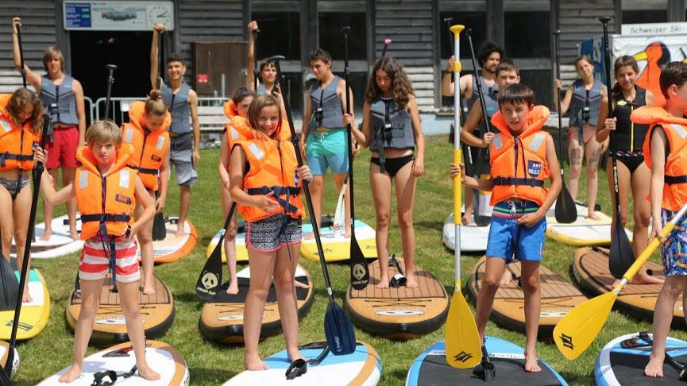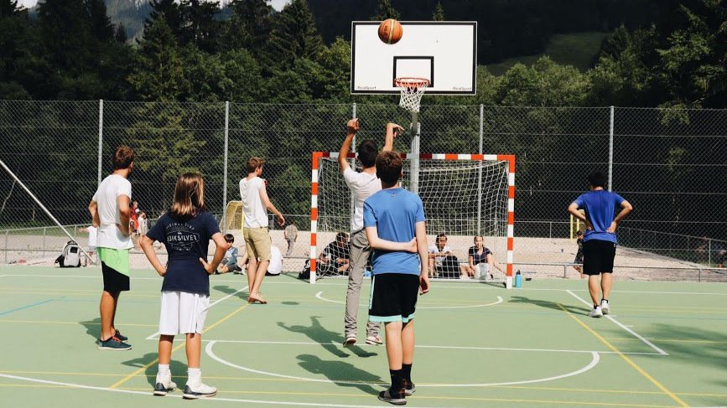

Schwarzsee, Switzerland, from 8 to 17 age

Course intensity | 15
Accommodation | Campus
Room type | Quadraple
Bathroom facilities | Shared
Meals | Breakfast, Lunch and Dinner
Excursions per week | 2
Weekday excursions | 1
Full day excursions | 1

Description

Why choose this program

Infrastructure

Sport infrastructure

Hobbies and clubs

What else included in the program price

Recommended arrival city

Женева

Sample timetable
 | Morning | Afternoon | Evening
Day 1 | Rest and brunch | Welcoming new participants | Presentations, and creation of note books to use during the week
Day 2 | Core linguistic competences, tools and conversation skills; Active language learning projects | Creative workshops / ateliers | Viewing of an art-house film/ documentary
Day 3 | Core linguistic competences, tools and conversation skills; Active language learning projects | Creative workshops / ateliers | Campfire with concert
Day 4 | Core linguistic competences, tools and conversation skills; Active language learning projects | Creative workshops / ateliers | Free evening
Day 5 | Core linguistic competences, tools and conversation skills; Active language learning projects | Hiking and sketching landscapes & situations | Creative disco evening
Day 6 | Core linguistic competences, tools and conversation skills; Active language learning projects | Sport and physical activities | Evening exhibition of projects, performances, projections...
Day 7 | Excursion in Fribourg/ Gruyères, museum (Jean Tinguely-Niki De Saint Phalle / Gyger aliens) and city | Free time with optional activities available | Evening games

For booking please go to www.travelclass.org

