Enforex Salamanca — summer school in Spain

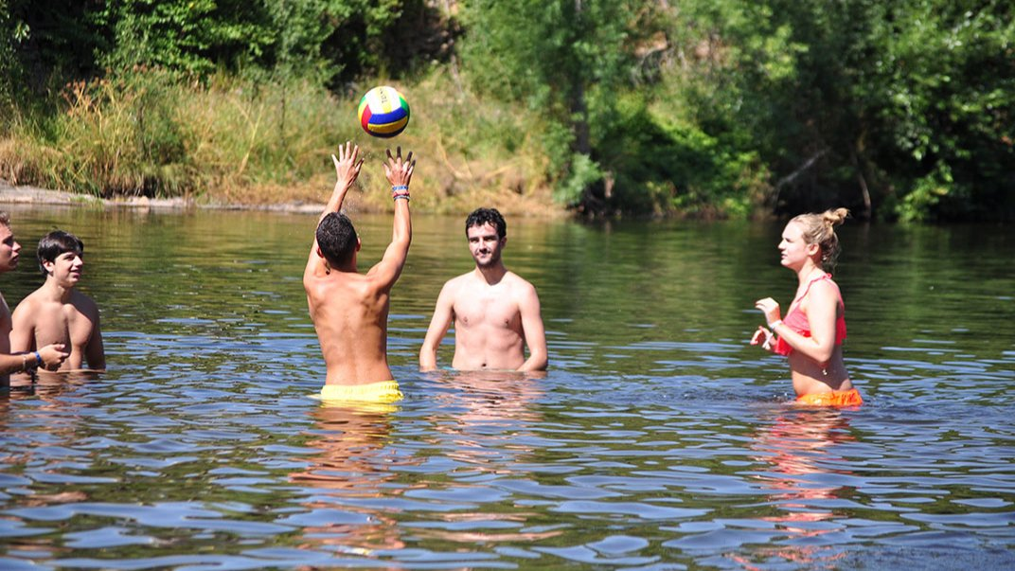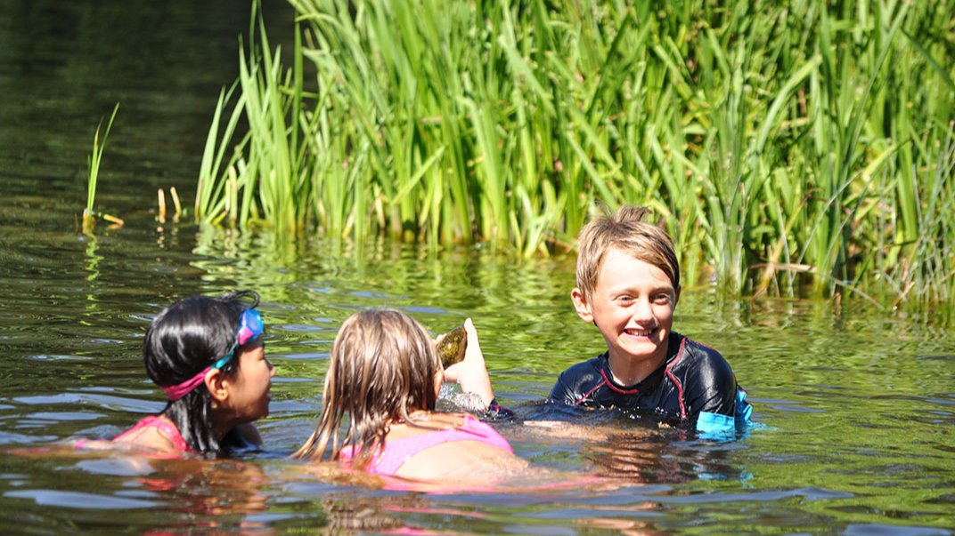

Paseo de Canalejas, 139-159, Salamanca, España, from 14 to 17 age

Course intensity | 20
Accommodation | Host family
Room type | Twin
Bathroom facilities | Shared
Meals | Breakfast, Lunch and Dinner
Excursions per week | 2
Weekday excursions | 1
Full day excursions | 1

Description

Why choose this program

Infrastructure

Sport infrastructure

Hobbies and clubs

What else included in the program price

Recommended arrival city

Мадрид

Sample timetable
 | Morning | Afternoon | Evening
Day 1 | Arrival to Madrid airport and city centre sightseeing | Arrival to Madrid airport and city centre sightseeing | Arrival to Madrid airport and city centre sightseeing
Day 2 | Level test & orientation | Discovering Salamanca historical heritage | Welcome dinner with the group
Day 3 | Spanish lessons | Visit to the Cathedral | Free time
Day 4 | Spanish lessons | Visit the Central Market | Free time
Day 5 | Spanish lessons | Literary route or Salsa dance lesson or Tapas | Free time
Day 6 | Spanish lessons | Movie | Tapas route
Day 7 | Trip to Segovia or Ávila or Madrid | Trip to Segovia or Ávila or Madrid | Dinner
Day 8 | Day with your host family | Day with your host family | Day with your host family
Day 9 | Spanish lessons | Soccer and basketball games | Free time
Day 10 | Spanish lessons | Free time | Free time
Day 11 | Spanish lessons | City tour | Free time
Day 12 | Spanish lessons | Movie | Free time
Day 13 | Spanish lessons | Free time | Free time
Day 14 | Day with your host family | Day with your host family | Day with your host family

For booking please go to www.travelclass.org

