NSTS Malta English Language Institute — language school in Malta

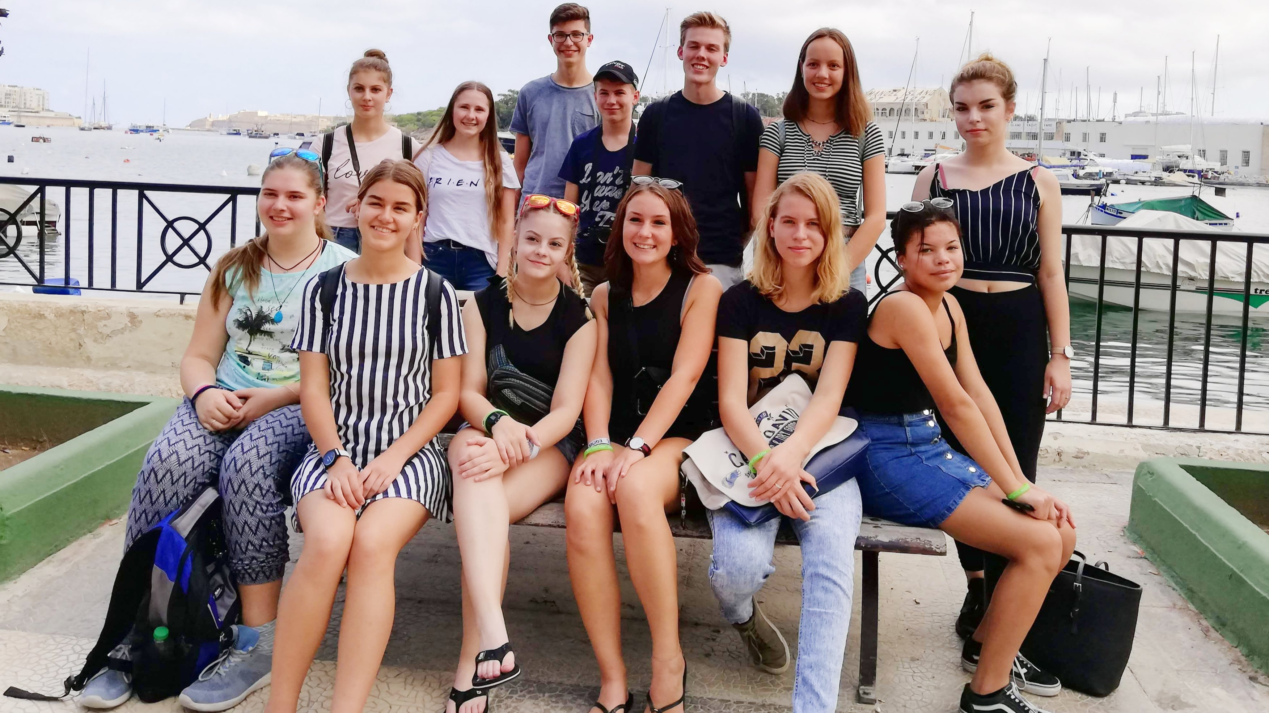

Gzira, Malta, 12 Taliana Lane, from 13 to 90 age

Course intensity | 9
Accommodation | Residence
Room type | Quadraple
Bathroom facilities | En-suite
Meals | Breakfast
Excursions per week | 0
Weekday excursions | 0
Full day excursions | 0

Description

Why choose this program

Infrastructure

Sport infrastructure

Hobbies and clubs

What else included in the program price

Recommended arrival city

Гзира

Sample timetable
 | Morning | Afternoon | Evening
Day 1

Day 2

Day 3

Day 4

Day 5

Day 6

Day 7

For booking please go to www.travelclass.org

