Australian International College of Language — language school in Australia

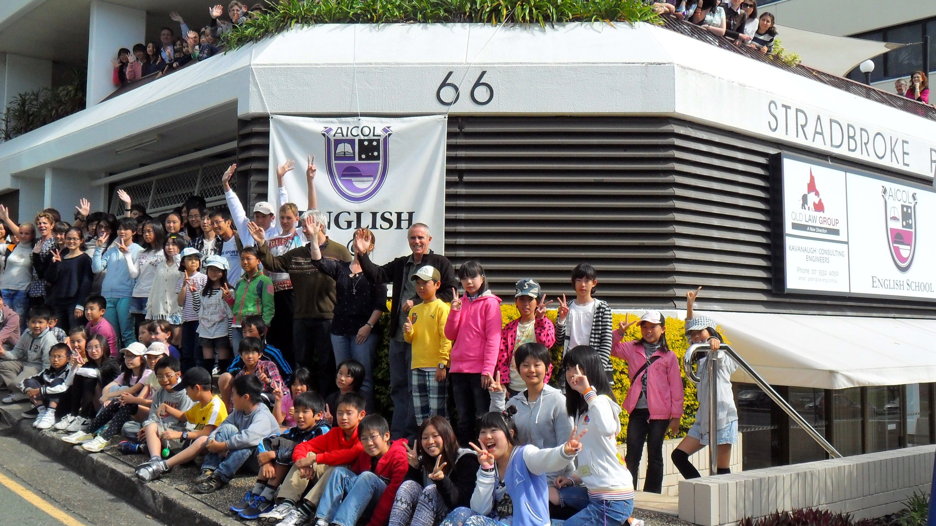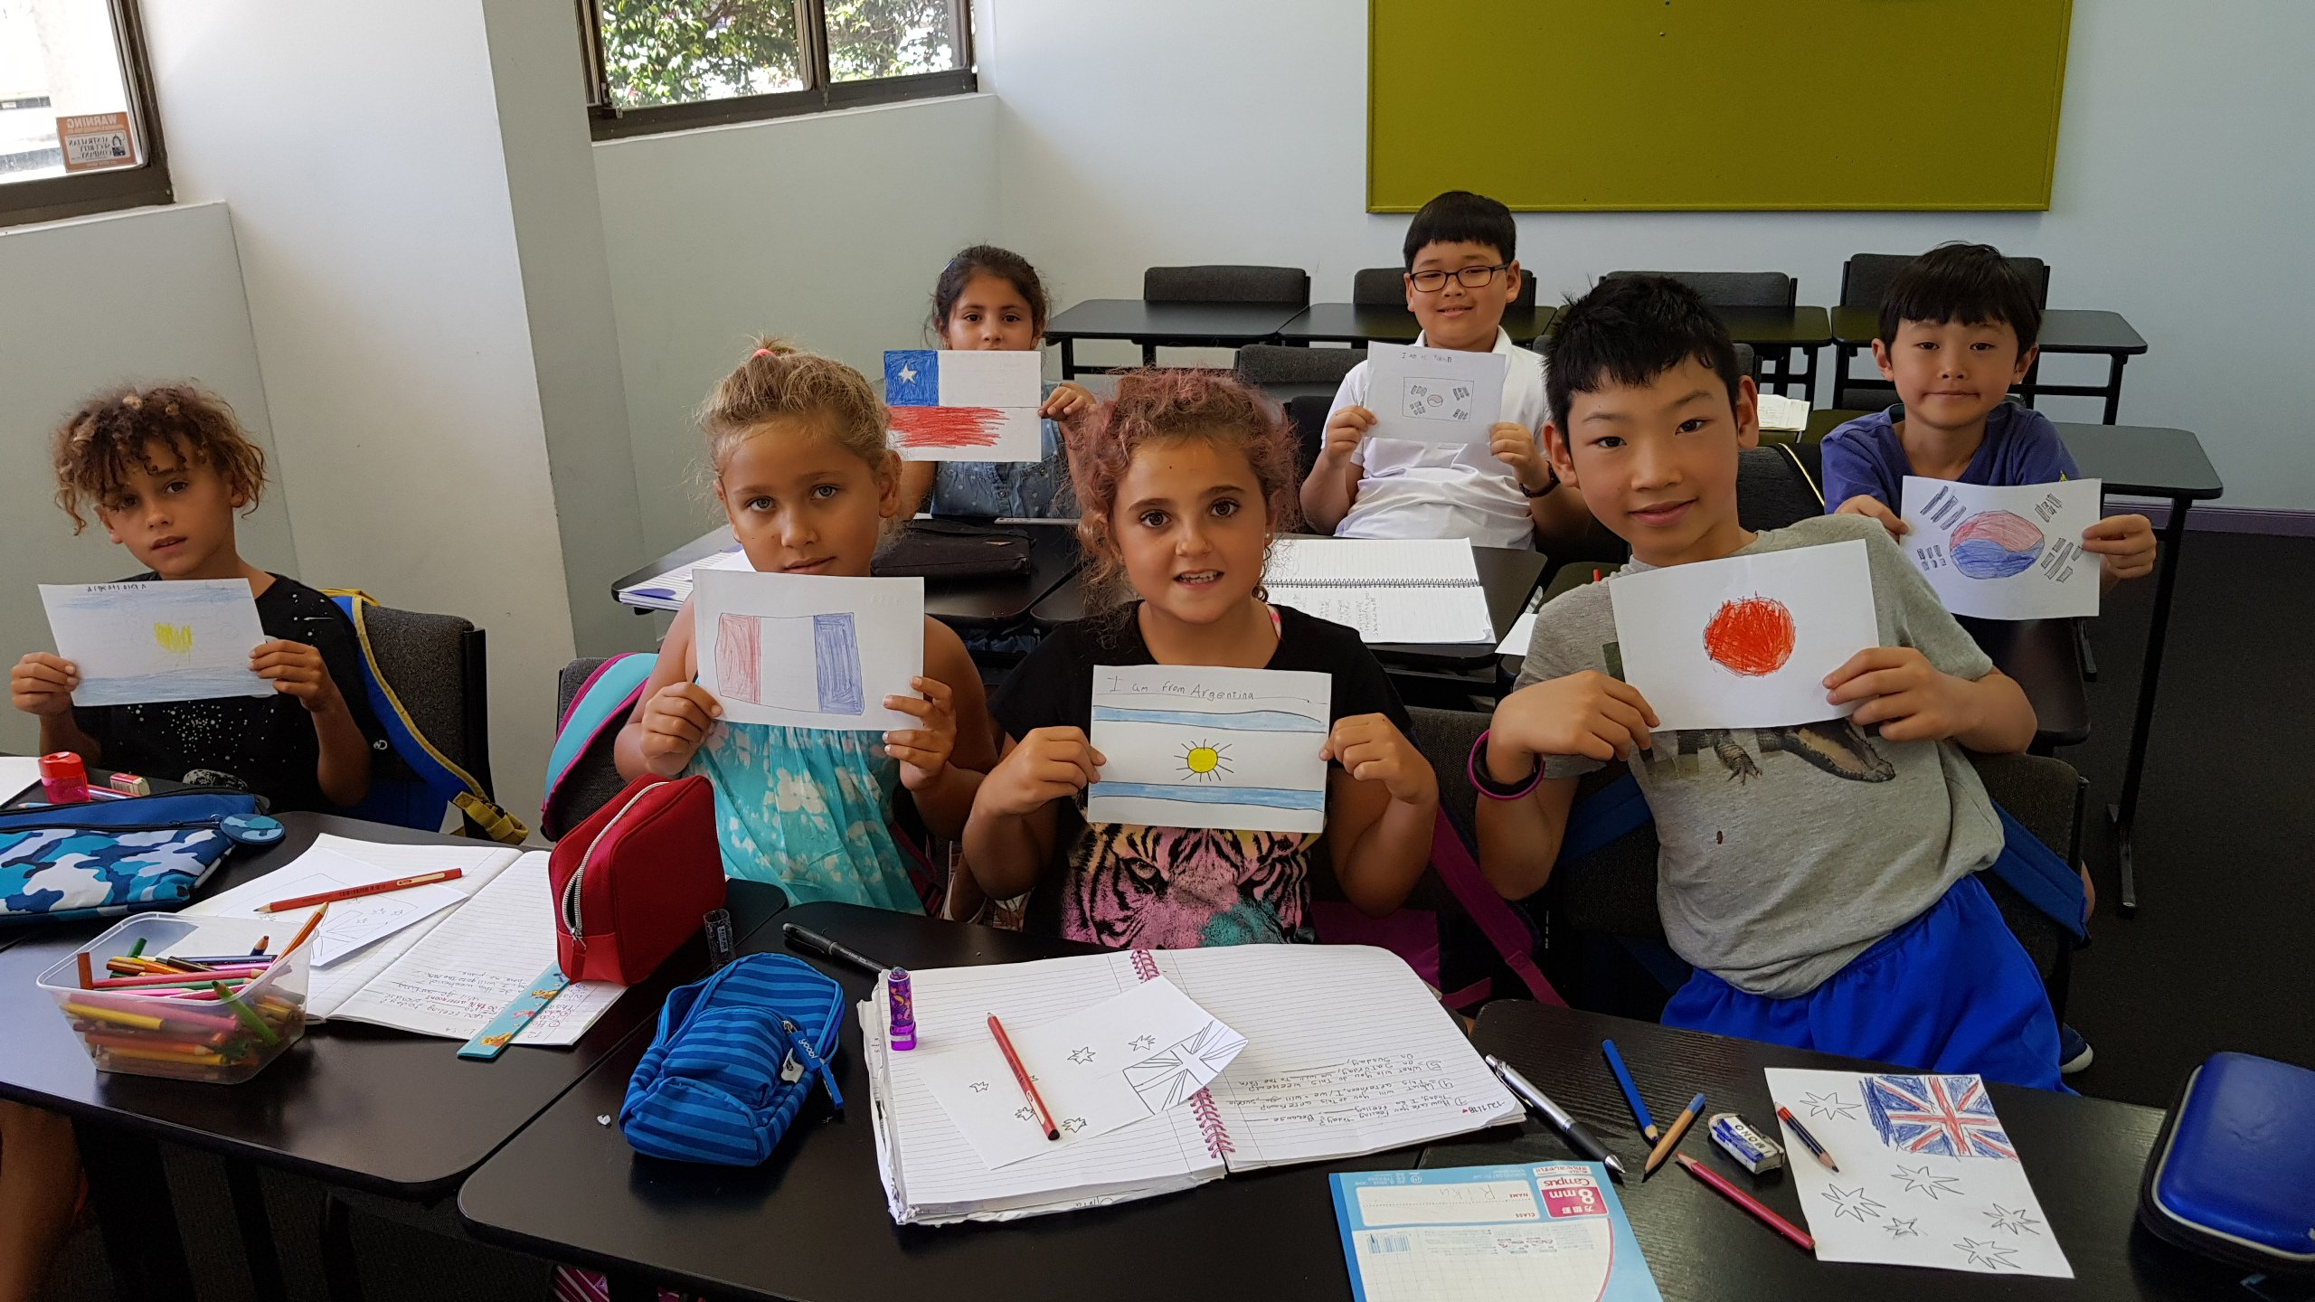

3/66 Marine Parade, Southport QLD, Australia, from 6 to 18 age

Course intensity | 20
Accommodation | Host family
Room type | Twin
Bathroom facilities | En-suite
Meals
Excursions per week | 3
Weekday excursions | 2
Full day excursions | 1

Description

Why choose this program

Infrastructure

Sport infrastructure

Hobbies and clubs

What else included in the program price

Recommended arrival city

Голд-Кост

Sample timetable
 | Morning | Afternoon | Evening
Day 1 | Arrival | Lesson | Evandale park
Day 2 | Lessons | Lessons | Bounce
Day 3 | Lessons | Holoverse | Homestay pick-up
Day 4 | Lessons | Shopping at Pacific Fair | Homestay pick-up
Day 5 | Lessons | Rock climbing | Homestay pick-up
Day 6 | Dreamworld | Dreamworld | Homestay pick-up
Day 7

For booking please go to www.travelclass.org

