Ardmore Brighton College — language school in the UK

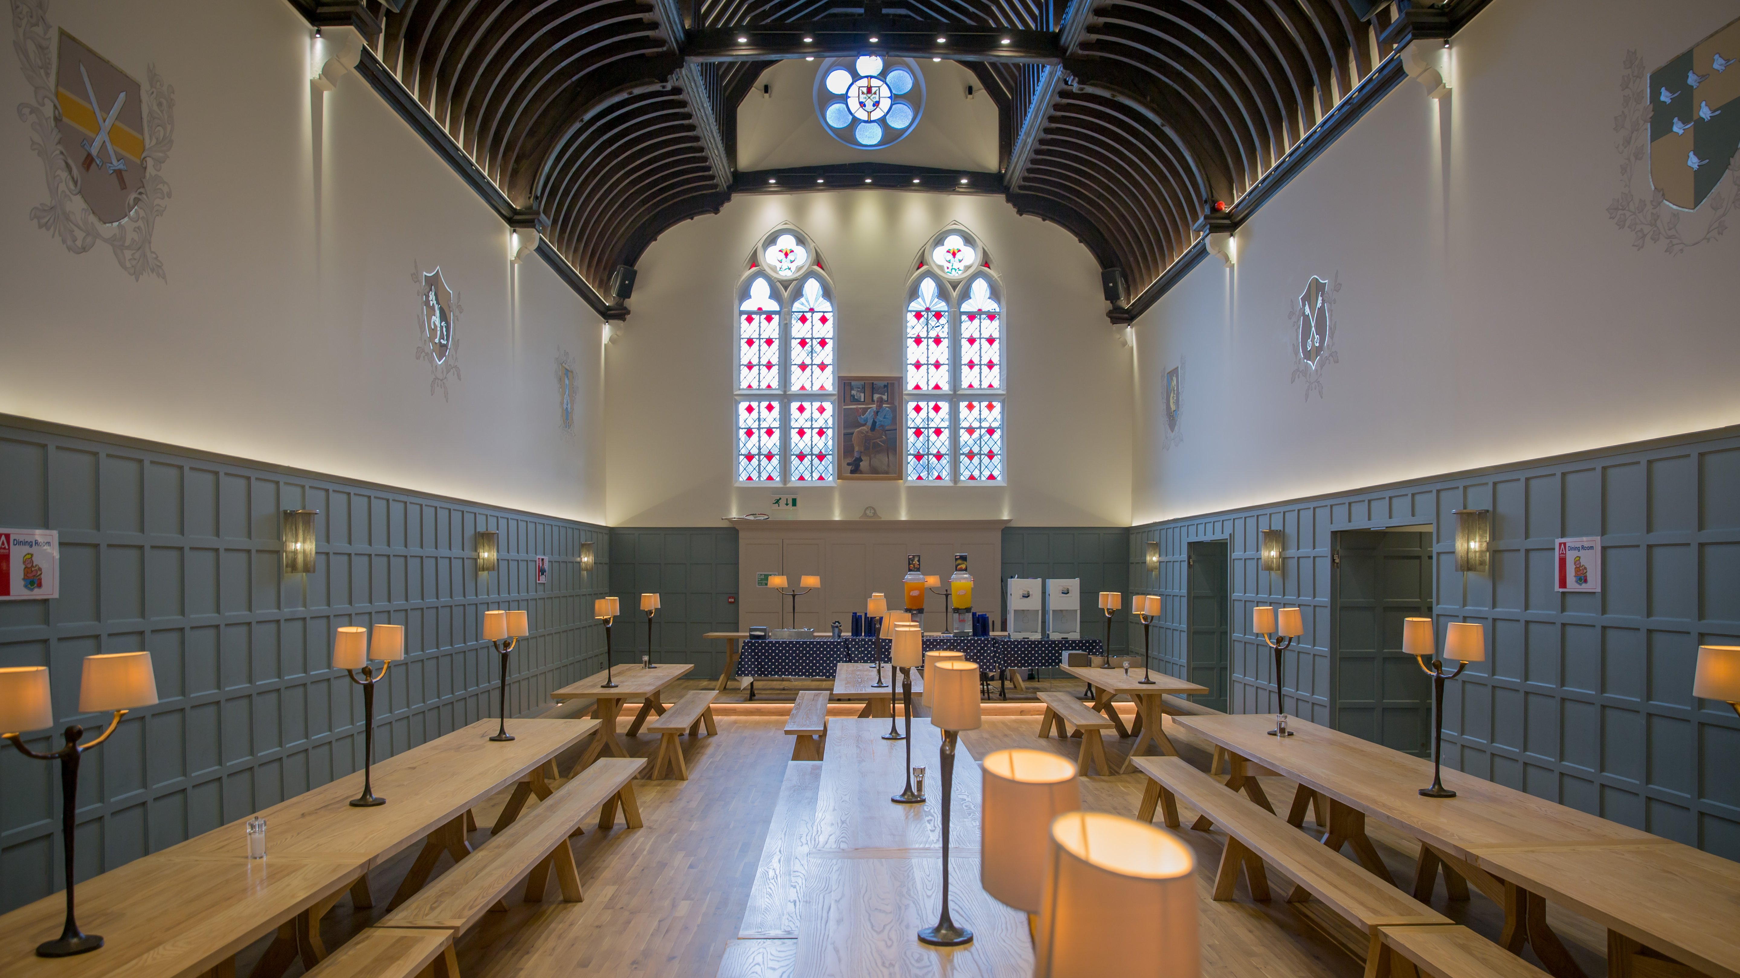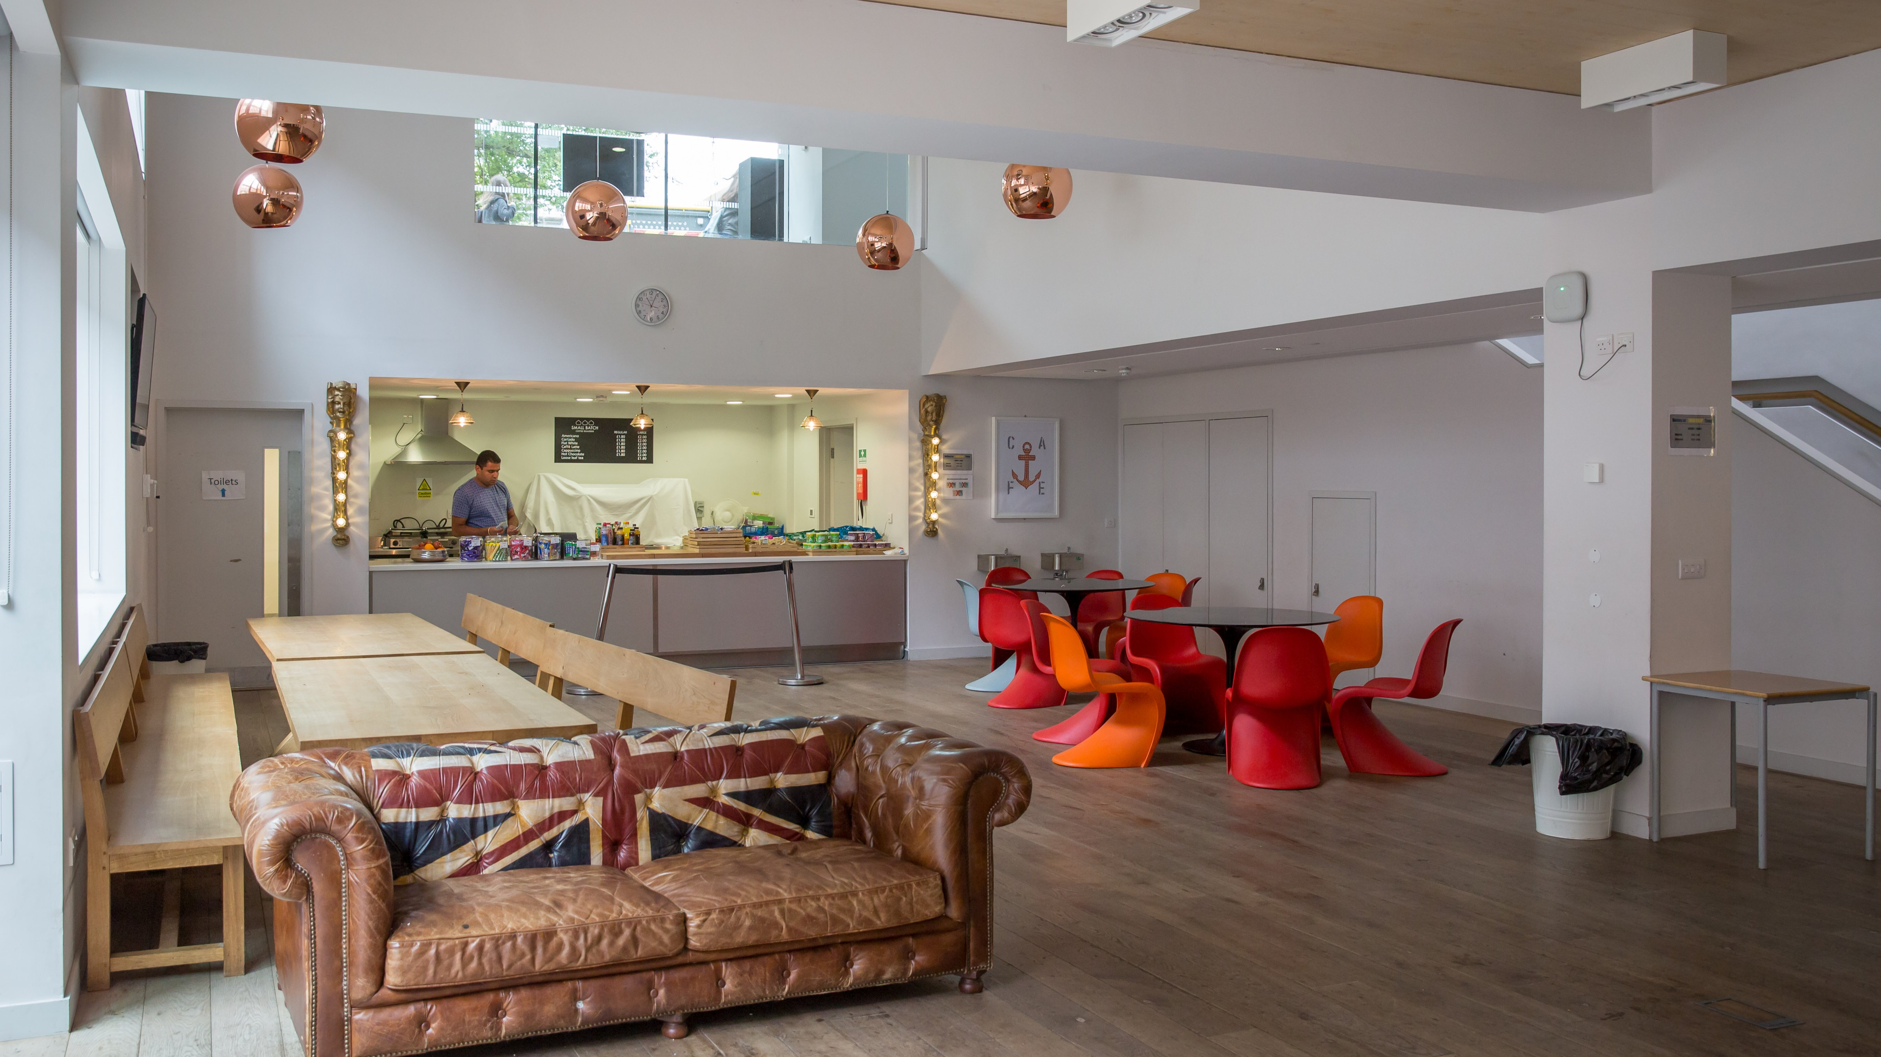

Eastern Road, Brighton, UK, from 9 to 17 age

Course intensity | 15
Accommodation | Campus
Room type | Multi-bedded
Bathroom facilities | Shared
Meals | Breakfast, Lunch and Dinner
Excursions per week | 4
Weekday excursions | 3
Full day excursions | 1

Description

Why choose this program

Infrastructure

Sport infrastructure

Hobbies and clubs

What else included in the program price

Recommended arrival city

Лондон

Sample timetable
 | Morning | Afternoon | Evening
Day 1 | Arrival | Arrival | Arrival
Day 2 | Lessons | Sports & Leisure Activities | Welcome Icebreaker Games
Day 3 | Lessons | Brighton Lanes | Egg Protector
Day 4 | Lessons | Half Day Excursion to Brighton i360 | Talent Show
Day 5 | Lessons | Sports & Leisure Activities | Casino Night
Day 6 | Lessons | Brighton Scavenger Hunt | Disco
Day 7 | Full Day Excursion to London, Thames River Cruise and Westminster Walking Tour Late return meal voucher provided | Full Day Excursion to London, Thames River Cruise and Westminster Walking Tour Late return meal voucher provided | Sports Tournament

For booking please go to www.travelclass.org

