Converse International School of Languages Marymount University Los Angeles — summer school in the US

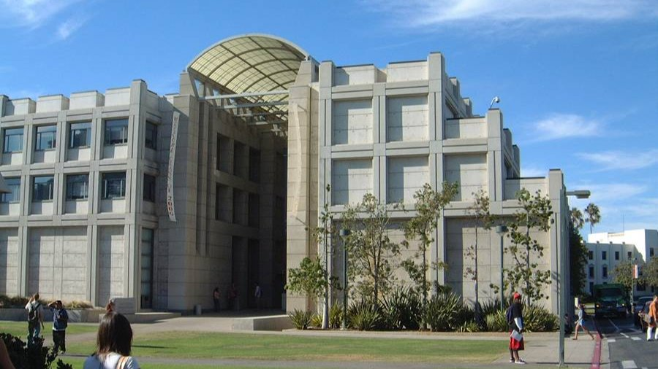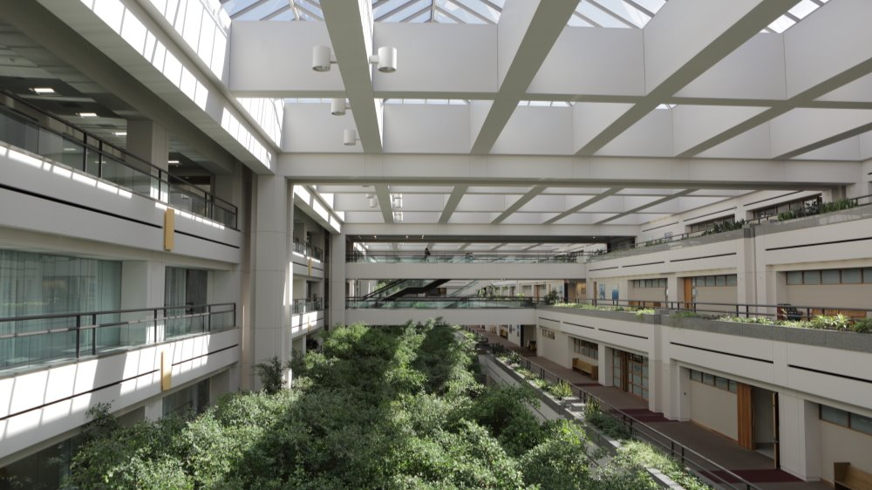

1 Loyola Marymount University Drive, Los Angeles, Калифорния, США, from 13 to 17 age

Course intensity | 16
Accommodation | Campus
Room type | Twin
Bathroom facilities | Shared
Meals | Breakfast, Lunch and Dinner
Excursions per week | 5
Weekday excursions | 4
Full day excursions | 1

Description

Why choose this program

Infrastructure

Sport infrastructure

Hobbies and clubs

What else included in the program price

Recommended arrival city

Лос-Анхелес

Sample timetable
 | Morning | Afternoon | Evening
Day 1 | Classes | Glendale Galleria | Dinner off campus
Day 2 | Classes | Cultural Workshop + Beverly Hills | The Grove for dinner
Day 3 | Classes | Surfing or cycling in Santa Monica | Activity on campus
Day 4 | Classes | Sports on campus | Pizza Party
Day 5 | Classes | Venice Beach + Abbott Kinney | Dinner off campus - Food truck Friday
Day 6 | San Diego Trip | San Diego Trip | Dinner off campus
Day 7 | Optional Activity | Optional Activity | Optional Activity
Day 8 | 4th of July Festivities | 4th of July Festivities | 4th of July Festivities
Day 9 | Classes | Cultural Workshop + Griffith Observatory and Hollywood | Dinner off campus
Day 10 | Classes | On Campus Activities | Activity on campus
Day 11 | LA Film School | Classes | Activity on campus
Day 12 | Classes | Surfing or Cycling in Santa Monica | Activity on campus
Day 13 | Six Flags | Six Flags | Six Flags
Day 14 | Optional Activity | Optional Activity | Optional Activity

For booking please go to www.travelclass.org

