Institut Linguistique Adenet - language school in France

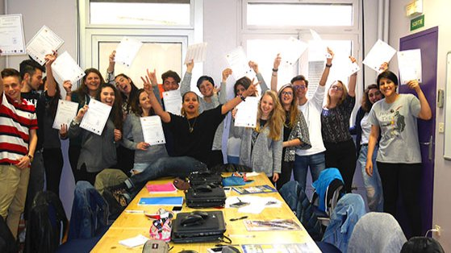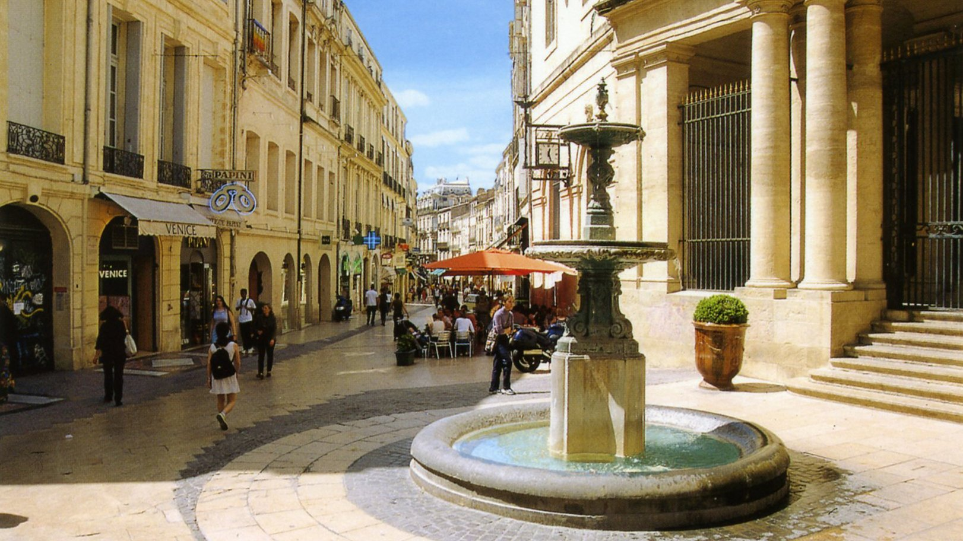

33 Grand Rue Jean Moulin, 34000 Montpellier, France, from to age

Course intensity
Accommodation
Room type | Single
Bathroom facilities | Shared
Meals
Excursions per week | 5
Weekday excursions
Full day excursions

Description

Why choose this program

Infrastructure

Sport infrastructure

Hobbies and clubs

What else included in the program price

Recommended arrival city

Монпелье

Sample timetable
 | Morning | Afternoon | Evening
Day 1

Day 2

Day 3

Day 4

Day 5

Day 6

Day 7

For booking please go to www.travelclass.org

