British Culture — English language camp in Turkey

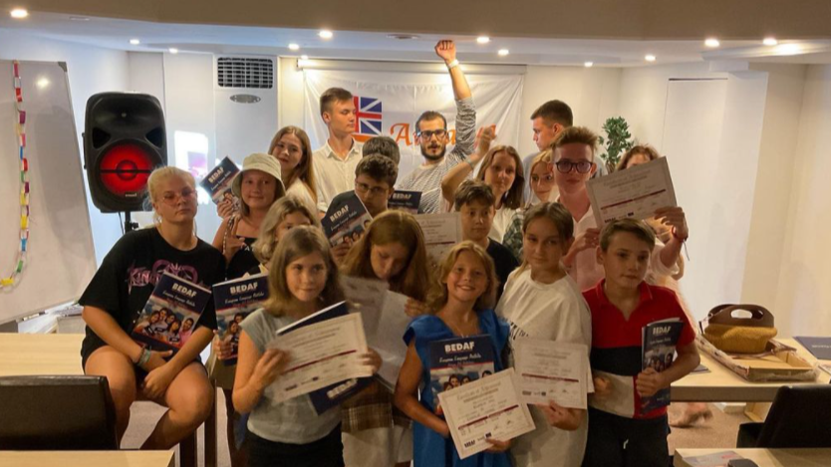

Deniz Caddesi No: 25, 07990 Кемер, Турция, from 9 to 16 age

Course intensity | 20
Accommodation | Hotel
Room type | Twin
Bathroom facilities | En-suite
Meals | Breakfast, Lunch and Dinner
Excursions per week
Weekday excursions
Full day excursions

Description

Why choose this program

Infrastructure

Sport infrastructure

Hobbies and clubs

What else included in the program price

Recommended arrival city

Анталья

Sample timetable
 | Morning | Afternoon | Evening
Day 1 | Arrival day
Day 2 | Lessons | Games and competitions | Conversational club
Day 3 | Lessons | Excursion to Aspendos | Games
Day 4 | Lessons | Cooking lesson | Cinema Night
Day 5 | Lessons | Games and competitions | Free time
Day 6 |  | Christmas dinner
Day 7 | Excursion | Excursion | Cinema
Day 8 | Departure
Day 9

Day 10

Day 11

Day 12

Day 13

Day 14

For booking please go to www.travelclass.org

