ILSC Toronto — summer school in Canada

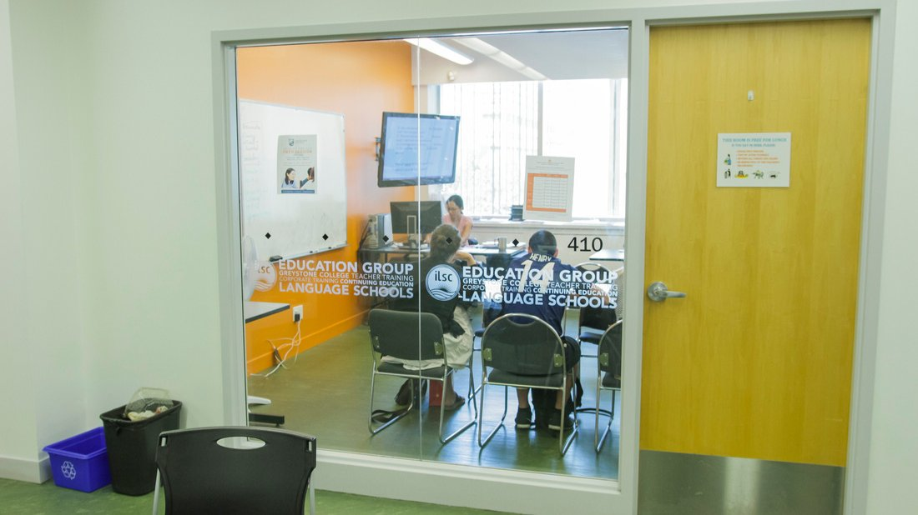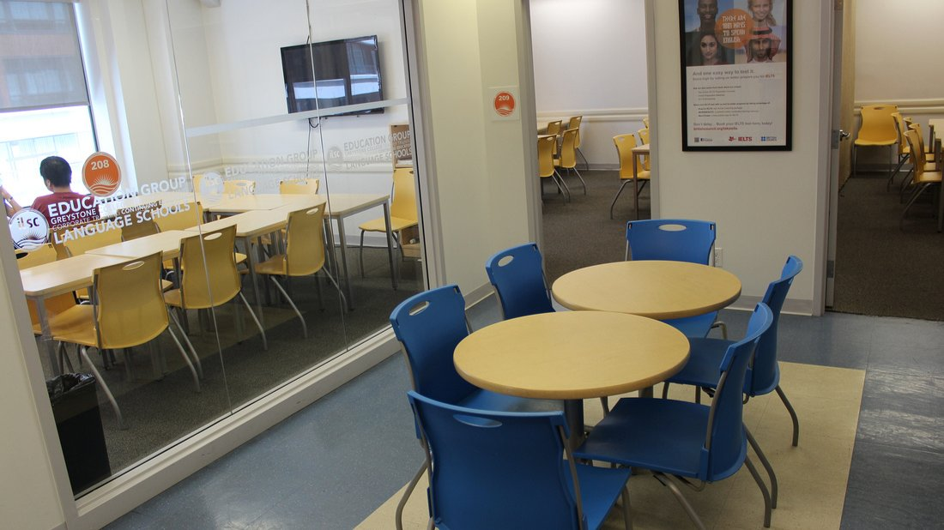

443 University Avenue, Toronto, ON, Canada, from 13 to 17 age

Course intensity | 17
Accommodation | Campus
Room type | Twin
Bathroom facilities | En-suite
Meals | Breakfast, Lunch and Dinner
Excursions per week | 5
Weekday excursions | 4
Full day excursions | 1

Description

Why choose this program

Infrastructure

Sport infrastructure

Hobbies and clubs

What else included in the program price

Recommended arrival city

Торонто

Sample timetable
 | Morning | Afternoon | Evening
Day 1 | English classes till 12:00 | Eaton Centre Shopping Trip | Scavenger Hunt
Day 2 | English classes till 12:00 | University of Toronto and Poutine Tasting | Movie Night
Day 3 | English classes till 12:00 | Laser Tag | Fashion Show Craft Night
Day 4 | English classes till 12:00 | Ontario Science Centre | Quiz Night
Day 5 | English classes till 12:00 | High Park Picnic | Dance Party
Day 6 | Niagara Falls (Packed lunch Served) | Niagara Falls (Packed lunch Served) | Niagara Falls (Dinner Out to Follow)
Day 7 | Toronto Zoo | Toronto Zoo | Games and Movie Night to follow

For booking please go to www.travelclass.org

