IP Hohensolms — summer school in Germany

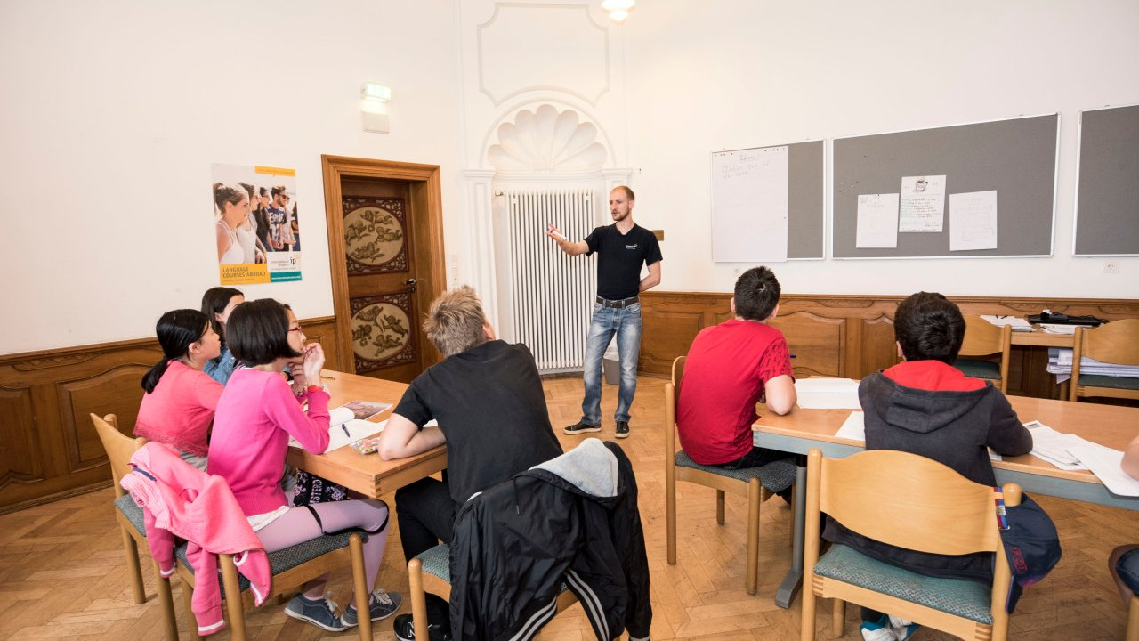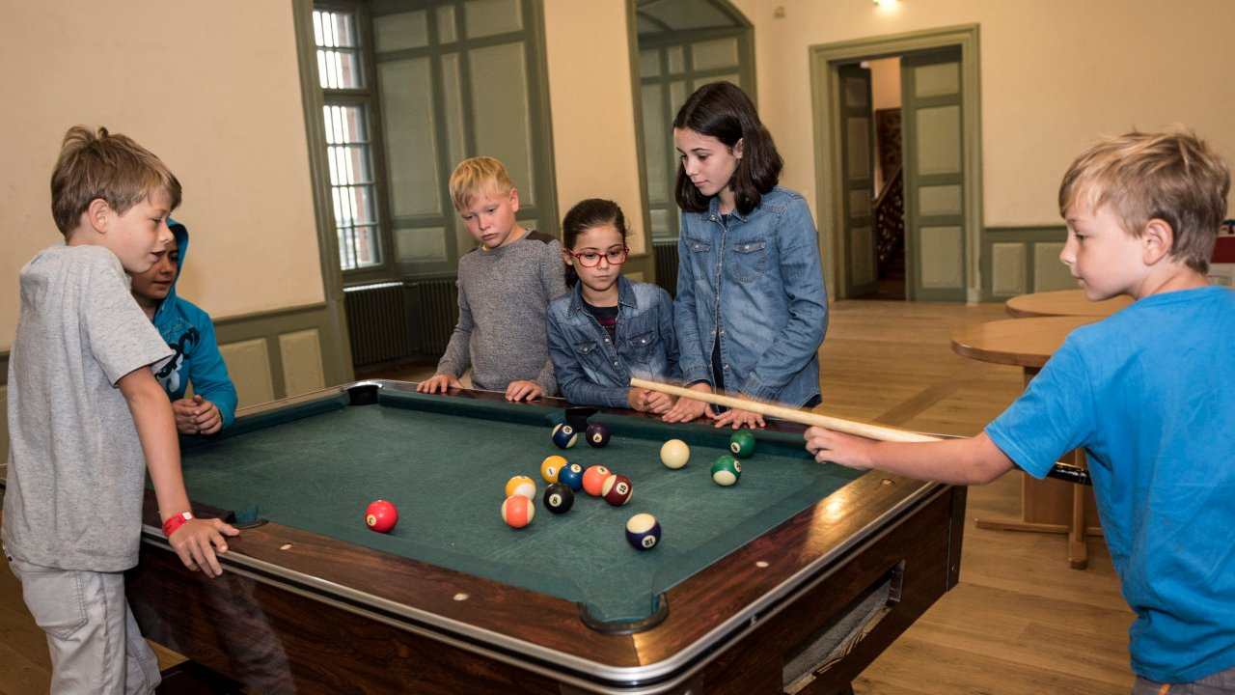

Hohensolms, Hohenahr, Germany, from 8 to 16 age

Course intensity | 15
Accommodation | Residence
Room type | Multi-bedded
Bathroom facilities | En-suite
Meals | Breakfast, Lunch and Dinner
Excursions per week | 2
Weekday excursions | 1
Full day excursions | 1

Description

Why choose this program

Infrastructure

Sport infrastructure

Hobbies and clubs

What else included in the program price

Recommended arrival city

Франкфурт

Sample timetable
 | Morning | Afternoon | Evening
Day 1 | Arrivals | Welcome meeting | Castle Treasure Hunt
Day 2 | Lessons | Outdoor swimming pool | Party Night
Day 3 | Lessons about Climate Change | Recycling Competition | Quiz Night
Day 4 | Lessons | Half day trip to Marburg | Games Night
Day 5 | Lessons | Archery & Medieval games | Bonfire Night
Day 6 | Lessons | Digital and dance workshop | IP’s a Got talented
Day 7 | Full day to Mainz/Koblenz | Full day to Mainz/Koblenz | Full day to Mainz/Koblenz
Day 8 | Fun games | Sports | Games
Day 9 | Lessons | Health & beauty | Party
Day 10 | Lessons | Recycling Competition | Quiz
Day 11 | Lessons | Half day trip to Limburger | Games
Day 12 | Lessons | Archery & Medieval games | Bonfire Night
Day 13 | Lessons | Digital and Dance workshop | IP’s Got talent
Day 14 | Departure

For booking please go to www.travelclass.org

