ATC University College Dublin — summer school in Ireland

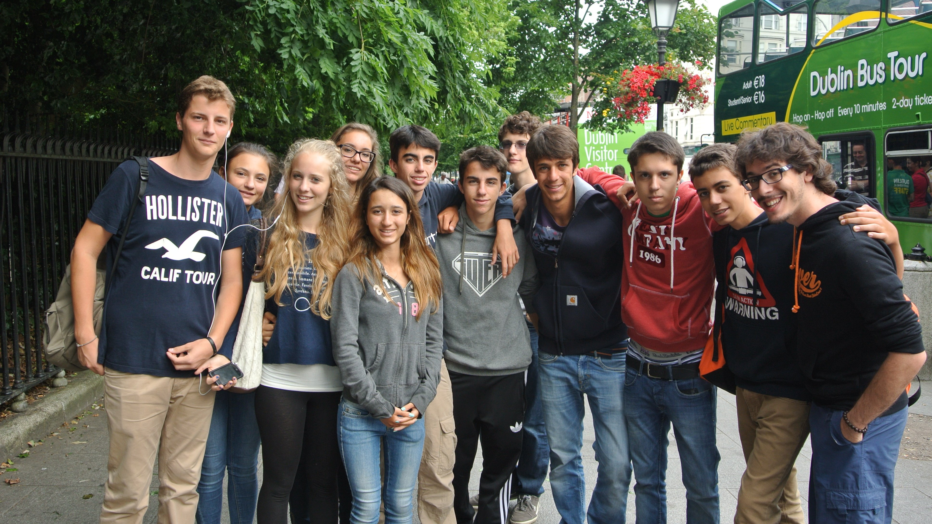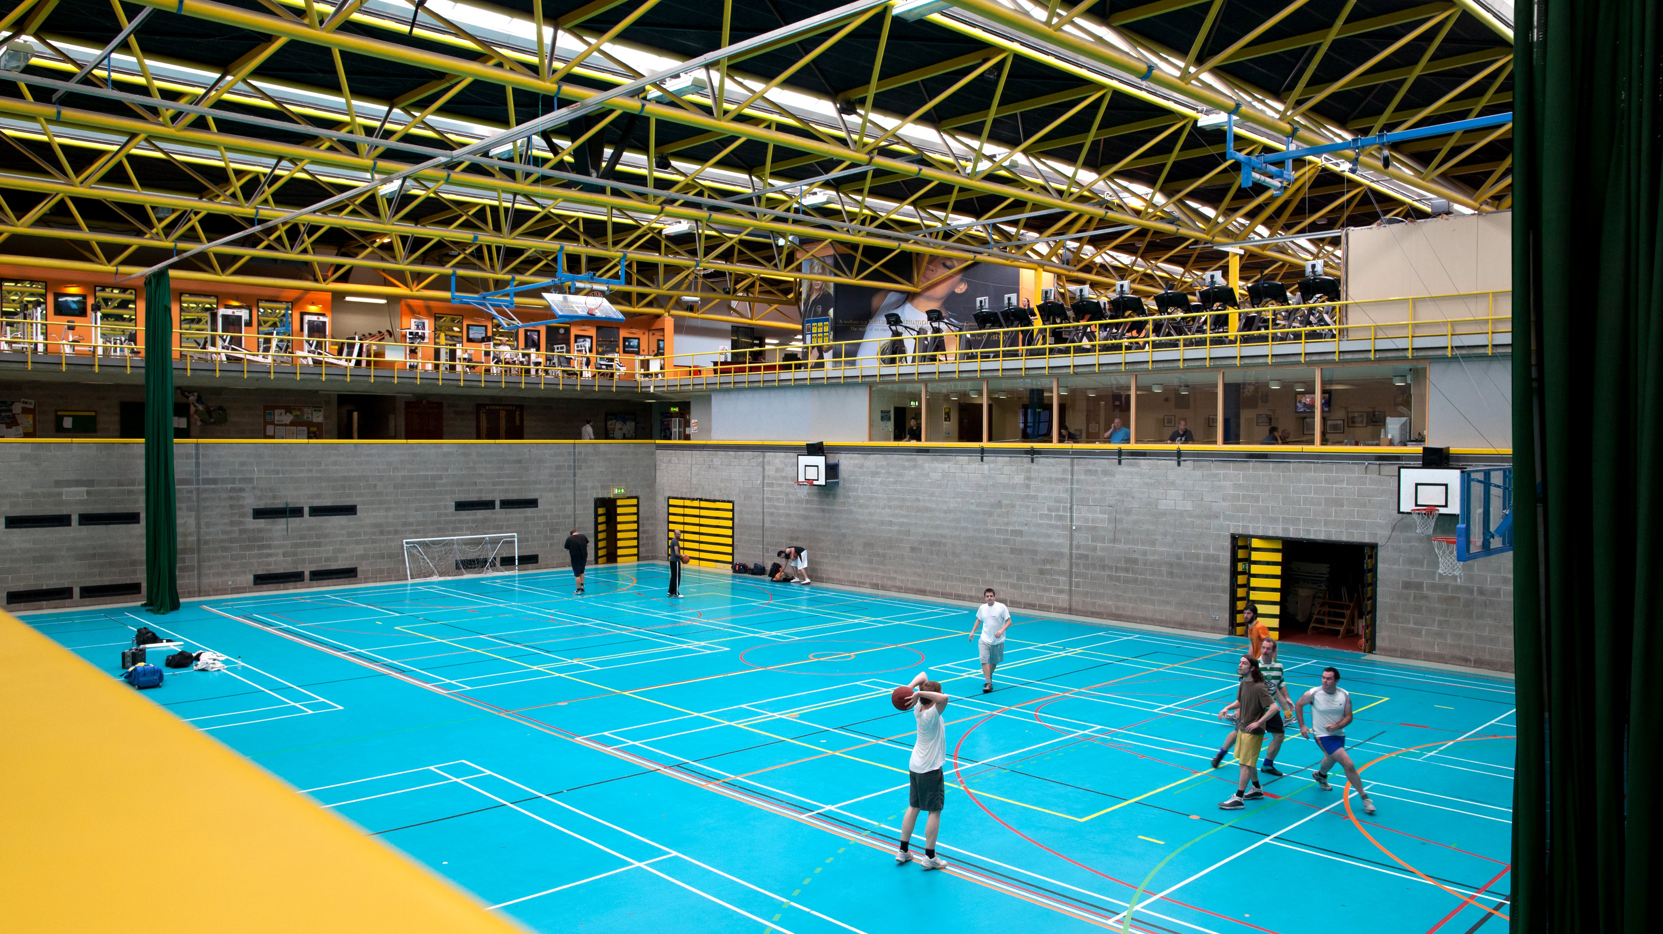

University College Dublin, Stillorgan Road, Belfield, Dublin 4, Ireland, from 13 to 17 age

Course intensity | 15
Accommodation | Campus
Room type | Single
Bathroom facilities | En-suite
Meals | Breakfast, Lunch and Dinner
Excursions per week | 4
Weekday excursions | 3
Full day excursions | 1

Description

Why choose this program

Infrastructure

Sport infrastructure

Hobbies and clubs

What else included in the program price

Recommended arrival city

Дублин

Sample timetable
 | Morning | Afternoon | Evening
Day 1 | Arrival Day! | Arrival Day! | Arrival Day!
Day 2 | Lessons | Orientation Tour of Dublin | Mixer Games
Day 3 | Lessons | EPIC Ireland | Trash Fashion
Day 4 | Lessons | World of Work | Irish Night
Day 5 | Lessons | ATC Projects- Photography | ATC Olympics
Day 6 | Full Day Tour - Cliffs of Moher | Cliffs of Moher | Black and White Disco
Day 7 | Full Day Tour - Bray |  | Karaoke
Day 8 | Free day
Day 9 | Lessons | ATC Projects | Games
Day 10 | Lessons | Half day excursion | Karaoke
Day 11 | Lessons | ATC Projects | Disco
Day 12 | Lessons | Half day excursion | Irish night
Day 13 | Lessons | ATC Projects | Quiz
Day 14 | Full day trip | Full day trip | Full day trip

For booking please go to www.travelclass.org

