Science Camps of America

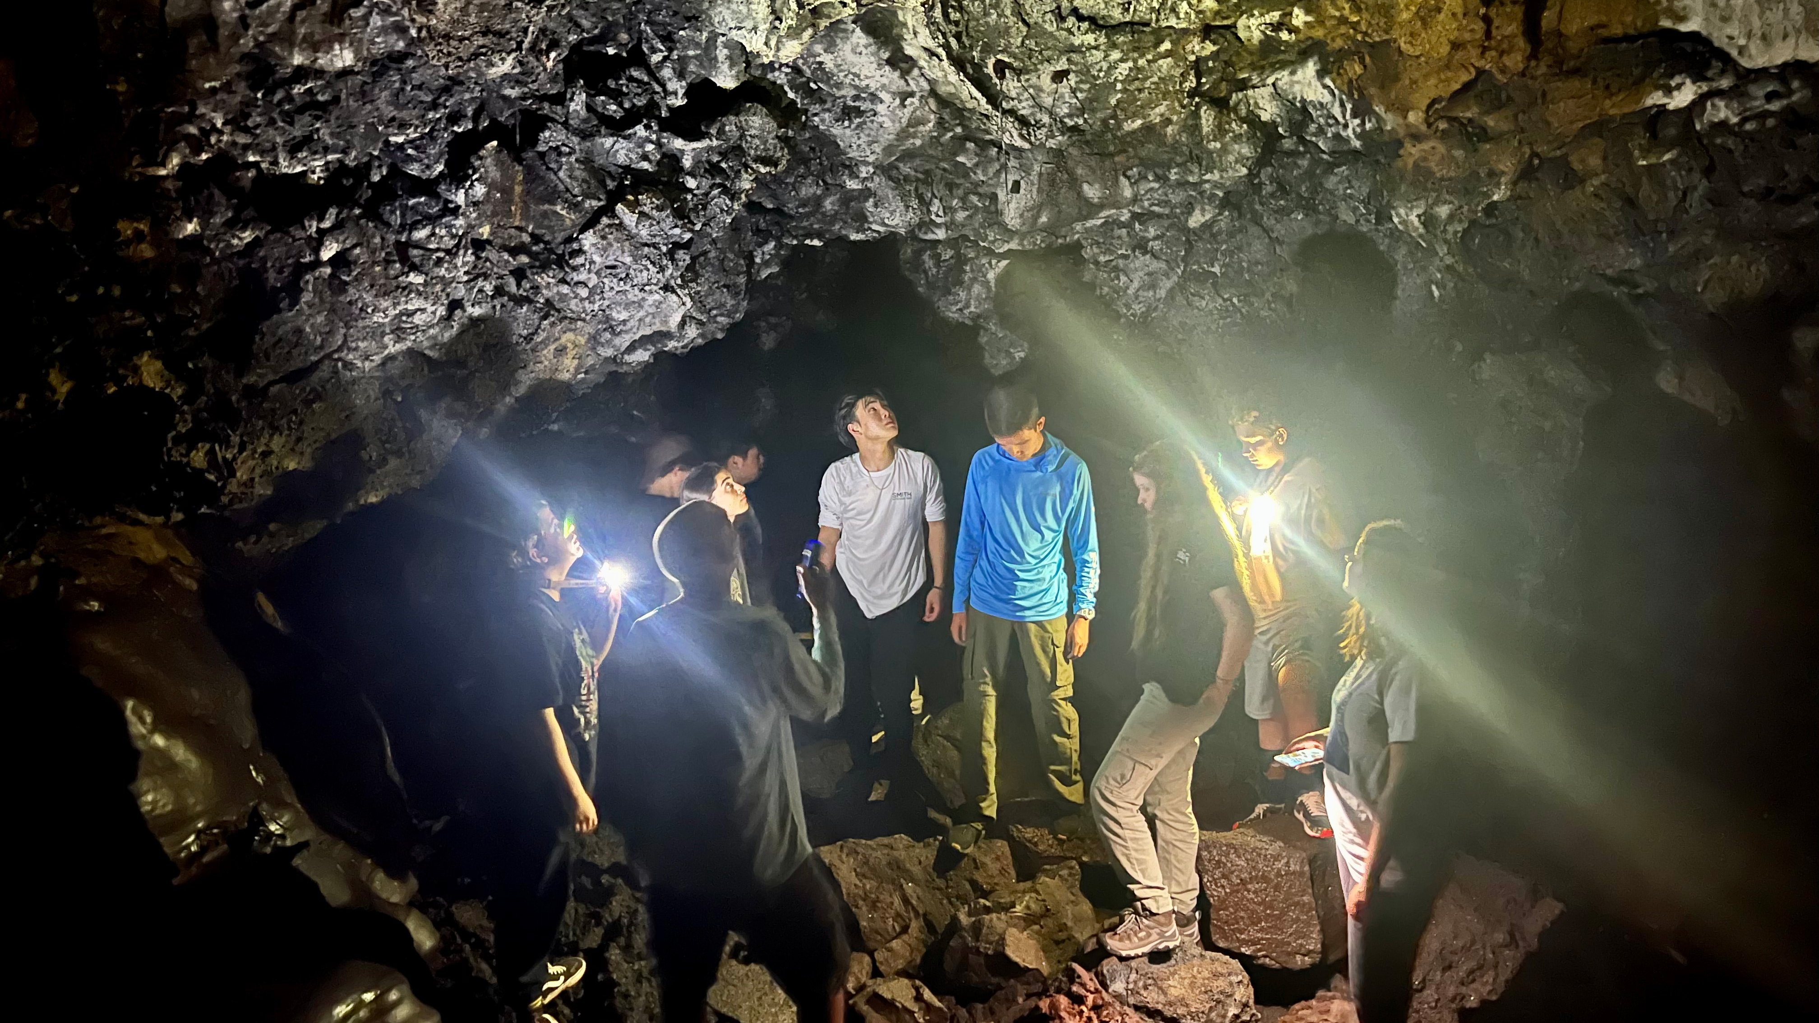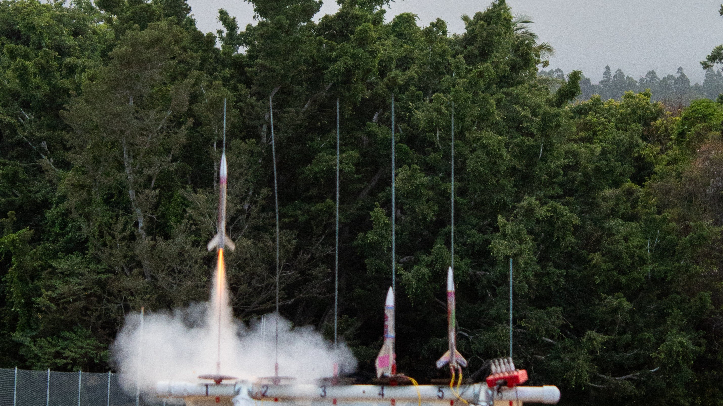

Maile Street, Pahala, HI, USA, from 13 to 17 age

Course intensity
Accommodation
Room type | Multi-bedded
Bathroom facilities | Shared
Meals | Breakfast, Lunch and Dinner
Excursions per week
Weekday excursions
Full day excursions

Description

Why choose this program

Infrastructure

Sport infrastructure

Hobbies and clubs

What else included in the program price

Recommended arrival city

Хило

Sample timetable
 | Morning | Afternoon | Evening
Day - | - | - | -

For booking please go to www.travelclass.org

