Converse International School of Languages Loyola University Chicago — summer school in the US

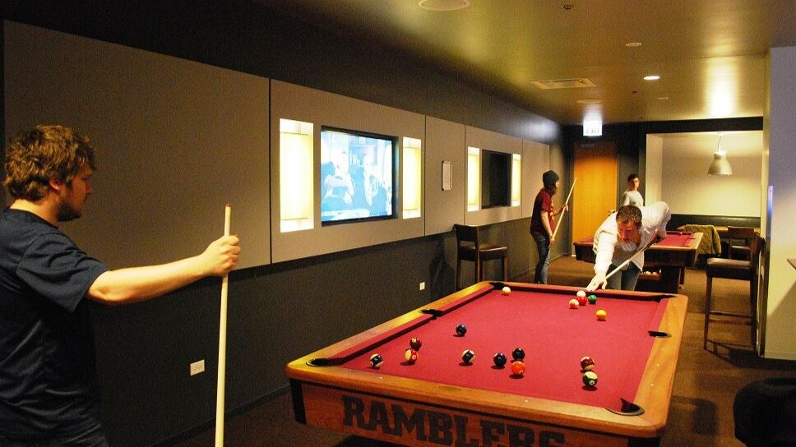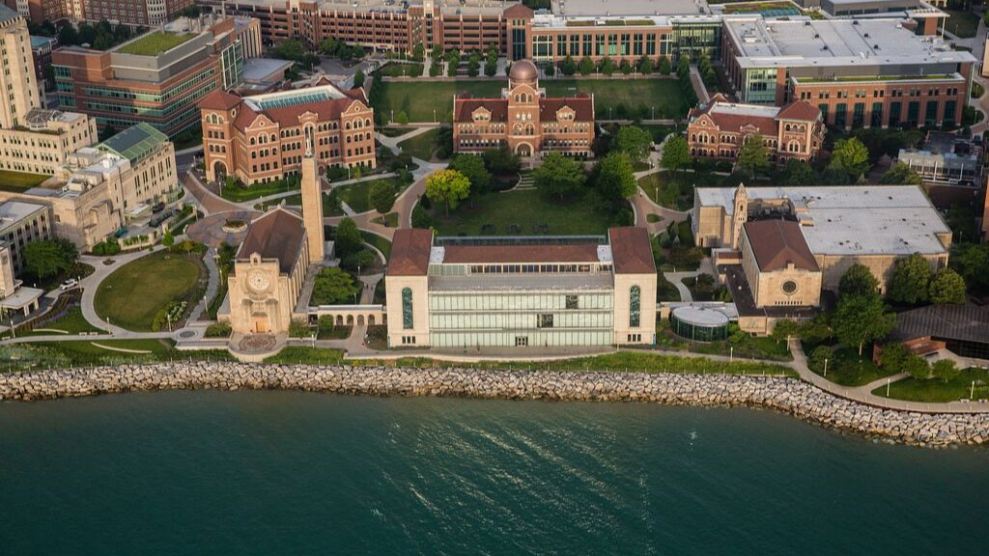

Chicago, Иллинойс, США, from 13 to 17 age

Course intensity | 16
Accommodation | Residence
Room type | Twin
Bathroom facilities | Shared
Meals | Breakfast, Lunch and Dinner
Excursions per week | 5
Weekday excursions | 4
Full day excursions | 1

Description

Why choose this program

Infrastructure

Sport infrastructure

Hobbies and clubs

What else included in the program price

Recommended arrival city

Чикаго

Sample timetable
 | Morning | Afternoon | Evening
Day 1 | CISL Orientation | CISL Orientation | River Tour
Day 2 | Classes | Cultural Workshop + excursion | Activity
Day 3 | Classes | Excursion | Activity
Day 4 | Classes | Excursion | Activity
Day 5 | Classes | Excursion | Activity
Day 6 | Full Day Excursion | Full Day Excursion | Full Day Excursion
Day 7 | optional activity | optional activity | optional activity
Day 8 | Classes | Biking Millennium Park | Activity
Day 9 | Classes | 360 Chicago | Activity
Day 10 | Classes | Chicago Fed Museum of Money | Activity
Day 11 | Classes | Museum of Contemporary Photography | Activity
Day 12 | Classes | Beach Day | Activity
Day 13 | Milwaukee | Milwaukee | Milwaukee
Day 14 | Departure

For booking please go to www.travelclass.org

