Oxford International University of Worcester — summer school in the UK

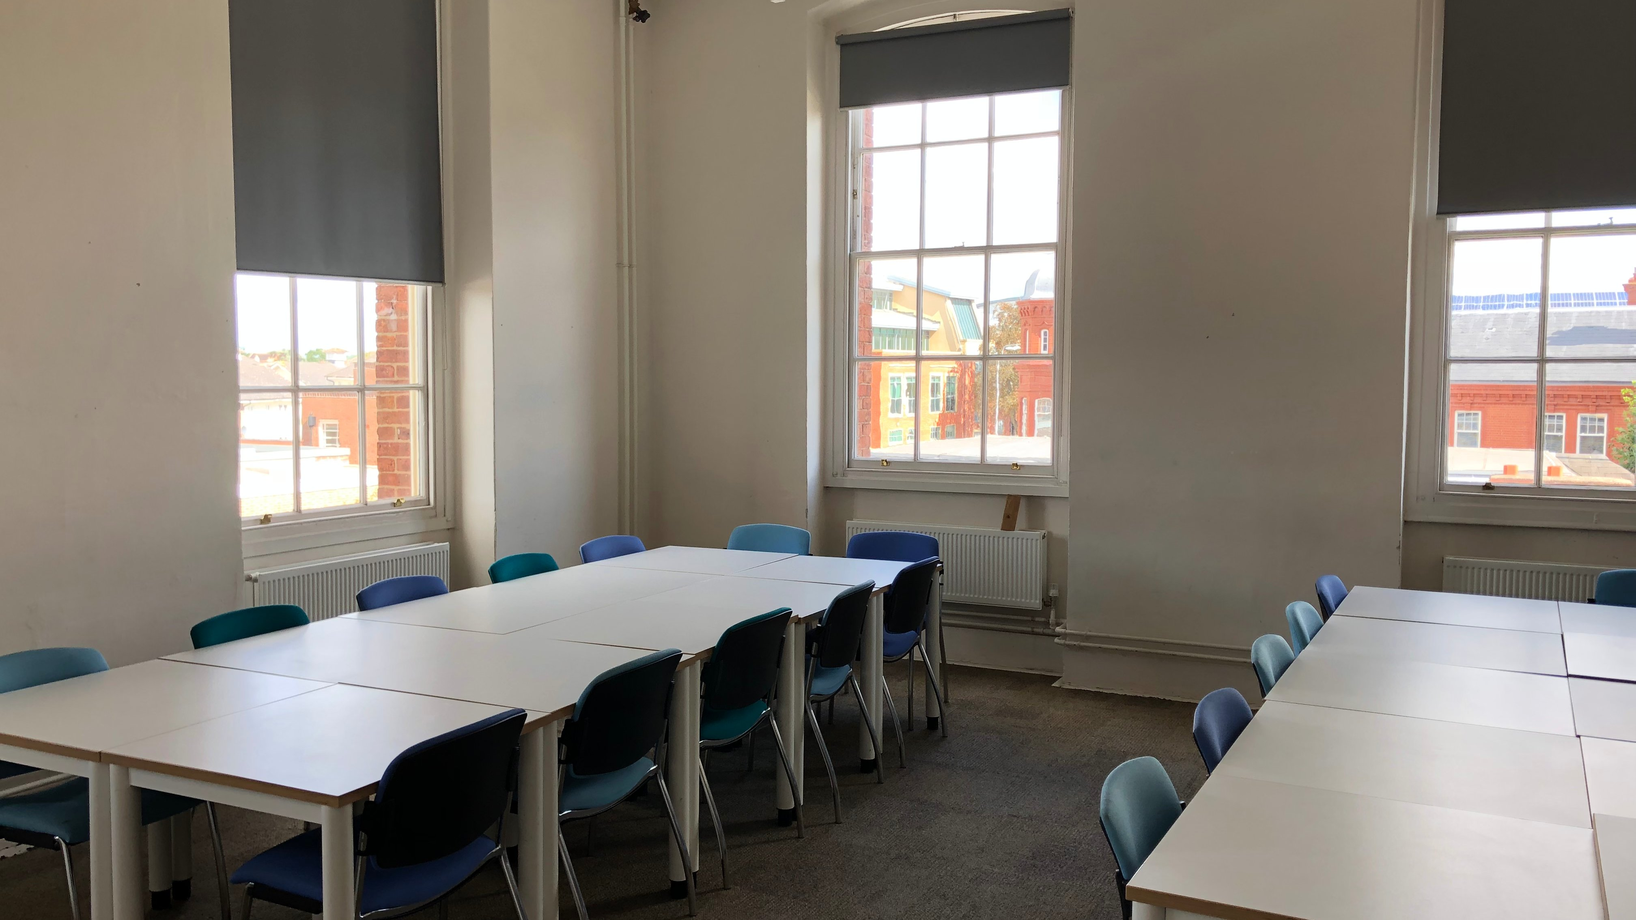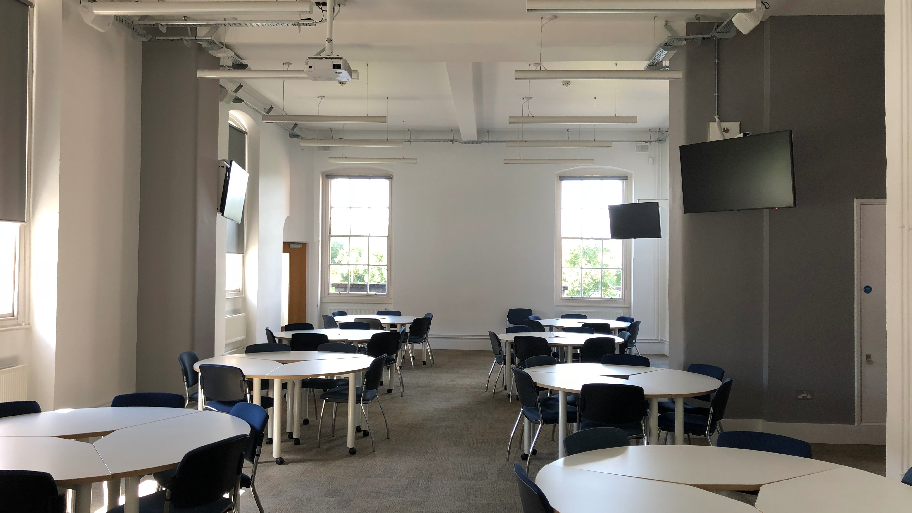

Castle Street, Worcester, UK, from 8 to 17 age

Course intensity | 15
Accommodation | Host family
Room type | Twin
Bathroom facilities | Shared
Meals | Breakfast, Lunch and Dinner
Excursions per week | 4
Weekday excursions | 2
Full day excursions | 2

Description

Why choose this program

Infrastructure

Sport infrastructure

Hobbies and clubs

What else included in the program price

Recommended arrival city

Лондон

Sample timetable
 | Morning | Afternoon | Evening
Day 1 | Arrivals | Arrivals | Campus tour and ice-breaker activities
Day 2 | Placement Test and Lessons | Half day excursion to Worcester with orientation and Instagram challenge | Onsite Activities
Day 3 | Lessons | Entrance to Worcester Cathedral | Welcome Disco
Day 4 | Full day excursion to Stratford-Upon-Avon | Entrance to Shakespeare's Birthplace | Onsite Activities
Day 5 | Onsite Activities | Lessons | Karaoke/Lip Sync Battle
Day 6 | Extended Full day excursion to London by train | Politics and Royalty Walking Tour | Late return to campus by train
Day 7 | Onsite Activities | Lessons | Disco
Day 8 | Lessons | Lessons | Onsite Activities
Day 9 | Lessons | Onsite Activities | Talent Show
Day 10 | Lessons | Half day excursion to Cadbury World | Onsite Activities
Day 11 | Full day excursion to Bath or Oxford | Entrance to Bath Abbey or Oxford College | International Evening
Day 12 | Onsite Activities | Lessons | Onsite Activities
Day 13 | Cruise on the River Severn | Lessons | Onsite Activities
Day 14 | Optional Day | Optional Day | Farewell Disco

For booking please go to www.travelclass.org

