Chelmsford Writtle University College — language school in the UK

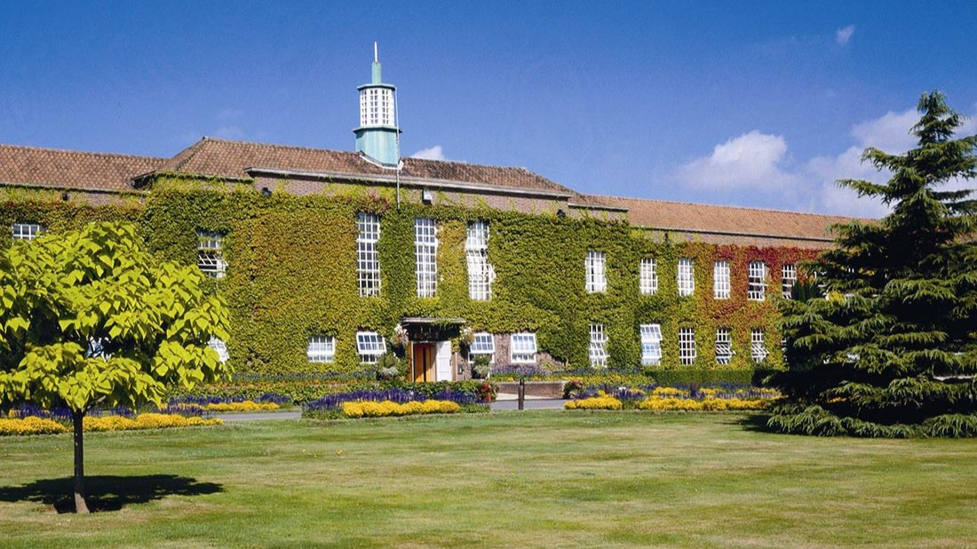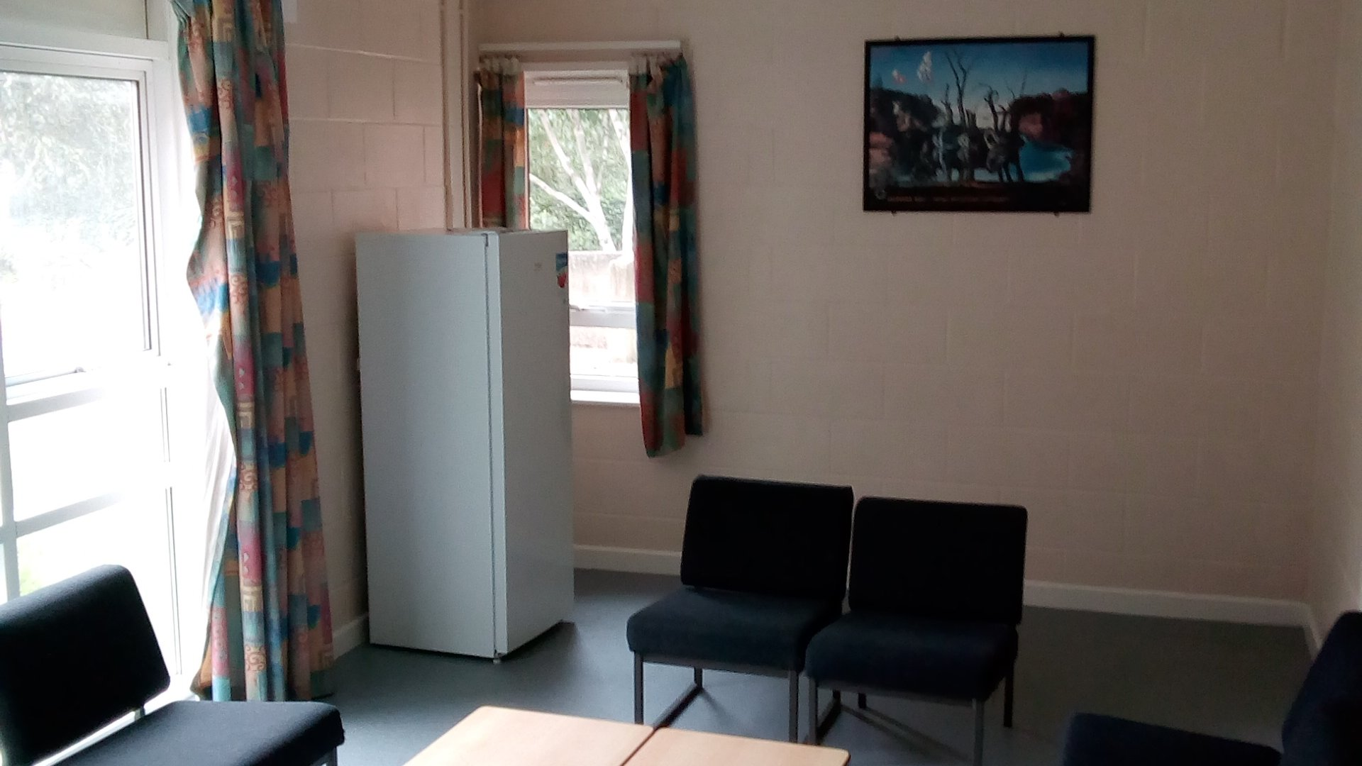

Lordship Road, Writtle, Chelmsford CM1 3RR, UK, from 11 to 17 age

Course intensity | 15
Accommodation | Residence
Room type | Single
Bathroom facilities | Shared
Meals | Breakfast, Lunch and Dinner
Excursions per week | 4
Weekday excursions | 2
Full day excursions | 2

Description

Why choose this program

Infrastructure

Sport infrastructure

Hobbies and clubs

What else included in the program price

Recommended arrival city

Лондон

Sample timetable
 | Morning | Afternoon | Evening
Day 1 | Arrival | Orientation tour | Welcome Party
Day 2 | Lessons | Chelmsford Walking tour of visit to local Cathedral | Scavenger Hunt
Day 3 | Lessons | Lessons | Film
Day 4 | Lessons | Chelmsford Walking tour of visit to local City Centre | Newspaper show
Day 5 | Full Day to Cambridge | Tour The Backs, Mathematical Bridge, St Catharine's College, Cambridge University and King's College, Trinity College, The Round Church and Bridge of Sighs + Punting | Karaoke
Day 6 | Full Day Excursion to London | Buckingham Palace, Westminster Abbey, Houses of Parliament, Big Ben, 10 Downing Street, Horse Guards, Trafalgar Square and National Gallery | Film
Day 7 | Lessons | Social Games and Sports | Optional Excursion

For booking please go to www.travelclass.org

