ALPADIA Brighton Roedean School — summer school in the UK

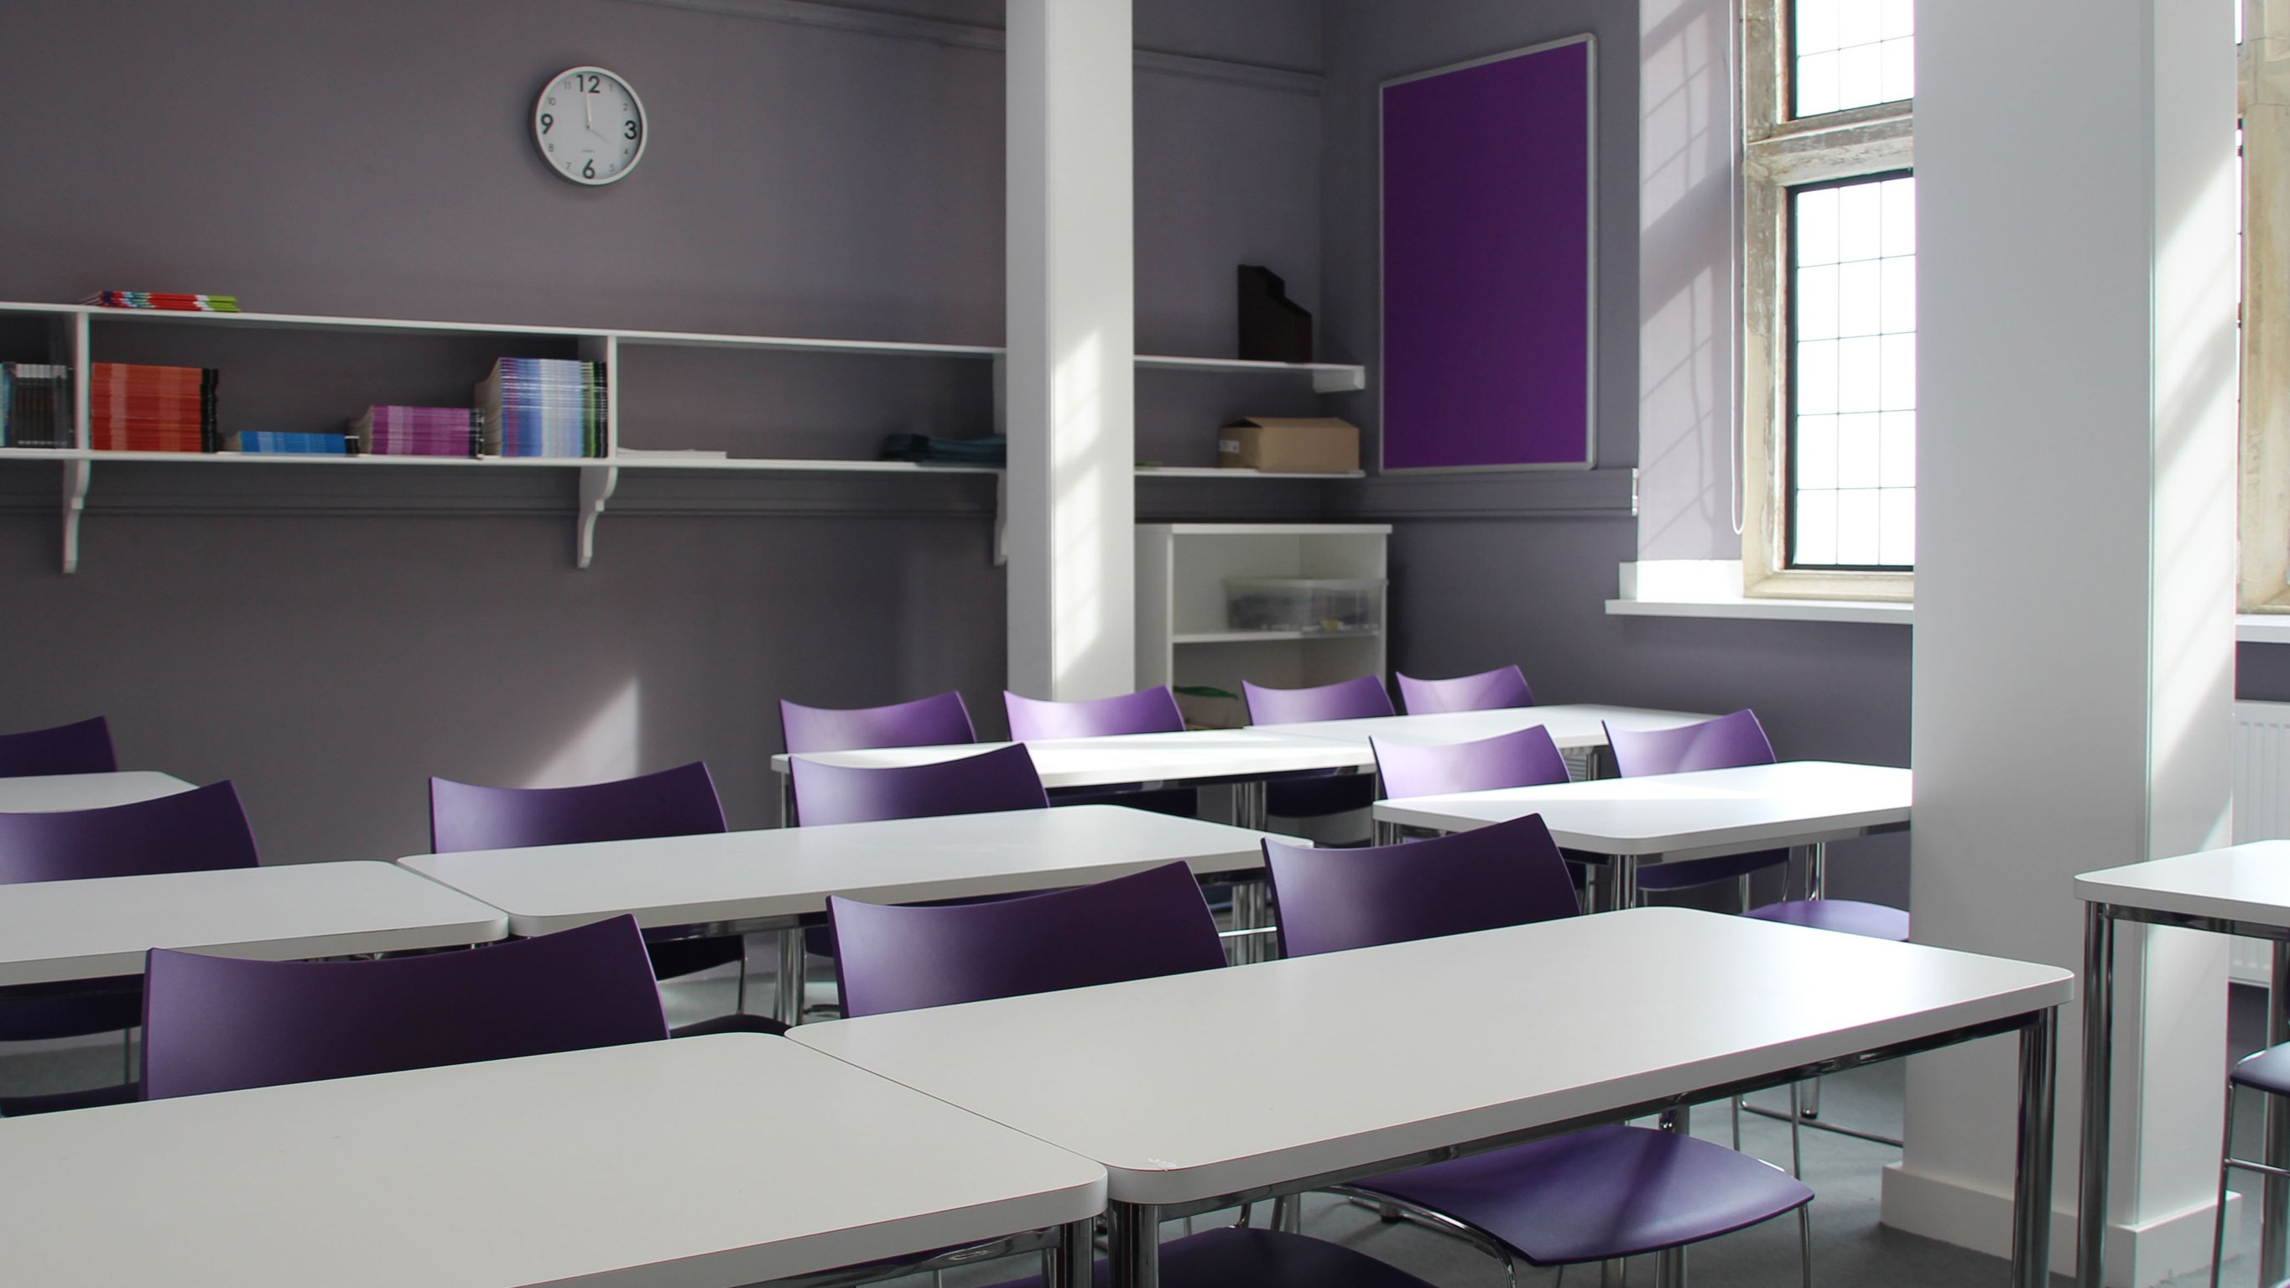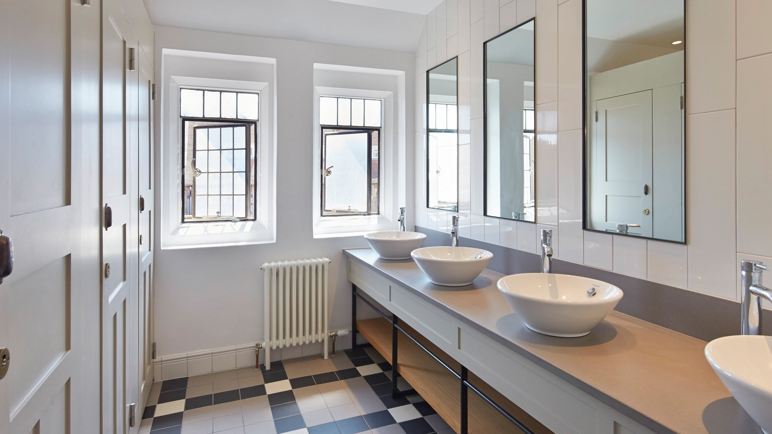

Roedean Way, Brighton BN2 5RQ, UK, from 10 to 17 age

Course intensity | 20
Accommodation | Campus
Room type | Single
Bathroom facilities | Shared
Meals | Breakfast, Lunch and Dinner
Excursions per week | 3
Weekday excursions | 2
Full day excursions | 1

Description

Why choose this program

Infrastructure

Sport infrastructure

Hobbies and clubs

What else included in the program price

Recommended arrival city

Лондон

Sample timetable
 | Morning | Afternoon | Evening
Day 1 | Arrival | Excursion to London or Cambridge | Ice breaker
Day 2 | Classes | Package activities | Murder Mystery night
Day 3 | Classes | Package activities | Fancy dress disco
Day 4 | Classes | Excursion to British Airways i360 Tower | Talent Show
Day 5 | Classes | Package activities | Casino night
Day 6 | Classes & weekly test | Package activities | Karaoke/Disco
Day 7 | VISIT TO BRIGHTON CITY CENTRE | VISIT TO BRIGHTON CITY CENTRE | Movie night

For booking please go to www.travelclass.org

