Humboldt-Institut Bad Schussenried — language school in Germany

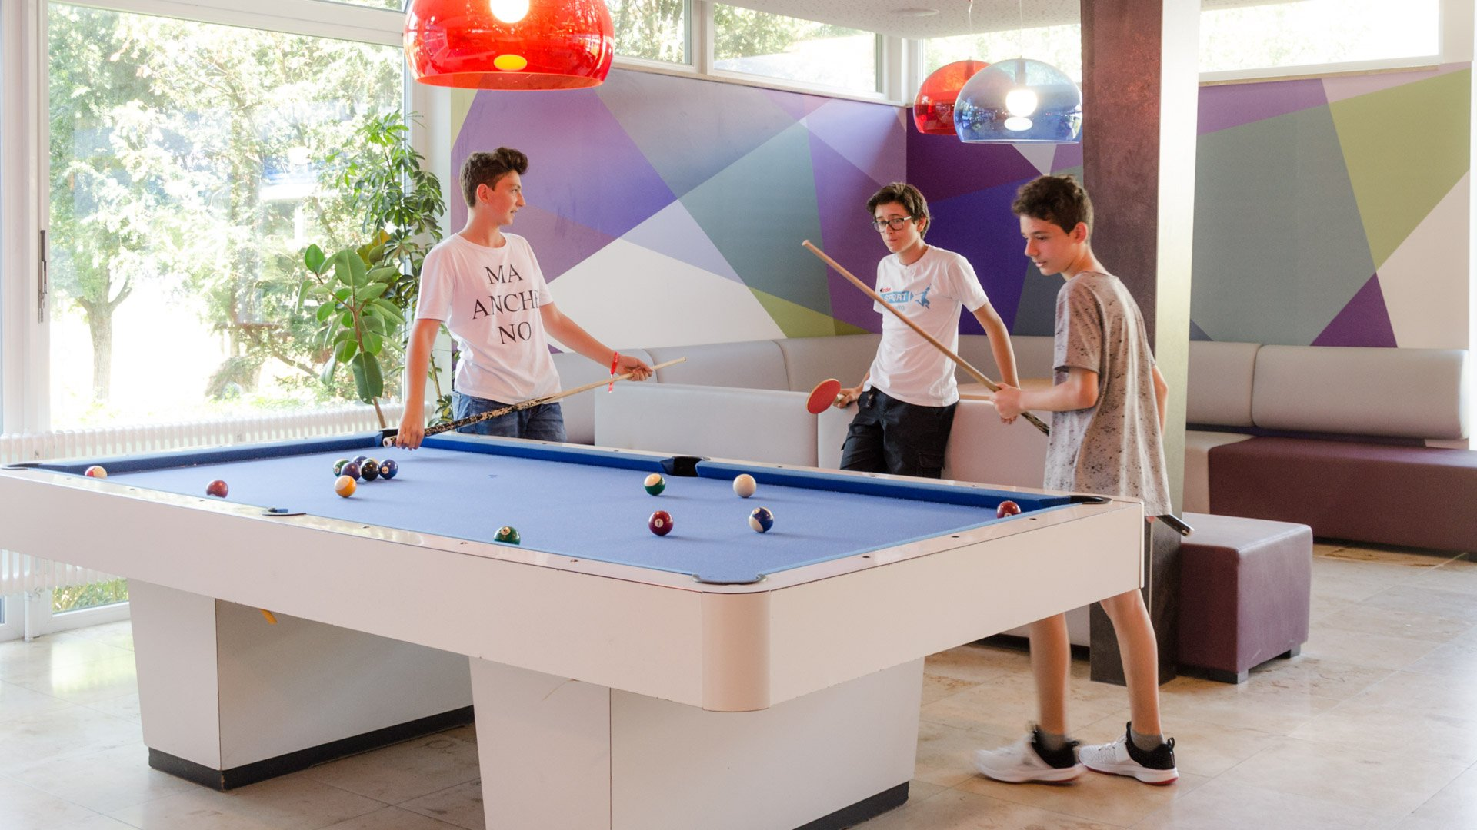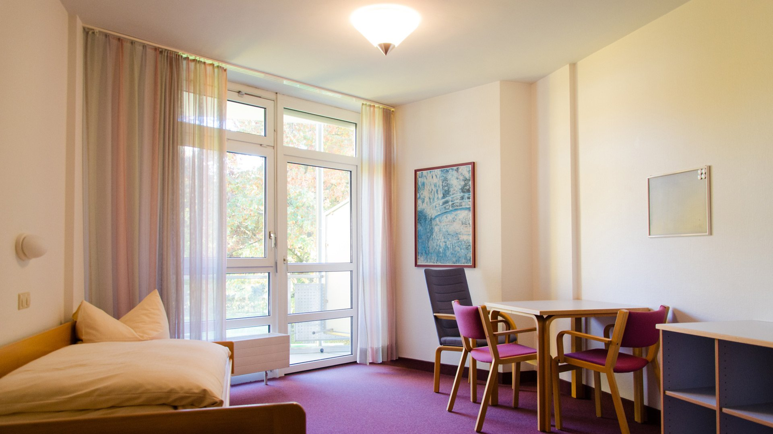

Humboldt-Institut Bad Schussenried, Zellerseeweg 11, Bad Schussenried, Deutschland, from 10 to 17 age

Course intensity | 23
Accommodation | Campus
Room type | Twin
Bathroom facilities | En-suite
Meals | Breakfast, Lunch and Dinner
Excursions per week | 2
Weekday excursions | 1
Full day excursions | 1

Description

Why choose this program

Infrastructure

Sport infrastructure

Hobbies and clubs

What else included in the program price

Recommended arrival city

Мюнхен

Sample timetable
 | Morning | Afternoon | Evening
Day 1 |  | Transfer | Leisure program
Day 2 | Lessons | Mountain biking or icebreaker games for new students | Basketball or stencil paint
Day 3 | Lessons | City walk or board games | Badminton or handicrafts: soap stones
Day 4 | Lessons | Excursion to Ravensburg: Visiting the Humpis Quartier & City rally | Playing board games
Day 5 | Lessons | City walk or soccer | Tennis or Quiz
Day 6 | Lessons | Humboldt Olympics or painting on t-shirts | School disco with karaoke
Day 7 | Fullday excursion to Munich: Visiting Allianz Arena | Fullday excursion to Munich: Visiting Allianz Arena | Barbecue & campfire
Day 8

Day 9

Day 10

Day 11

Day 12

Day 13

Day 14

For booking please go to www.travelclass.org

