SCL International College North Acton — London language school, UK

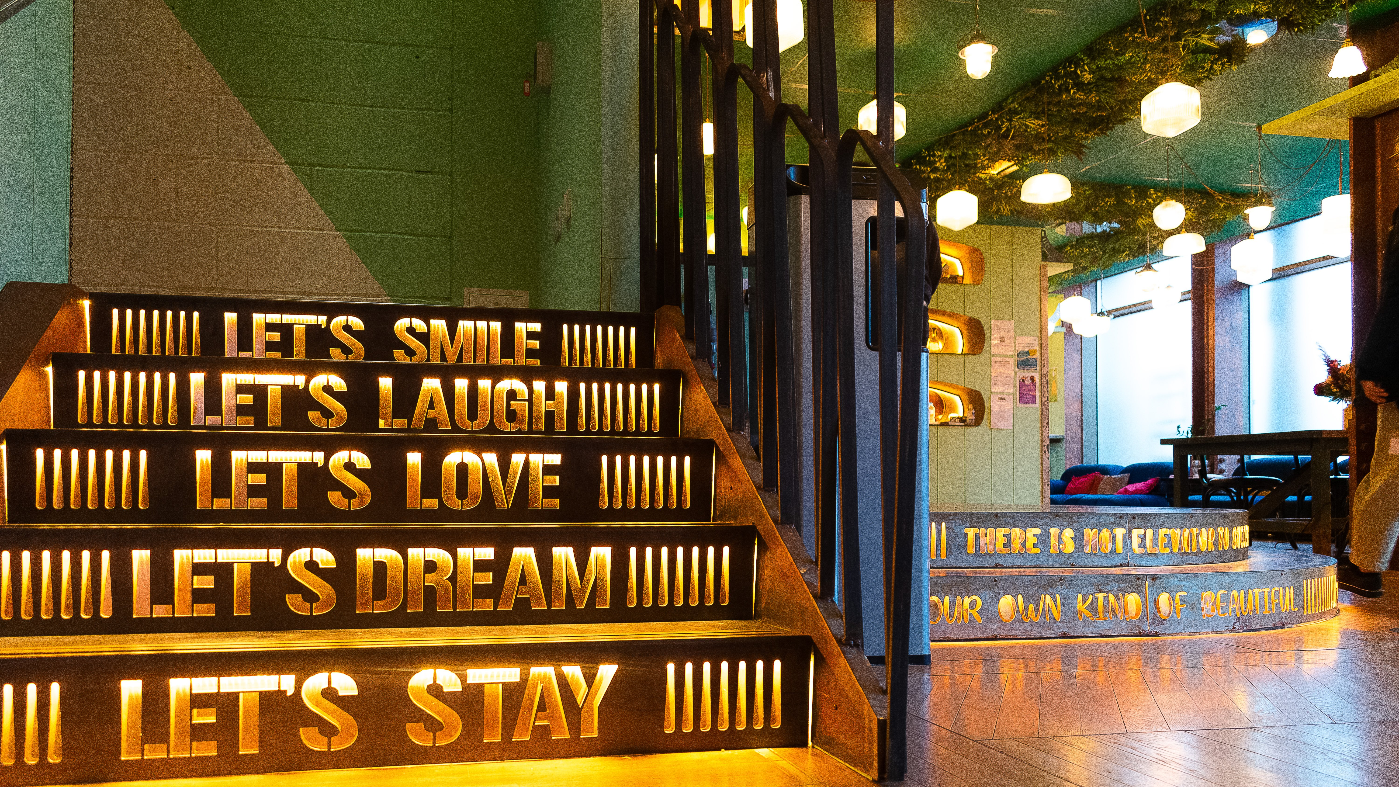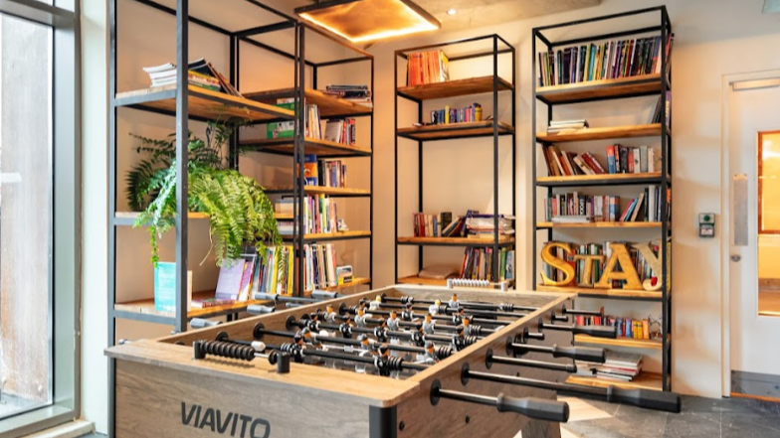

200 Western Avenue, London, W3 6FW, from 12 to 17 age

Course intensity | 15
Accommodation | Campus
Room type | Twin
Bathroom facilities | En-suite
Meals | Breakfast, Lunch and Dinner
Excursions per week | 0
Weekday excursions | 0
Full day excursions | 0

Description

Why choose this program

Infrastructure

Sport infrastructure

Hobbies and clubs

What else included in the program price

Recommended arrival city

Лондон

Sample timetable
 | Morning | Afternoon | Evening
Day 1 | Arrival | Arrival | Arrival
Day 2 | Lessons | London Eye | Film night
Day 3 | Lessons | Tower of London | Games
Day 4 | Lessons | Thanes river Cruise | Evening activities
Day 5 | Lessons | National Gallery | Evening activities
Day 6 | Lessons | British Museum | Disco
Day 7 | Departure | Departure

For booking please go to www.travelclass.org

