MLA St. Albans College — language school in Ireland

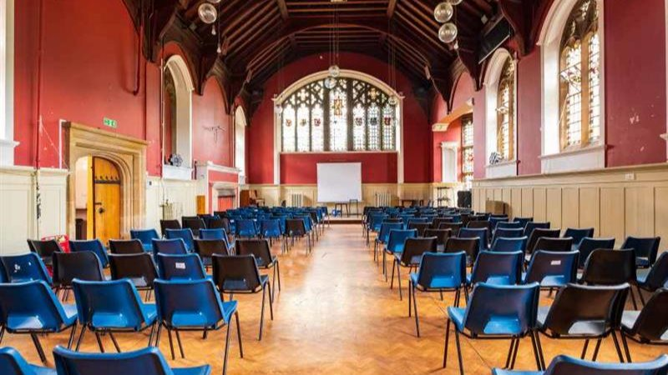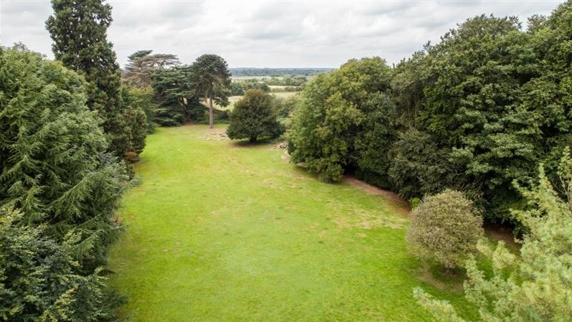

All Saints Pastoral Centre, London Colney, St Albans, UK, from 10 to 18 age

Course intensity | 15
Accommodation | Campus
Room type | Twin
Bathroom facilities | Shared
Meals | Breakfast, Lunch and Dinner
Excursions per week | 2
Weekday excursions | 1
Full day excursions | 1

Description

Why choose this program

Infrastructure

Sport infrastructure

Hobbies and clubs

What else included in the program price

Recommended arrival city

Лондон

Sample timetable
 | Morning | Afternoon | Evening
Day 1 | Arrival | Transfer from airport | Settling in
Day 2 | Lessons | Optional day in London | Disco Night
Day 3 | Lessons | Sport sessions | Quiz Night
Day 4 | Lessons | Half Day Excursion to Cambridge | Movie Night
Day 5 | Lessons | Sport sessions | Fashion Night
Day 6 | Full Day Excursion to London | Full Day Excursion to London | Karaoke Night
Day 7 | Graduation Ceremony | Graduation Ceremony | Departure

For booking please go to www.travelclass.org

