Humboldt-Institut Cologne — language school in Germany

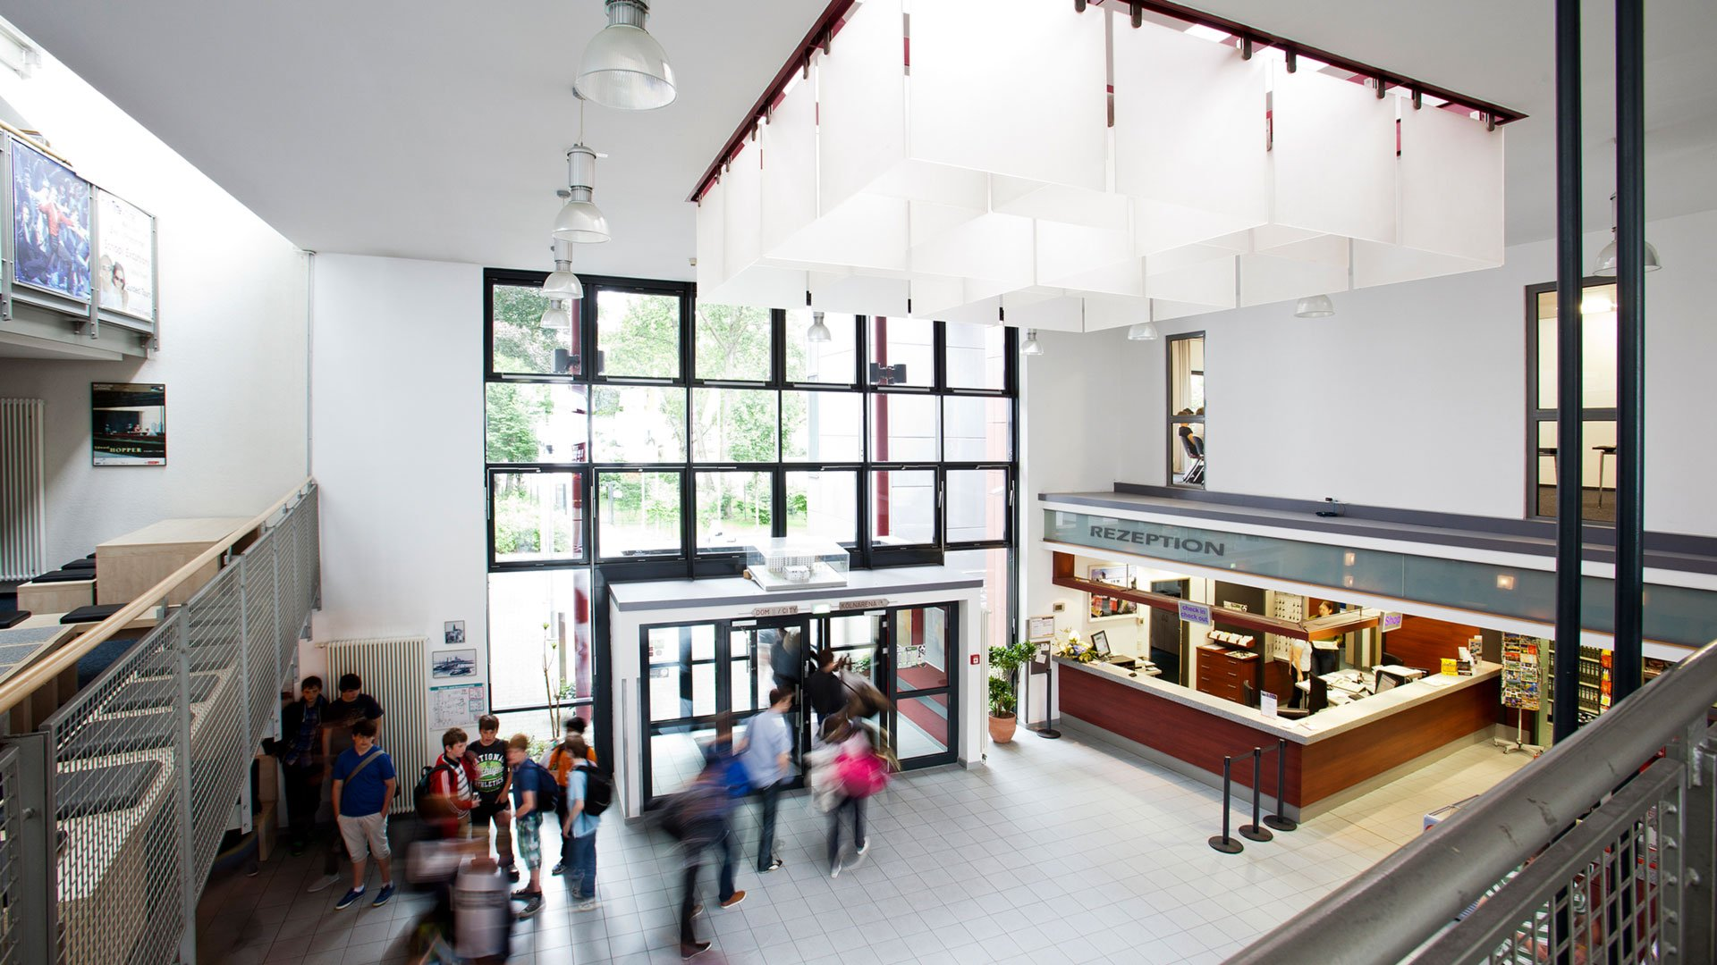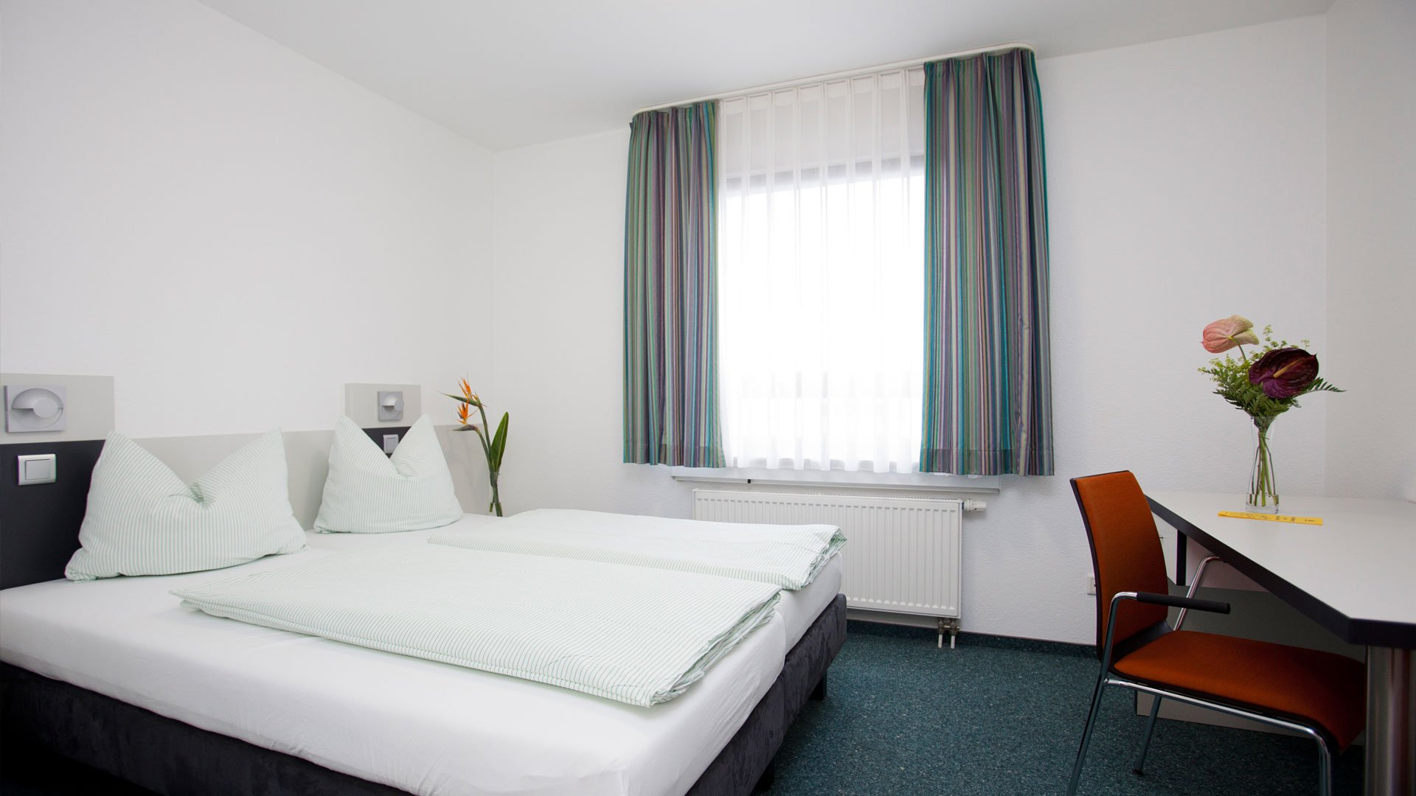

DJH Jugendherberge Köln-Deutz, Siegesstraße 5, 50679 Köln, Deutschland, from 15 to 18 age

Course intensity | 23
Accommodation | Campus
Room type | Twin
Bathroom facilities | En-suite
Meals | Breakfast, Lunch and Dinner
Excursions per week | 2
Weekday excursions | 1
Full day excursions | 1

Description

Why choose this program

Infrastructure

Sport infrastructure

Hobbies and clubs

What else included in the program price

Recommended arrival city

Кёльн

Sample timetable
 | Morning | Afternoon | Evening
Day 1 | Arrival
Day 2 | Class | Visiting museum „Ludwig“ or soccer | Table tennis or cinema
Day 3 | Class | City walk | Ping-pong or walk through the university district
Day 4 | Class | Halfday excursion: Visit of the Kölner Dome | Playing cards or foosball
Day 5 | Class | City walk | Aqua park: swimming or board games
Day 6 | Class | City Rally or sports and games in the Rhinepark | Cologne by night: evening walk or karaoke
Day 7 | Fullday excursion to Bonn
Day 8

Day 9

Day 10

Day 11

Day 12

Day 13

Day 14

For booking please go to www.travelclass.org

