Estudio Sampere Salamanca — language school in Spain

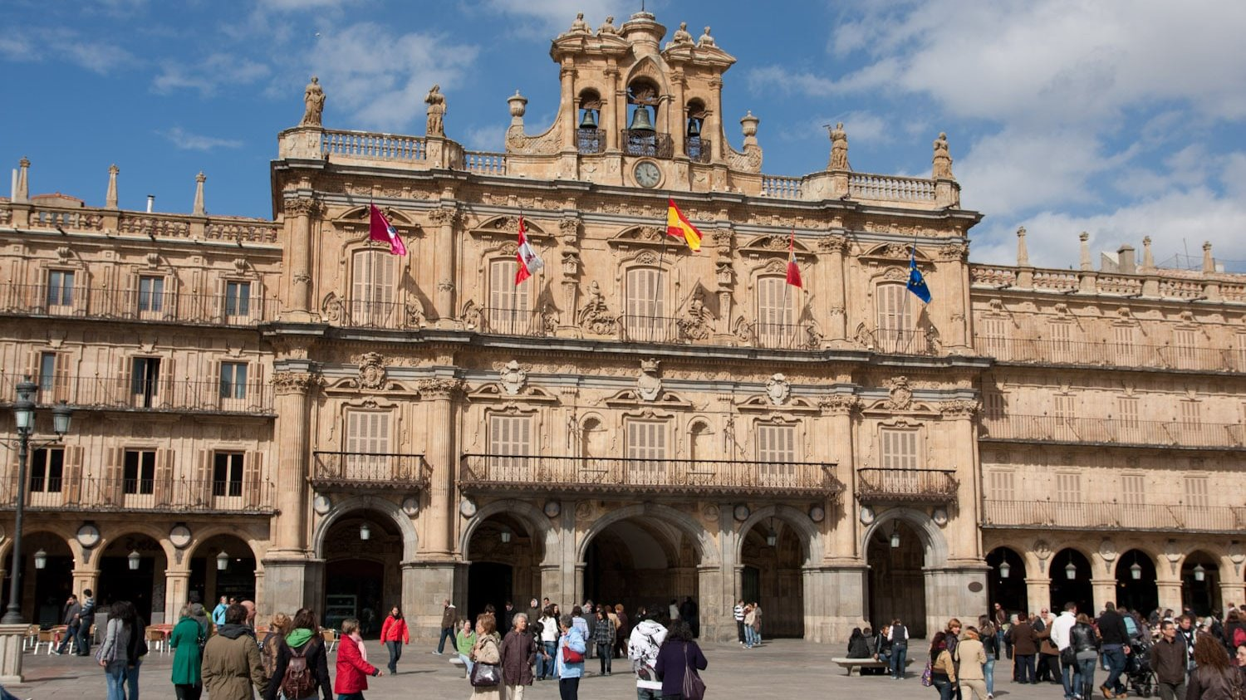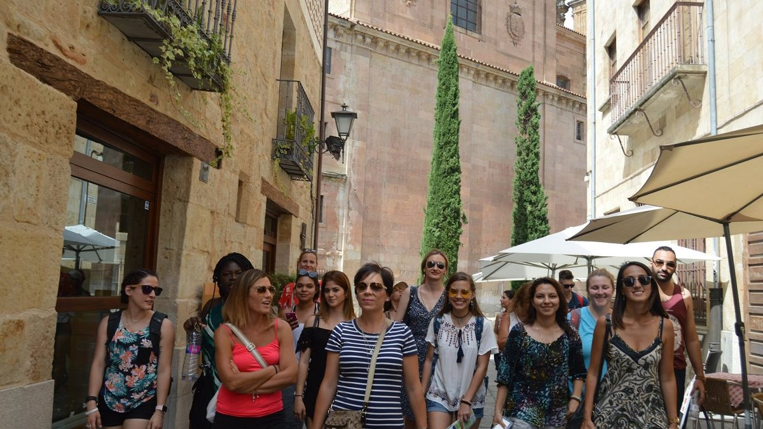

Plaza de San Blas, Salamanca, España, from 12 to 99 age

Course intensity | 15
Accommodation | Host family
Room type | Twin
Bathroom facilities | Shared
Meals | Breakfast, Lunch and Dinner
Excursions per week | 2
Weekday excursions | 1
Full day excursions | 1

Description

Why choose this program

Infrastructure

Sport infrastructure

Hobbies and clubs

What else included in the program price

Recommended arrival city

Саламанка

Sample timetable
 | Morning | Afternoon | Evening
Day 1 | Lessons | City Orientation Walking Tour | Free Time
Day 2 | Lessons | Treasure Hunt | Free Time
Day 3 | Lessons | Dance classes or Cooking | Free Time
Day 4 | Lessons | Cultural visit to Salamanca Cathedrals of Romanesque, Gothic and Barroque Arquitecture | Free Time
Day 5 | Lessons | Comics’ creation workshop | Free time
Day 6 | Visit to Segovia | Visit to Segovia | Visit to Segovia
Day 7 | Free day with your teachers! | Free day with your teachers! | Free day with your teachers!

For booking please go to www.travelclass.org

