Frances King School of English — language school in the UK

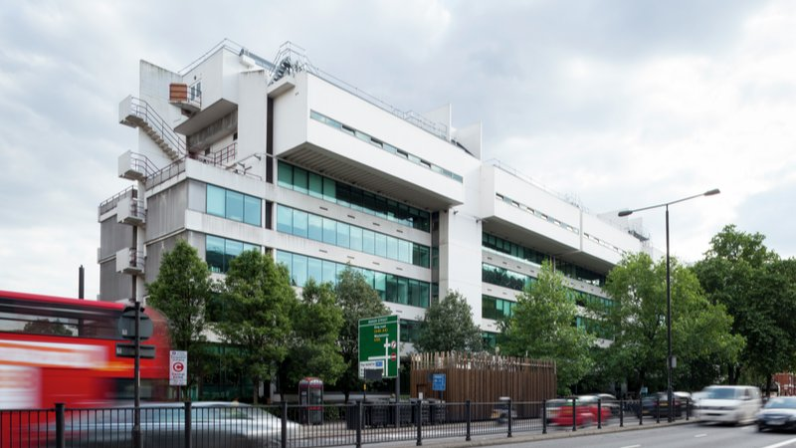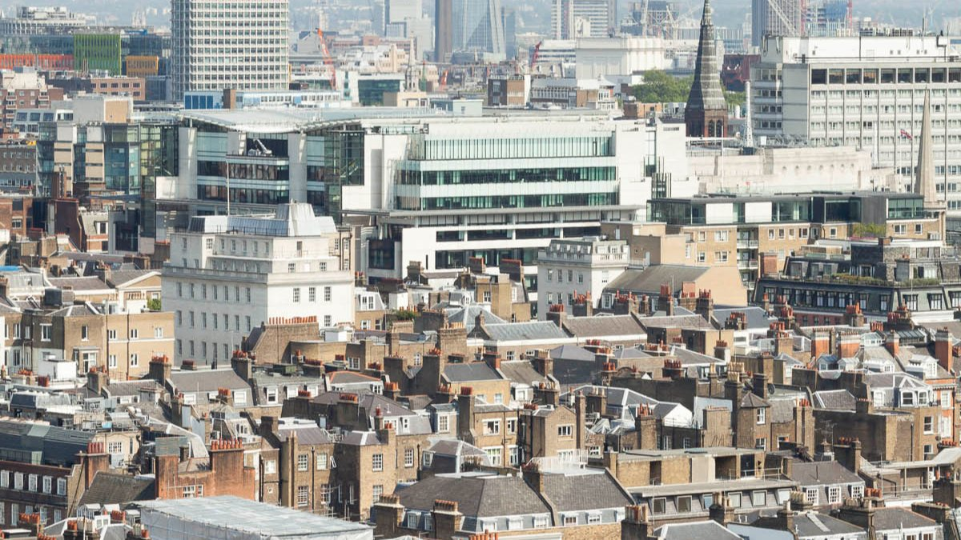

35 Marylebone Rd, London NW1 5LS, UK, from 12 to 17 age

Course intensity | 45
Accommodation | Campus
Room type | Twin
Bathroom facilities | En-suite
Meals | Breakfast, Lunch and Dinner
Excursions per week | 6
Weekday excursions | 5
Full day excursions | 1

Description

Why choose this program

Infrastructure

Sport infrastructure

Hobbies and clubs

What else included in the program price

Recommended arrival city

Лондон

Sample timetable
 | Morning | Afternoon | Evening
Day 1 | 08.00-09.00 Breakfast | 09.00-12.15 Lessons  12.15-13.45 Lunch  14.00-18.00 Activities | 18.00-19.00 Dinner  19.00-20.00 Free Time and Meeting  20.00-22.00 Evening Activities
Day 2 | 08.00-09.00 Breakfast | 09.00-12.15 Lessons  12.15-13.45 Lunch  14.00-18.00 Activities | 18.00-19.00 Dinner  19.00-20.00 Free Time and Meeting  20.00-22.00 Evening Activities
Day 3 | 08.00-09.00 Breakfast | 09.00-12.15 Lessons  12.15-13.45 Lunch  14.00-18.00 Activities | 18.00-19.00 Dinner  19.00-20.00 Free Time and Meeting  20.00-22.00 Evening Activities
Day 4 | 08.00-09.00 Breakfast | 09.00-12.15 Lessons  12.15-13.45 Lunch  14.00-18.00 Activities | 18.00-19.00 Dinner  19.00-20.00 Free Time and Meeting  20.00-22.00 Evening Activities
Day 5 | 08.00-09.00 Breakfast | 09.00-12.15 Lessons  12.15-13.45 Lunch  14.00-18.00 Activities | 18.00-19.00 Dinner  19.00-20.00 Free Time and Meeting  20.00-22.00 Evening Activities
Day 6 | 08.00-09.00 Breakfast | 09.00-12.15 Lessons  12.15-13.45 Lunch  14.00-18.00 Activities | 18.00-19.00 Dinner  19.00-20.00 Free Time and Meeting  20.00-22.00 Evening Activities
Day 7 | 08.00-09.00 Breakfast | 09.00-12.15 Lessons  12.15-13.45 Lunch  14.00-18.00 Activities | 18.00-19.00 Dinner  19.00-20.00 Free Time and Meeting  20.00-22.00 Evening Activities

For booking please go to www.travelclass.org

