CES Wimbledon — language school in the UK

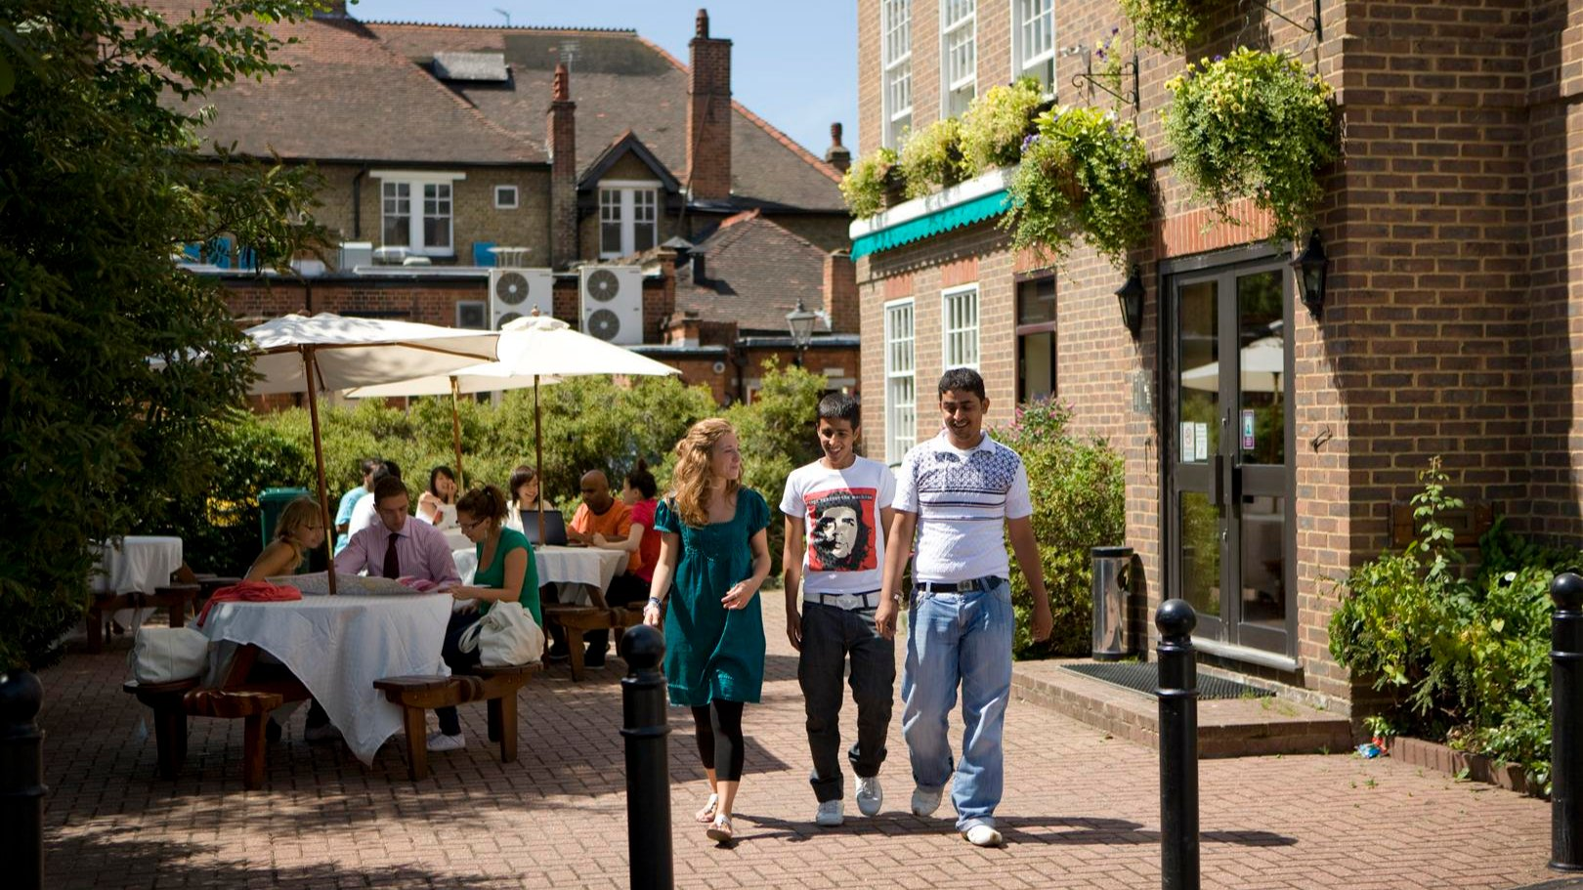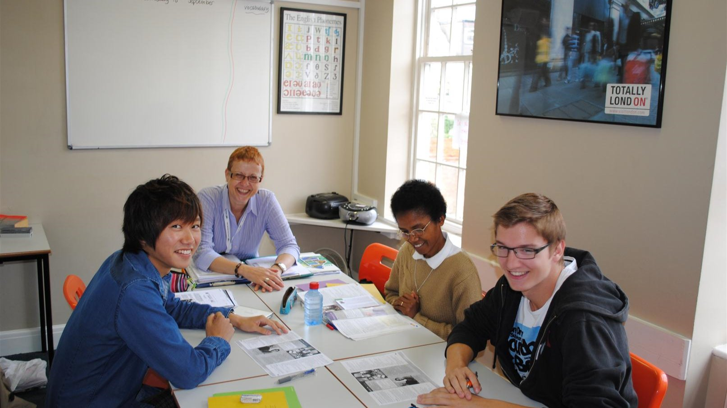

Nelson House, 271 Kingston Road, London, UK, from 14 to 18 age

Course intensity | 15
Accommodation | Host family
Room type | Single
Bathroom facilities | Shared
Meals | Breakfast + Dinner
Excursions per week | 0
Weekday excursions | 0
Full day excursions | 0

Description

Why choose this program

Infrastructure

Sport infrastructure

Hobbies and clubs

What else included in the program price

Recommended arrival city

Лондон

Sample timetable
 | Morning | Afternoon | Evening
Day 1 | English Lessons | Welcome Drinks & Games Free | Salsa Class
Day 2 | English Lessons | TABLE TENNIS TOURNAMENT | Video Games
Day 3 | English Lesson | Squash & Badminton | Evening Activity
Day 4 | English Lessons | JOB CLUB workshop | Free time
Day 5 | English Lessons | Tennis | Excursion to Wimbledon Tennis Museum
Day 6 | Excursion to London | Excursion to London | Free time
Day 7 | Optional excursion to Oxford/Cambridge/Brighton (extra pay) | Optional excursion to Oxford/Cambridge/Brighton (extra pay) | Optional excursion to Oxford/Cambridge/Brighton (extra pay)
Day 8 | English Lesson | Free time | Cinema
Day 9 | English Lesson | Table tennis | Excursion to British Museum
Day 10 | English Lesson | Excursion to National Gallery and Trafalgar Square | Free time
Day 11 | English Lesson | Wimbledon Quiz | Free time
Day 12 | English Lesson | Sports Afternoon | BBQ
Day 13 | Hampton Court and Kingston (Includes admission to Hampton Court) | Hampton Court and Kingston (Includes admission to Hampton Court) | Free time
Day 14 | Departure

For booking please go to www.travelclass.org

