Ardmore London King's College — summer school in the UK

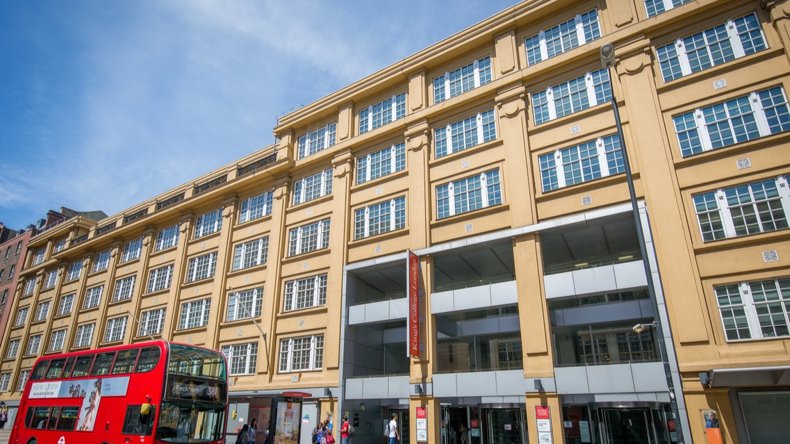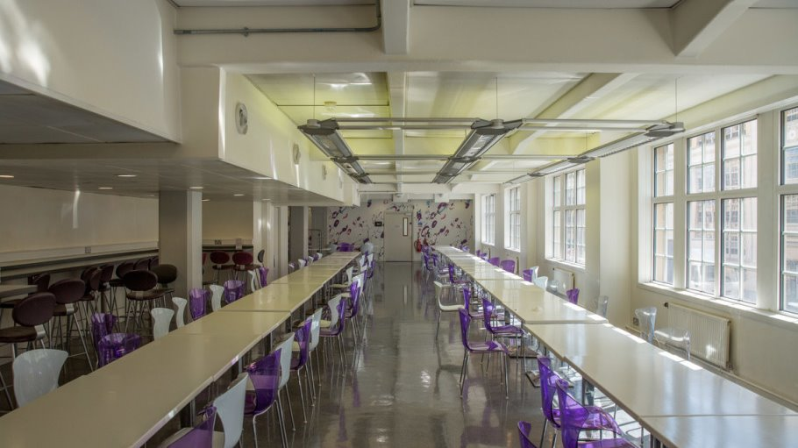

Strand Ln, London WC2R 2NA, UK, from 12 to 17 age

Course intensity | 15
Accommodation | Campus
Room type | Single
Bathroom facilities | En-suite
Meals | Breakfast, Lunch and Dinner
Excursions per week | 6
Weekday excursions | 5
Full day excursions | 1

Description

Why choose this program

Infrastructure

Sport infrastructure

Hobbies and clubs

What else included in the program price

Recommended arrival city

Лондон

Sample timetable
 | Morning | Afternoon | Evening
Day 1 | Lessons | One Half Day Excursion Westminster Walking Tour | Welcome Icebreaker Games
Day 2 | Lessons | One Half Day Excursion Piccadilly Circus and  The National Gallery | Blind Date
Day 3 | Lessons | One Half Day Excursion Hyde Park Selfie Challenge | Talent Show
Day 4 | Lessons | One Half Day Excursion Southbank Walk | Casino Night
Day 5 | Lessons | One Half Day Excursion Notting Hill and Portobello Market | Disco
Day 6 | One Full Day Excursion to British Museum, Oxford Street and Regent Street | One Full Day Excursion to British Museum, Oxford Street and Regent Street | Sports Tournament
Day 7 | Sports & Leisure Activities on Campus/ Optional Extra Excursion | Sports & Leisure Activities on Campus/ Optional Extra Excursion | Movie Night
Day 8 | One Half Day Excursion Natural History Museum | Lessons | Capture the Flag
Day 9 | One Half Day Excursion Thames River Cruise | Lessons | Find Dr Ardmore
Day 10 | One Half Day Excursion Imperial War Museum | Lessons | Karaoke
Day 11 | One Half Day Excursion Science Museum | Lessons | Rounders
Day 12 | One Half Day Excursion Covent Garden Scavenger Hunt | Lessons | Disco
Day 13 | One Full Day Excursion to Greenwich Observatory, Greenwich Park and Greenwich Market | One Full Day Excursion to Greenwich Observatory, Greenwich Park and Greenwich Market | Mini Olympics
Day 14 | Departure | Goodbye Ardmore | Goodbye Ardmore

For booking please go to www.travelclass.org

