Ardmore University of Bath — summer school in the UK

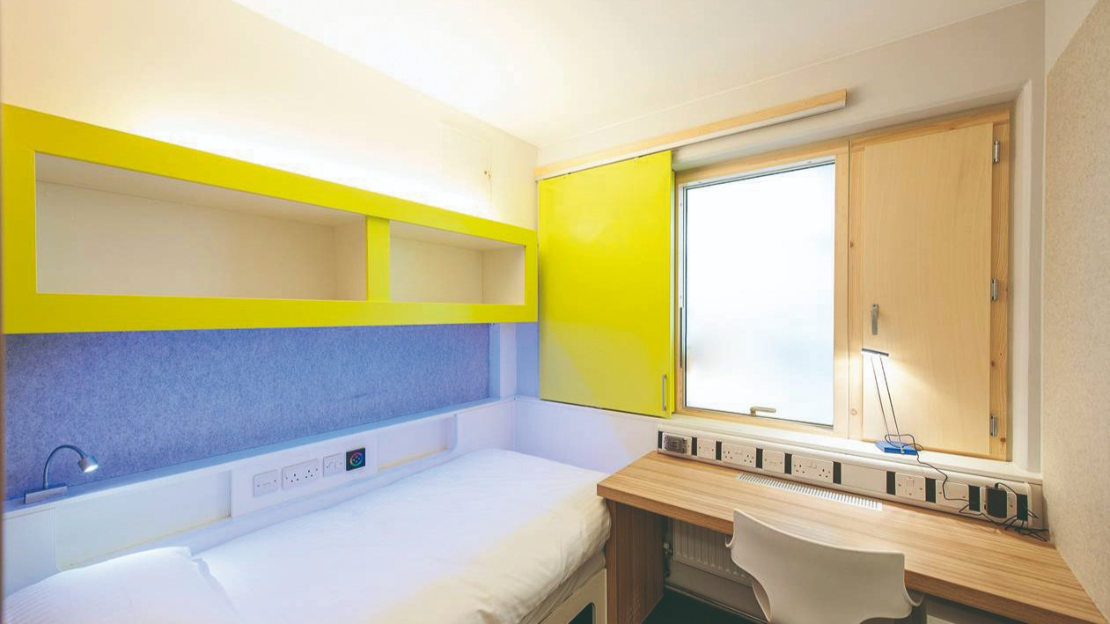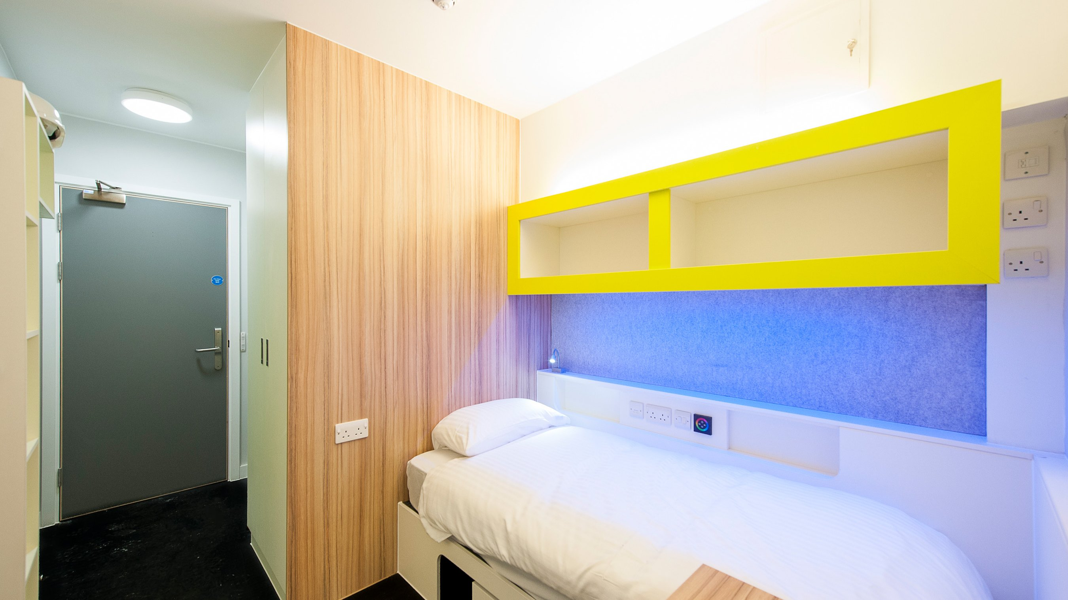

Claverton Down, Bath, UK, from 9 to 17 age

Course intensity | 15
Accommodation | Campus
Room type | Single
Bathroom facilities | Shared
Meals | Breakfast, Lunch and Dinner
Excursions per week | 2
Weekday excursions | 1
Full day excursions | 1

Description

Why choose this program

Infrastructure

Sport infrastructure

Hobbies and clubs

What else included in the program price

Recommended arrival city

Лондон

Sample timetable
 | Morning | Afternoon | Evening
Day 1 | Arrival | Arrival | Icebreaker games
Day 2 | Lessons- placement exam | Sports and Leisure activities | Blind Date
Day 3 | Lessons | Sports and Leisure Activities | Casino Night
Day 4 | Lessons | HD excursion to Bristol Walking Tour | Talent Show
Day 5 | Lessons | Sports and Leisure Activities | Disco
Day 6 | FD Excursion to London, Thames River Cruise, and Westminster Walking Tour ( Late return meal vouchers provided) | FD Excursion to London, Thames River Cruise, and Westminster Walking Tour ( Late return meal vouchers provided) | Sports Tournament
Day 7 | Sports and Leisure Activities on Campus / Optional Extra Excursions | Sports and Leisure Activities on Campus / Optional Extra Excursions | Sports and Leisure Activities on Campus / Optional Extra Excursions

For booking please go to www.travelclass.org

