PLUS University of Kingston — summer school in the UK

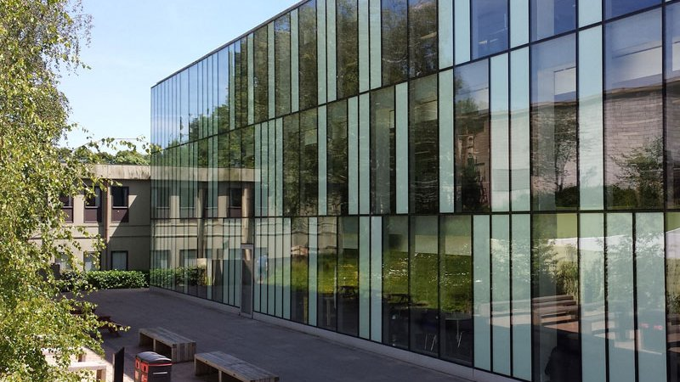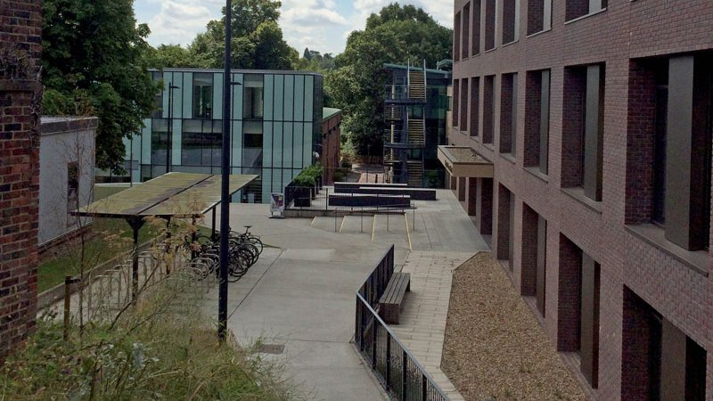

Kingston University London Kingston Hill Campus, Kingston Hill, Кингстон, Великобритания, from 12 to 17 age

Course intensity | 15
Accommodation | Host family
Room type | Twin
Bathroom facilities | Shared
Meals | Breakfast, Lunch and Dinner
Excursions per week | 4
Weekday excursions
Full day excursions | 4

Description

Why choose this program

Infrastructure

Sport infrastructure

Hobbies and clubs

What else included in the program price

Recommended arrival city

Лондон

Sample timetable
 | Morning | Afternoon | Evening
Day 1 | Arrival | Arrival | Welcome Talk & Orientation Walk
Day 2 | Project Lesson | Activities on campus | Summer Disco
Day 3 | Lessons | Lessons | Knockout
Day 4 | Full day in Brighton | ROYAL PAVILION, BRIGHTON MUSEUM, BRIGHTON DOME & PAVILION GARDENS, LANES, CHRUCHILL SQUARE SHOPPING CENTRE, BRIGHTON PIER | Monopoli
Day 5 | Lessons | Lessons | Movie
Day 6 | Full Day Excursion to London | SHAKESPEARE'S GLOBE (entry included) , BUCKINGHAM PALACE, ST JAMES`S PARK, WESTMINSTER ABBEY, HOUSES OF PARLIAMENT, BIG BEN, 10 DOWNING STREET, HORSE GUARDS, TRAFALGAR SQUARE & NATIONAL GALLERY | Karaoke
Day 7 | Lessons | Lessons | Black and White Disco
Day 8 | Lesson | Lesson | Disco
Day 9 | Full Day Excursion to London | Full Day Excursion to London | Full Day Excursion to London
Day 10 | Full Day Excursion to Brighton | Full Day Excursion to Brighton | Full Day Excursion to Brighton
Day 11 | Lesson | Lesson | Murder Mysetery
Day 12 | Full Day Excursion to London | Full Day Excursion to London | Full Day Excursion to London
Day 13 | Lesson | Lesson | Plus Has Got Talent
Day 14 | Full Day Excursion to London | Full Day Excursion to London | Graduation & Farewell Disco

For booking please go to www.travelclass.org

