LAL London St Mary’s University — summer school in the UK

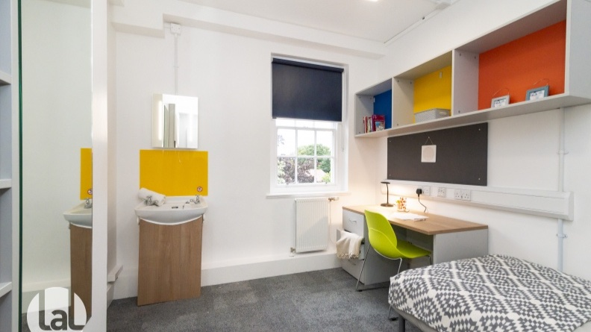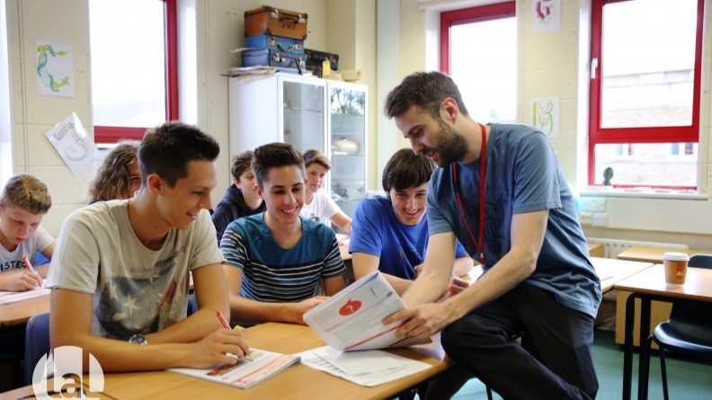

Waldegrave Road, Twickenham TW1 4SX, UK, from 12 to 17 age

Course intensity | 15
Accommodation | Host family
Room type | Twin
Bathroom facilities | Shared
Meals | Breakfast, Lunch and Dinner
Excursions per week | 5
Weekday excursions | 4
Full day excursions | 1

Description

Why choose this program

Infrastructure

Sport infrastructure

Hobbies and clubs

What else included in the program price

Recommended arrival city

Лондон

Sample timetable
 | Morning | Afternoon | Evening
Day 1 | Arrivals / Departures | Arrival / Departures | Dinner & Evening with Host Home
Day 2 | School tour & walk into town | Level Test / Induction | Welcome Disco / Travel to Homestay
Day 3 | London South Bank Walk | Lessons | Dragon's Den / Travel to Homestay
Day 4 | Kingston | Lessons | Dinner & Evening with Host Home
Day 5 | Activities | Lessons | Dinner in Center London / Travel to Homestay
Day 6 | Hampton Court | Lessons | Bigger, Better, Best / Travel to Homestay
Day 7 | Camden & Regent's Park | Camden & Regent's Park | Speed Friending & Disco / Travel to Homestay
Day 8 | Activities/Optional Excursion/ Premium Option | Activities/Optional Excursion/ Premium Option | Trash Fashion
Day 9 | Lessons | Mini Olympics | Gladiator Contest
Day 10 | Lessons | Royal Walk | Murder Mystery Night
Day 11 | Lessons | British Museum or Madame Tussaud’s | Talent Show & Karaoke
Day 12 | Lessons | West End Walk & Thames Disco Cruise | West End Walk & Thames Disco Cruise
Day 13 | Lessons | Natural History/Science Museum or Tower of London | Casino & Auction
Day 14 | Oxford | Oxford | Graduation & Farewell Party

For booking please go to www.travelclass.org

