friLingue St Bernard School — language school in Switzerland

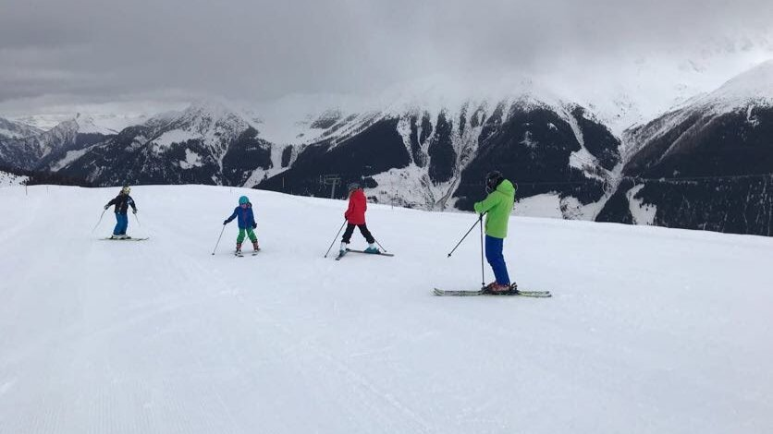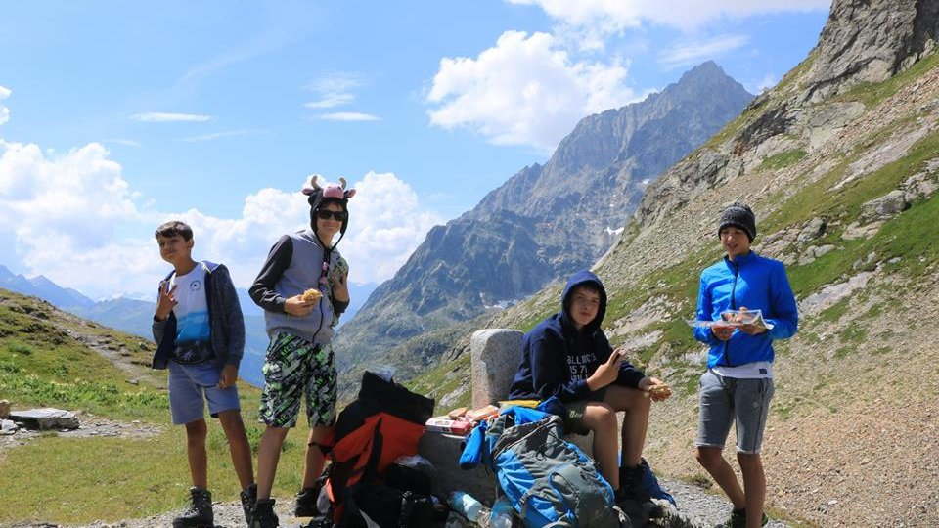

Liddes, Лидд, Switzerland, from 8 to 17 age

Course intensity | 15
Accommodation | Campus
Room type | Quadraple
Bathroom facilities | Shared
Meals | Breakfast, Lunch and Dinner
Excursions per week | 2
Weekday excursions | 1
Full day excursions | 1

Description

Why choose this program

Infrastructure

Sport infrastructure

Hobbies and clubs

What else included in the program price

Recommended arrival city

Женева

Sample timetable
 | Morning | Afternoon | Evening
Day 1 | Free | Arrivals | Welcoming games + level test
Day 2 | Language Class | Tennis with professionals | Thematic Evening
Day 3 | Language Class | Excursion in Bavon | Fire camp/concert
Day 4 | Language Class | Tennis with professionals | Treasure Hunt
Day 5 | Language Class | Excursion in Aoste (Italy) | Free evening
Day 6 | Language Class | Tennis with professionals | Disco
Day 7 | Excursion to Sion | Excursion to Sion | Free

For booking please go to www.travelclass.org

