Gateway School of English — language school in Malta

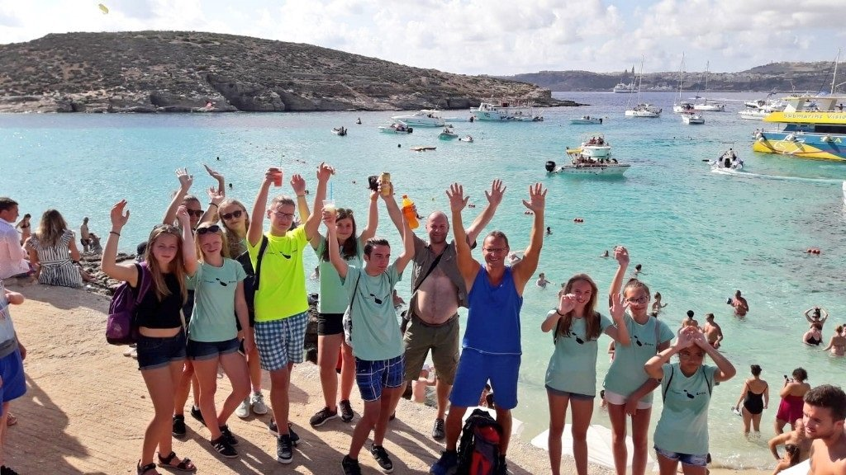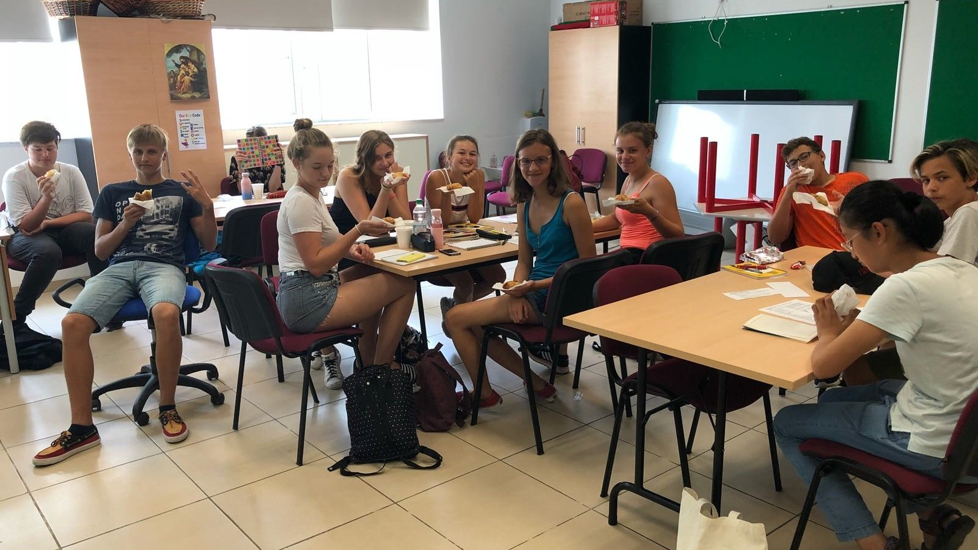

San Gwann Primary School (St Clare College), Myrtle Avenue, San Gwann, from 12 to 17 age

Course intensity | 15
Accommodation | Host family
Room type | Multi-bedded
Bathroom facilities | Shared
Meals | Breakfast, Lunch and Dinner
Excursions per week | 8
Weekday excursions | 6
Full day excursions | 2

Description

Why choose this program

Infrastructure

Sport infrastructure

Hobbies and clubs

What else included in the program price

Recommended arrival city

Luqa

Sample timetable
 | Morning | Afternoon | Evening
Day 1 | Arrival Day - Check in - Orientation walk around St Julian’s for new students | Arrival Day - Check in - Orientation walk around St Julian’s for new students | Arrival Day - Check in - Orientation walk
Day 2 | Lessons | Free Afternoon | Treasure Hunt at Valletta by Night / Mdina by Night
Day 3 | Lessons | Bowling at Eden Superbowl St Julian's | Free Evening (Students can go out with the GSE Group Leader)
Day 4 | Lessons | Ta' Qali Crafts Village, Mdina, Rabat & Dingli Cliffs | Supervised Night Out in St Julian's
Day 5 | Lessons | Afternoon in St Julian's / Sliema | Free evening
Day 6 | Lessons | Free afternoon | Supervised night out in St Paul's Bay
Day 7 | Full day Tour to the open market at Marsaxlokk Fishing Village + Pretty Bay + the Blue Grotto | Full day Tour to the open market at Marsaxlokk Fishing Village + Pretty Bay + the Blue Grotto | Free evening
Day 8 | Full Day Tour to the open market at Marsaxlokk Fishing Village + Pretty Bay + the Blue Grotto | Full Day Tour to the open market at Marsaxlokk Fishing Village + Pretty Bay + the Blue Grotto | Free time
Day 9 | Lessons | Free Afternoon | Treasure Hunt
Day 10 | Lessons | Bowling at Eden Superbowl St Julian’s | Free time
Day 11 | Lessons | Free Afternoon | Supervised night out in Sliema
Day 12 | Lessons | Beach Games at St George's Bay | Sports Night at San Gwann FC (Football, Volleyball & Handball)
Day 13 | Lessons | Free Afternoon | Supervised Night out in St Paul’s Bay
Day 14 | Free Day (Gozo & Comino Optional: Price Euro 35) | Free Day (Gozo & Comino Optional: Price Euro 35) | Free time

For booking please go to www.travelclass.org

