Twin English School London Ravensbourne University — summer school in the UK

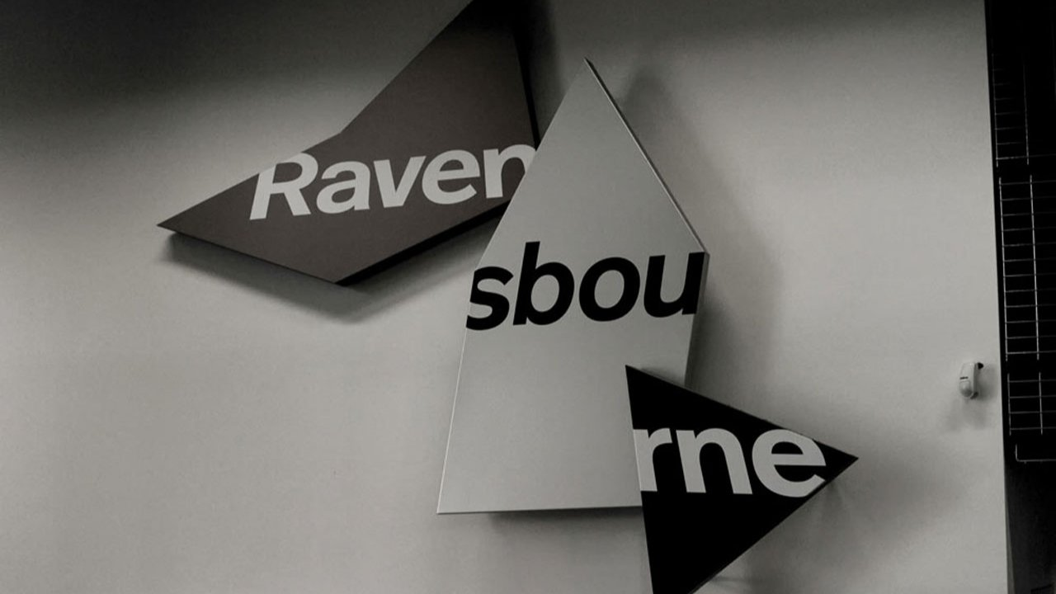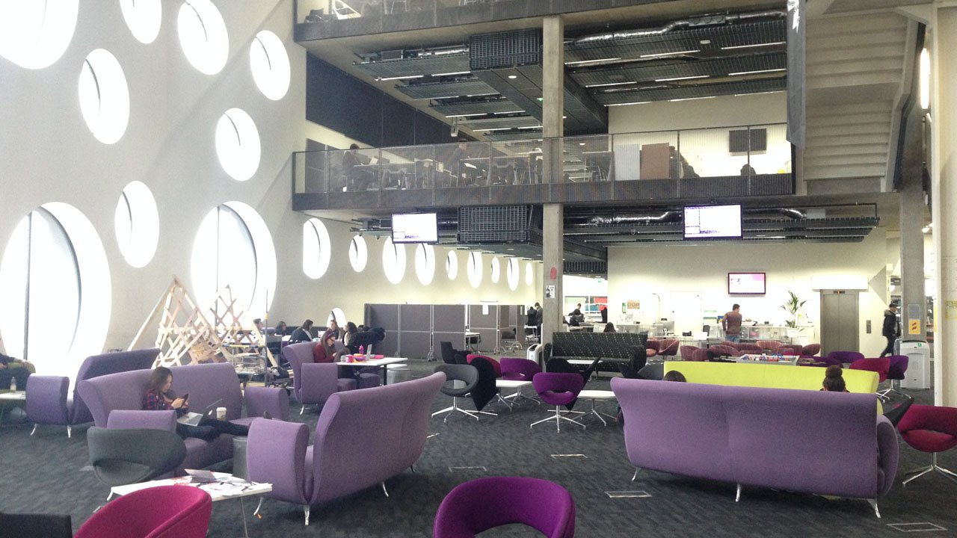

6 Penrose Way, London, UK, from 12 to 17 age

Course intensity | 15
Accommodation | Host family
Room type | Twin
Bathroom facilities | Shared
Meals | Breakfast, Lunch and Dinner
Excursions per week | 4
Weekday excursions | 3
Full day excursions | 1

Description

Why choose this program

Infrastructure

Sport infrastructure

Hobbies and clubs

What else included in the program price

Recommended arrival city

Лондон

Sample timetable
 | Morning | Afternoon | Evening
Day 1 | Arrival/Meet & Greet | Settling in | Homestay
Day 2 | Testing and English Lessons | English Lessons | Newspaper Fashion Show
Day 3 | Full day in London | Thames River Cruise, Big Ben, Houses of Parliament, Westminster Abbey, St James’s Park, Buckingham Palace, Piccadilly Circus, Trafalgar Square | Homestay
Day 4 | English lessons | English lessons | Social Games
Day 5 | Full Day in London | Tower of London, Tower Bridge, HMS Belfast, Southbank, Shakespeare's Globe, Tate Modern (with entrance), Millennium Bridge, St Paul’s Cathedral | Homestay
Day 6 | English Lessons | English Lessons | Building Competition
Day 7 | Full day excursion to Brighton | Walking tour in Brighton with entrance to Brighton Pavilion | Homestay

For booking please go to www.travelclass.org

